

DEVELOPMENT BANK OF LATIN AMERICA (CAF)

PROJECT DOCUMENT

ON A

PROPOSED GLOBAL ENVIRONMENT FACILITY (GEF) TRUST GrANT

IN THE AMOUNT OF US $ 2.9 MILLION

TO

THE MINISTRY OF ENVIRONMENT OF CHILE

FOR A

Supporting the Chilean Low Emissions Transport Strategy (CLETS) PROJECT

10 April 2019

Executive President: |  | Luis Carranza Ugarte
Sustainable Development Vice-president: |  | Julian Suarez Migliozzi
Environmental and Climate Change Senior Executive: |  | René Gómez-García Palao

CURRENCY EQUIVALENTS
(Exchange Rate Effective April 24, 2018)
600.58 Chilean Pesos = 1.00 US$

FISCAL YEAR
January 1 – December 31

ABBREVIATIONS AND ACRONYMS
AR5 Fifth Assessment Report of the IPCC
AWP Annual Work Plan
CAF Development Bank of Latinamerica (Banco de Desarrollo de América Latina)
CASEN Ministry of Social Development’s National Socioeconomic Characterization Survey (Encuesta de Caracterización Socioeconómica Nacional del Ministerio de Desarrollo Social)
CC Climate Change (Cambio Climático)
DTPR Regional Transport Directorate (Dirección de Transporte Público Regional)
ECLAC Economic Commission for Latin America and the Caribbean (Comisión Económica para Latina América y el Caribe - CEPAL)
EOD MTT’s Origin-Destination Survey (Encuesta Origen-Destino del Ministerio de Transporte)
GDP Gross Domestic Product (Producto Interno Bruto)
GEF Global Environment Facility (Fondo Mundial para el MEDIUM Ambiente)
GEFTF Global Environment Facility Trust Fund (Fideicomiso del Fondo para el Medio Ambiente Mundial)
ICR Implementation Completion and Results Report
INDC Intended Nationally Determined Contribution towards the Climate Agreement of Paris 2015
IPCC Intergovernmental Panel on Climate Change (Grupo Intergubernamental de Expertos sobre el Cambio Climático)
MDG Millennium Development Goals (Objetivos de Desarrollo del Milenio)
MEKLE Monitoring and Evaluation, Knowledge Management and Lessons-Learned
MINVU Ministry of Housing and Urban Planning (Ministerio de Vivienda y Urbanismo)
MMA Ministry of Environment (Ministerio de Medio Ambiente), Chile
MRV Monitoring, Reporting and Verification
MTT Ministry of Transport and Telecommunications (Ministerio de Transporte y Telecomunicaciones), Chile
M&E Monitoring and Evaluation (Monitoreo y Evaluación)
NAMA Nationally Appropriate Mitigation Action
STGZ Transport Green Zone in Santiago, Chile
NGO Non-Governmental Organization (Organización no Gubernamental)
OECD Organization for Economic Co-operation and Development (Organización para la Cooperación y el Desarrollo)
PIF Project Idea Form (Formato de Idea de Proyecto)
ProDoc Project Document (Documento de Proyecto)
PDO Project Development Objective (Objetivo de Desarrollo del Proyecto)
PMU Project Management Unit (Unidad Gestora del Proyecto)
PLACC CAF’s Latin American Climate Change Programme (Programa Latinoamericano de Cambio Climático de CAF)
PPDA Atmospheric Prevention and Decontamination Plans (Plan de Prevención y Descontaminación Ambiental)
PPK per-kilometre payment (Pago Por Kilometro)
PPT per-passenger payment (Pago Por Pasajero)
UNE United Nations Environment (Programme, Programa de las Naciones Unidas para el Medio Ambiente, antes PNUMA)
PSC Project Steering Committee (Comité Directivo del Proyecto)
SECTRA Vice-Ministry of Transport (Secretaría de Transporte)
SEREMI Regional Ministerial Secretary (Secretaría Regional Ministerial)
SDG Sustainable Development Goals of the United Nations
SNC Second National Communication to the UNFCCC (Segunda Comunicación Nacional a la CMNUCC)
SOE Statement of Expenses
UNFCCC United Nations Framework Convention on Climate Change (Convención Marco de las Naciones Unidas sobre el Cambio Climático)
UN United Nations (Naciones Unidas)
UNDP United Nations Development Programme (Programa de las Naciones Unidas para el Desarrollo)
USD United States dollar (Dólares de los Estados Unidos de América)
WB World Bank (Banco Mundial)
WHO World Health Organisation (Organización Mundial de la Salud)
TABLE OF CONTENT

PROJECT DATASHEET 8
1. STRATEGIC CONTEXT AND BASELINE SCENARIO 9
a. National Context 9
b. Sectorial and Institutional Context 11
c. Higher Level Objectives to which the Project Contributes 18
2. PROJECT DEVELOPMENT OBJECTIVES 23
a. PDO 23
i. Project Beneficiaries 23
ii. PDO (Outcome) Level Results Indicators 26
b. Project Description 26
i. Project Rationale 26
ii. Project Components 28
iii. Project Financing 29
iv. Lessons Learned and Reflected in the Project Design 30
v. Coordination with Other Initiatives Including Relevant GEF Funded Initiatives 30
vi. Incremental Cost Reasoning 30
c. Implementation 32
i. Institutional and Implementation Arrangements 32
ii. Results Monitoring and Evaluation 33
iii. Innovativeness, Up-Scaling and Sustainability 35
d. Key Risks and Mitigation Measures 37
i. Overall Risk Rating and Explanation of Key Risks 37
e. Summary Project Analyses 38
i. Economic and Financial (if applicable) Analysis 38
ii. Technical 39
iii. Financial Management 39
iv. Procurement 40
v. Environmental and Social (including Safeguards) 40
vi. Gender Mainstreaming 40
vii. Socioeconomic Benefits 43
viii. Stakeholder Participation 44
ANNEX 1. RESULTS FRAMEWORK AND MONITORING 46
ANNEX 2. DETAILED PROJECT DESCRIPTION 53
ANNEX 3. SUMMARIZED PROJECT IMPLEMENTATION SCHEDULE 58
ANNEX 4. INCREMENTAL COST MATRIX 60
ANNEX 5. CALCULATION AND MODELLING PARAMETERS 62
ANNEX 6. IMPLEMENTATION ARRANGEMENTS 77
ANNEX 7. TOR, PROJECT COORDINATOR 81
ANNEX 8. TOR, PILOT INITIATIVES 83
ANNEX 9. CDKM PLAN 102
ANNEX 10. MONITORING & EVALUATION WORK PLAN 109
ANNEX 11. MAJOR RISKS AND MITIGATION MEASURES 111
ANNEX 12. ENDORSEMENT BY GEF FOCAL POINT 112
ANNEX 13. ENDORSEMENT BY EXECUTIVE AGENCY/IES 113
ANNEX 14. CO-FINANCING LETTERS 114

Index of Tables
Table 1. Bus and collective taxi, Chile, fleet size (source: SECTRA, 2016) 14
Table 2. Transantiago foreseen renewal (source: DTPM, 2016) 14
Table 3. RTM programme historic data (source: SECTRA, 2016) 16
Table 4. RTC programme historic data and forecast (source: SECTRA, 2016) 16
Table 5. Project Stakeholders 23
Table 6. Project’s Summary Budget 29
Table 5. Risk Rating Summary Table 37

Index of figures
Figure 1. Chile’s total energy balance (source: Ministry of Energy, 2017) 9
Figure 1. General distribution of all travel. Santiago metropolitan area, week day (in red: public transport) (souce: EOD 2012) 10
Figure 2. Detail 40-80%, share of travels with data, week day, four selected cities (source: EOD, 2010-14) (disaggregated by income quintile and gender) 10
Figure 3. Modal share of all travels with data, week day, ten Chilean cities (source: EOD, 2010-14) (disaggregated by gender) 12
Figure 4. Policy and implementation, non-motorised transport (Source: UN Environment (2016) Global Outlook on Walking and Cycling - Policies & realities from around the world 18
Figure 6. Stakeholder map, bus (source: MMA, 2017) 25
Figure 7. Stakeholder map, collective taxi (source: MMA, 2017) 25
Figure 7. Procedure maps, bus (RTM, left) / collective taxi (RTC, right) (in Spanish; source: MTT, 2018) 26
Figure 9. Project organigram 34
Figure 8. Direct health benefits (avoided premature deaths) per income quintile, disaggregated by gender 44

PROJECT DATASHEET

Country/ies: Republic of Chile
Project Title: Supporting the Chilean Low Emissions Transport Strategy (CLETS) – Apoyo a la Estrategia Chilena de Transporte Público Sustentable (CLETS)
GEF Project ID: 9742
CAF Project ID: CAF/GEF 004
GEF Agency: development bank of Latin America (CAF)
Project Executing Organization: Ministry of Environment
Other Executing Partners: Ministry of Transport and Telecommunications, Ministry of Housing and Urban Planning
GEF Focal Area: Climate Change
GEF Strategic Objective: CCM-2 Programme 3
CAF Priority Environmental Sustainability and Climate Change
Duration: 5 years
Estimated Starting Date: January 2020
Estimated Completion: December 2024

Financing Plan (US$M) | USD | %
GEF Allocation | 3.16 | 5.15%
GEFTF | 3.16
Co-financing:
Governments (In Kind) | 00.07
Governments (Cash) | 58.00
CAF (In Kind) | 0.15
Sub-Total Co-Financing | 58.22 | 94.85%
Total Project Budget | 61.38 | 100.00%

Estimated Disbursements (CAF FY, US$M) | FY1 | FY2 | FY3 | FY4 | FY5 | Total
Annual | 0.93 | 0.45 | 0.55 | 0.45 | 0.53 | 2.90
Cumulative | 0.93 | 1.38 | 1.93 | 2.37 | 2.90 | 2.90

- STRATEGIC CONTEXT AND BASELINE SCENARIO
  - National Context
- Background. The transport sector currently produces some 11,5% of Chilean GHG emissions (INGEI 2016). Of that (almost 24 MtCO₂eq in 2014), public passenger transport accounts for about a fifth (about 4.8 million tCO₂eq·yr⁻¹ in 2014) while at the same time having a disproportionate impact on the perceived environmental (and general) quality of urban environments for the population. Public urban mobility is currently at a crossroads, with emissions volumes and governance settings that provide an opportunity for globally-significant emissions reductions, but also with threats coming from the overwhelming reality of a system that is used (and scrutinised) daily by millions of persons and emerging mobility solutions that take for granted a future public transport in the lines of the current one, but undermine it through the privatisation of mobility data and mobility business models. Besides, a paradigm shift from the current to a new, cleaner mobility is not possible without the incorporation to that shift of the modes of urban transport, be they traditional (in this project, urban bus and collective taxi) or non-traditional (new pedestrianism and public bicycle systems) in the project context.

Figure 1. Chile’s total energy balance (source: Ministry of Energy, 2017)
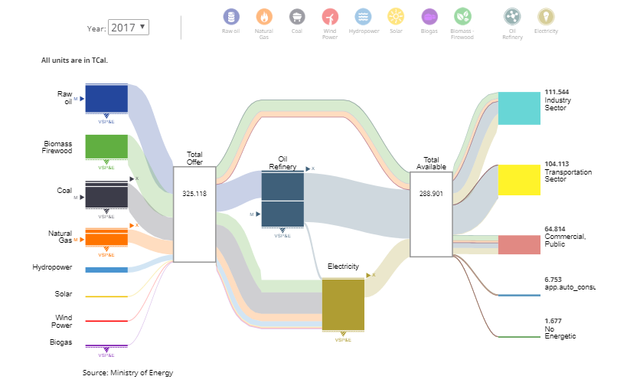

- In Latin-American contexts, capital and other megacities account for very significant proportions of national population, so they constitute a special case that needs to be analysed in its specificity. In the case of Chile, Santiago metropolitan area counts some 6.7 million inhabitants out of a total national population of around seventeen million. Santiaguinos make a mean 2.78 displacements per day, of which 1.71 are made in motorised modes, measuring around 6 km per displacement and taking some 30 minutes each. Of those displacements, 29.1% are made in public transport, 28% in private car, 34.5% are pedestrian and 4% on bicycle. 60% of all households do not count with a private car (EOD 2012) (see also Figure 1), while public and pedestrian modes of transport have a disproportionate participation of poorer people and women (see Figure 2).

Figure 1. General distribution of all travel. Santiago metropolitan area, week day (in red: public transport) (souce: EOD 2012)
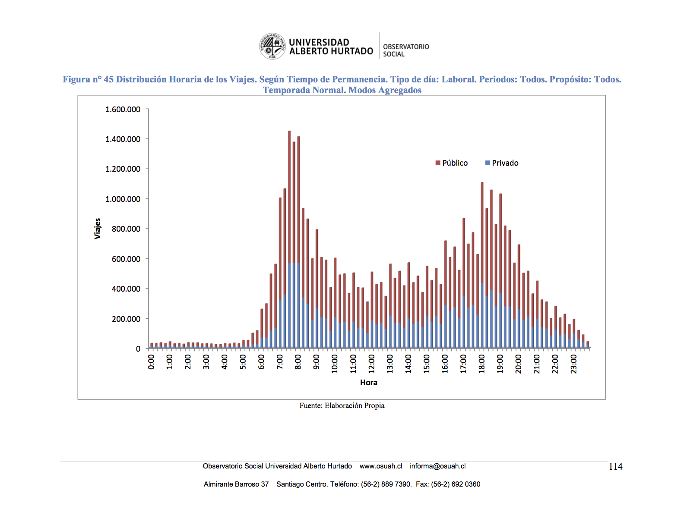

Figure 2. Detail 40-80%, share of travels with data, week day, four selected cities (source: EOD, 2010-14) (disaggregated by income quintile and gender)
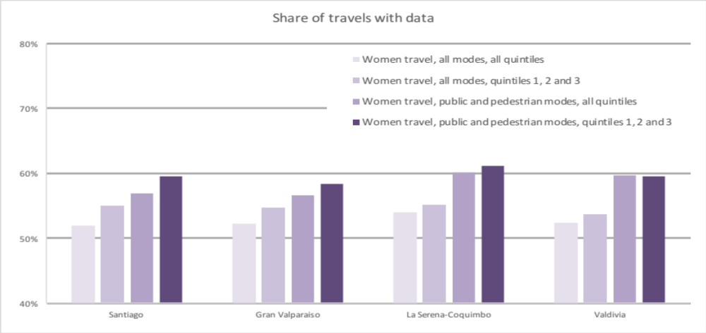
- Global Significance and Threats. Public urban mobility in Chile accounts for about 5.4 million tCO₂eq·yr⁻¹ in 2016 while at the same time having a disproportionate impact on the perceived environmental (and general) quality of urban environments for the general population. The transport sector currently produces some 11,5% of Chilean GHG emissions (almost 20 MtCO₂eq in 2010, almost 25 in 2013). Therefore, public urban mobility produces 2-3% of Chilean GHG emissions, but the sector is more important to Chile’s climate change (CC) strategy than suggested by those numbers. As Chile’s Intended Nationally Determined Contribution (INDC, 2015) to the Paris Agreement states, “Despite Chile’s progress … in providing coverage in services …, improving the quality of such services remains an issue. In this regard, reducing the high levels of inequality in the Chilean economy as well as providing security to vulnerable groups with little social protection are still pending tasks.” This is specially visible in the case of transport, since improvements in it are capable of yielding, at the same time, relevant vulnerability reductions and GHG abatement gains. Concurrently, Chile’s INDC puts transportation as its second priority sector, only after electricity generation.
- While the country has realised significant progress in the abatement of GHG in the power-generation sector, the transportation sector has comparatively lagged behind, with the national transport policy priorities through to 2020 and beyond put on cross-cutting (efficiency, quality), social (access) and economic (capacity, continuity) aims, with little regard for the environmental implications of the sectorial strategy. Although there are not finer-grain numbers, in 2013 transportation-sector emissions had grown by 165.4% from 1990 and 17.1% from 2010, with heavy-duty diesel engines such as those used by buses accounting for more than half (52.4%, INGEI 2016) of emissions. This lack of progress is specially worrying in the context of latest Intergovernmental Panel on Climate Change (IPCC) estimations of the (modest) likelihood of current efforts to reduce global warming to less than 2ºC (IPCC 2018). Therefore, mitigation efforts need to be accelerated to the possible extent.

  - Sectorial and Institutional Context
- A total of 216 zero- or low- emission vehicles (less than 0.005% of the total fleet) occurred in Chile in 2016, most of them concentrated in Santiago. The metropolis counts more than 1.2 million private vehicles, 6577 urban buses, more than 38 thousand taxis and 5 metro lines with more than 104 km of tracks (2016), as well as one of the better-developed bus rapid transit (BRT) systems in Latinamerica: 61.7 km of segregated lanes, 31 km of exclusive lanes and 119.3 km of bus-only tracks. Public transport in Santiago is also subsidised to the tune of 35-40% of operational costs, one of very few cases in which this is so in developing countries, and territorial-balance worries make that subsidy being mirrored with funds for the rest of the country’s public transport (“fondos espejo”, see below).
- Data for the rest of urban areas are patchier, but bigger ones entertain transport dynamics as similar to Santiago’s as its sizes. Figure 3 shows modal share, disaggregated by gender, for ten cities for which it has been possible to gather enough current data.

Figure 3. Modal share of all travels with data, week day, ten Chilean cities (source: EOD, 2010-14) (disaggregated by gender)
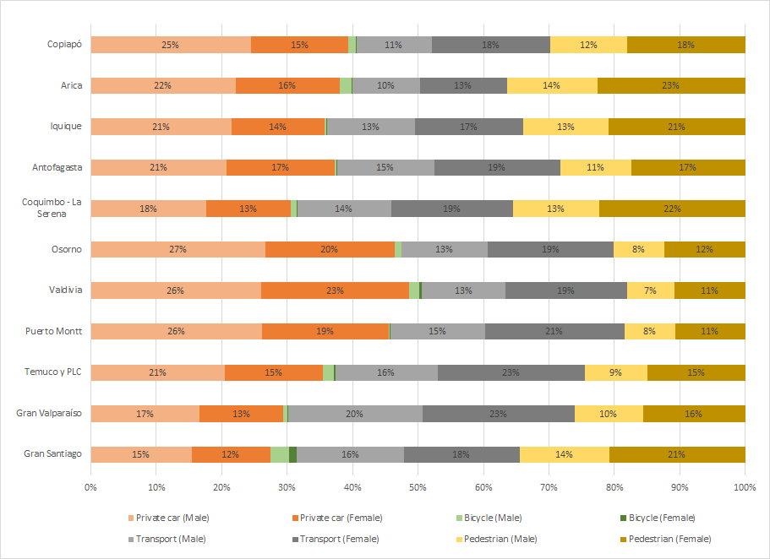

- The research carried out for the development of this project proposal (there is not much quantitative research results on women and emissions in transport) suggests that the contribution of vulnerable women to climate change mitigation is disproportionately high, which would provide ground for benefits following suit. With our data, while women make 53% of comparable travels (in number) in the Santiago Metropolitan Area, the contribution of those travels to emissions is 46%, while men’s contribution of 47% of travels produces 54% of emissions. In our calculations, a typical men’s travel produces 642 g of CO₂e, while the homologous woman’s travel produces 496 g of CO₂e. This is because women use more less contaminant modes (in this exercise, mainly bus and pedestrian), while men consistently use more contaminant modes (mainly private car). These results are consistent with the available, mostly qualitative, research on the issue, such as the CAF-commissioned study “Ella se mueve segura” (She Moves Safely), a study on women’s personal security and public transport in three Latinamerican cities, including Santiago.
- The Vice-Ministry of Transport (SECTRA) of the Ministry of Transport and Telecommunications (MTT) counts with relevant regulatory and financial capabilities, but by the conception of this project these were not focused on environmental concerns. The focus of the national public transport policy priorities through to 2020 and beyond are established on cross-cutting (efficiency, quality), social (access) and economic (capacity, continuity) aims. Environmental concerns related to traffic in general, and public transportation specifically, are housed in the Ministry of Environment (MMA), which can approve plans setting upper limits, but has little jurisdictional capacity on the public transportation sector. Meanwhile, the structural and integral aspects of urban mobility are overseen by the Ministry of Housing and Urbanism (MINVU) and local authorities.
- The project idea focuses on urban mobility as a common (rivalrous but non-excludable) good: it tackles regulated sectors (urban public transport, see Table 1) which function through public-private partnerships (PPPs, for bus) and a licensing system (for collective taxi); and a complex common issue with multiple stakeholders (non-motorised, personal urban mobility); it does not, therefore, focus on private modes of transportation, but instead on regulated subsectors where a public-private, multi-stakeholder approach is mandatory. Crucially, the MTT enforces a policy of keeping every efficiency gain in further regulation. This policy is translated to the technical, detailed level in the three main instruments in consideration (see below), so it constitutes a major opportunity for the project to enact sustainable emissions reductions.

Table 1. Bus and collective taxi, Chile, fleet size (source: SECTRA, 2016)
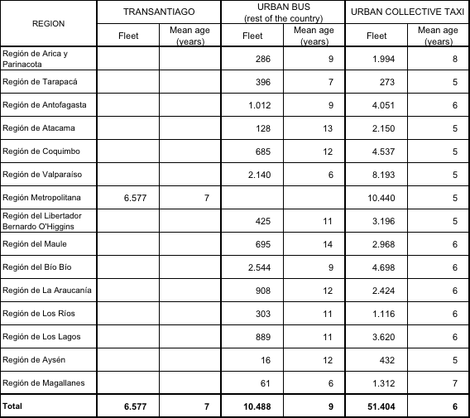

- A key feature of the regulated markets that the project seeks to address is a trend towards the implementation of public bidding processes for the concession/renovation of concession of these regulated services. This is defined as a trend since different administrative regions of the country present this feature in different stages of development. In all cases, the original regulations for any region’s transport system are established by the MTT’s REGIONAL Transport Directorate (Dirección de Transporte Público Regional, DTPR), but the allocation processes vary with local supply-demand balances. Terms of Reference and Technical Specifications for these concessions and the immediately-subsequent arrangements for the securing of assets provide the opportunity for the intended changes. Crucially, these bidding processes, which regularly renew Transantiago’s PPPs and on a rolling basis other local ones, are planned to substitute more than 3100 buses (48% of total fleet, see Table 2) during the period 2017-2022. The contracts establish a fixed per-kilometre payment (“PPK”) and a variable per-passenger one (“PPT”), with the former depending on different variables (established at the contract’s onset) that are discretional to the regulator and that can be used, within the logical limits, to incentive efficiency, low emissions or other factors of interest.

Table 2. Transantiago foreseen renewal (source: DTPM, 2016)
 | Total (#)
Year | Buses | Passenger seats
2019 | 667 | 60.030
2020 | 227 | 20.430
2021 | 1492 | 134.280
2022 | 201 | 18.090

- Transantiago has revealed, during the procedure of identification and formulation of this project, a remarkable flexibility. Although the system is frequently criticised by politicians and routinely proposed for reform, its combination of centralised planning and regulated operation provides room for adaptation and innovation within a continued perception of stability in its functioning. Evidence that supports this inference is provided by the system’s capacity to provide market signals to innovating agents, creating expectations to which it is then able to respond, even while this process has been still in planning stages. Therefore, the process of identification of this project meant the assumption of a political commitment that the country has been able to fulfil at a pace that exceeds expectations, putting itself at the forefront of public transport innovation in its region and beyond. This project will seek to sustain and benefit from the opportunity for accelerated uptake in the whole country being provided by Transantiago’s innovation capacity.
- Another key feature from this project’s point of view are the support programmes for fleet renewal that mirror (“fondos espejo”) the subsidy provided to Transantiago to compensate what would otherwise be a subsidy from the rest of the country to Santiago’s transport. These have a demonstrated capacity to boost market innovation trends, even to limited levels (see below). Both programmes (“Renueva Tu Micro”, RTM, see Table 3, for bus; “Renueva Tu Colectivo”, RTC, see Table 4, for collective taxi) are national (out of Santiago metropolitan area for bus, and not-limited for collective taxi) incentive programmes that support the renewal of fleets through demand subsidies applied to the asset purchase. The abovementioned differences in the state of development of this general process in the different regions of the country is responsible for the differences between these regions that have been taken into account for the selection of pilot and demonstrative activities of the project.

Table 3. RTM programme historic data (source: SECTRA, 2016)
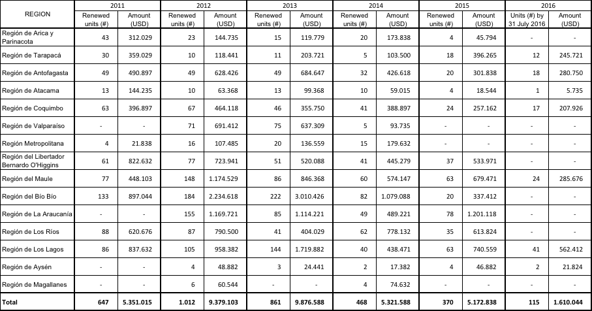

Table 4. RTC programme historic data and forecast (source: SECTRA, 2016)
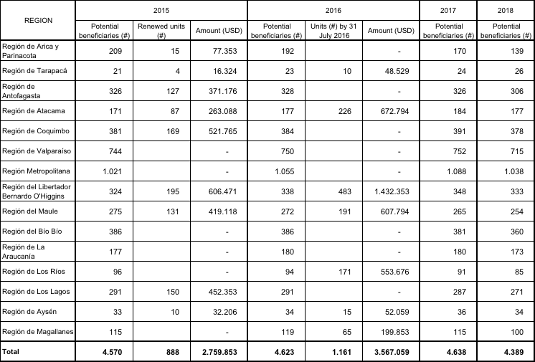

- The issue of non-motorised, personal urban transportation is a urban-fabric issue in which the participating Ministries intervene with limited and sometimes overlapping degree of regulatory capacity along with private actors, subnational governments (in the Chilean case, regional and municipal governments) and other agents and forces. In Chile, efforts to improve cycling infrastructure and non-motorised and integrated mobility are well below in its development with respect to conventional public transport solutions, with a gender bias that is quite well identified at a qualitative level, but that lacks quantitative incorporation in process and impact monitoring and evaluation of transport projects. The baseline in this case is provided by the National Urban Development Policy (2014), which includes no environmental principle among its 12 guiding principles. In this case, the project has assessed integrated urban planning measures that have shown, according to studies including those recently conducted by CAF in the region at different readiness levels, to contribute to a shift in the mobility paradigm towards the advancement of integrated sustainable mobility. Thus, incremental support to the replication out of Santiago of public bicycle systems (already successful in the metropolis) have been assessed. Smart pedestrianisation would also be supported so its costs and benefits are fully systematised, and therefore provide knowledge for the involved stakeholders and policy-makers. And finally, metro-bus-bicyle intermodality has been assessed, with metro-bicycle and interurban-bicycle interchangeability and payment-systems integration being measures that would attend perceived shortcomings of urban mobility in Chile.
- Cycling infrastructure is the factor that most improves cyclers’ safety according to studies, including those recently conducted by CAF in the region, which shows to be the main factor influencing bicycle usage. the design-funding cycle of high-standard cycling infrastructure is, during the next years, the critical step needed for cycling infrastructure to gain critical mass, and therefore upkeep the subsided demand for non-motorised personal transportation existing in the Chilean society, specially from women (SECTRA 2013). Comprehensive cycling infrastructure plans have only been developed at a demonstrative level (Quillota, 80990 inhab. - INE2004). A methodology for the design and ex-ante evaluation (travel-time savings) of cycling infrastructure is available, and 900 km of cycling infrastructure have been prioritised at the feasibility level (some designs exist, but not to the required standard). With respect to the availability of inexpensive, pay-as-you-go access to bicycles and other personal vehicles, public bicycle systems exist in the Metropolitan region that would benefit from support measures designed to capitalise them in a way that improves capacity and interoperability. Also, these examples would be useful for replication-oriented systematisation and dissemination in the lines of recent studies (CAF 2015, CAF 2016).

Figure 4. Policy and implementation, non-motorised transport (Source: UN Environment (2016) Global Outlook on Walking and Cycling - Policies & realities from around the world
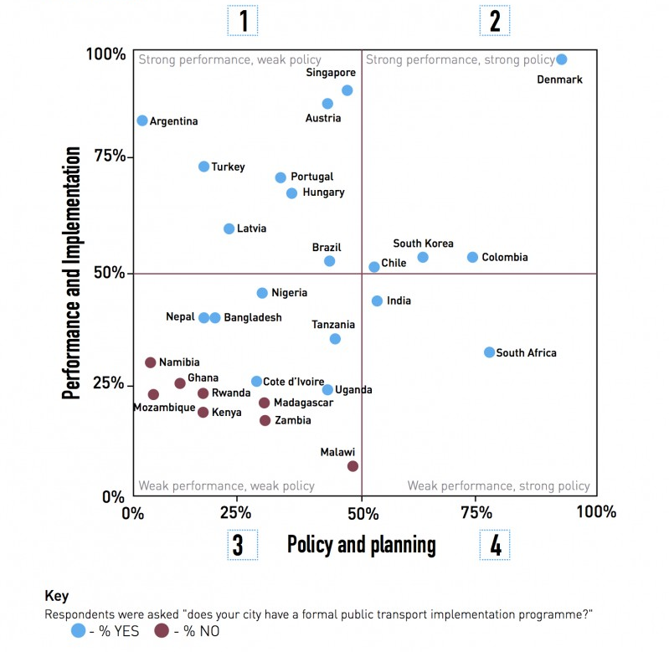

  - Higher Level Objectives to which the Project Contributes
- Value Added of CAF. The project objectives are aligned with CAF’s Climate Change Mitigation Programme and CAF’s agenda for Environmental Sustainability and Climate Change under its Integrated Vision for Sustainable Development. CAF plays a key role in climate change abatement, and in the promotion of renewable and sustainable energy sources. Since 1999, the Institution established its Latin American Climate Change Programme (PLACC in its Spanish acronym). The activities undertaken by the programme target actions related to the severe problem of climate change phenomena and their impacts. CAF supported the establishment and strengthening of institutions in an effort to integrate both the public and private sectors of the countries in the region into emerging activities that entail Greenhouse Gases (GHG) emission reductions markets through the Clean Development Mechanism (CDM), and within the scope of the United Nations’ Framework Convention on Climate Change (UNFCCC). As PLACC strengthened its lines of action, CAF positioned itself as a leading regional development bank in the GHG emission reduction market in Latin America. Two high-ranking GHG emission reduction purchase and sale arrangements were articulated by CAF: i) The CAF-Netherlands CDM Facility, accounting for ten million tons of GHG, and ii) the Ibero-American Carbon Initiative between CAF and the Spanish Government, accounting for nine million tons of GHG.
- Regarding climate change adaptation, and through its Risk Management and Prevention Programme, CAF has attended the prevention, abatement and socio-economic and environmental impacts associated to natural disasters and climate change. The programme targets four working areas: risk management and abatement of El Niño Phenomenon, contingencies derived from natural disasters; risk prevention; support to countries in the identification of vulnerabilities and climate change adaptation actions. Through the CAF-Netherlands CDM Facility and the Ibero-American Carbon Initiative, CAF promoted CDM projects in the LAC region. Projects, all of them coming from the Latin American region, that achieved reductions of 12.1 million tons of CO₂ and represented additional revenues in the projects for around EUR 120 million. After the first commitment period of the Kyoto Protocol, CAF made a review of the scope of PLAC and as a result of this review, launched a new programme with a broad approach for Adaptation and Mitigation.
- This project is also consistent with CAF’s Institutional Gender Equity Guidelines. CAF promotes the development and safeguarding of gender equity through studies and financing of projects and programmes with the overall objective of closing existing gaps between men and women through enhanced equal access to opportunities and competences. Regarding this project, and as already mentioned, the study “Ella se mueve segura” (She Moves Safely), a study on women’s personal security and public transport in three Latinamerican cities, including Santiago, is of special relevance.
- CAF has progressively diversified its portfolio and looks to further do so in Chile in sectors directly and indirectly relevant to the objectives of this project: climate change mitigation and adaptation, solid waste management, institutional strengthening, and natural disaster response. CAF also manages the Latin American Programme on Climate Change fund, which focuses on mitigation of climate change, adaptation to climate change and carbon markets. Specifically, CAF has been instrumental in the development of policy instruments for the mitigation of greenhouse gases, nationally appropriate mitigation actions (NAMA) in the sectors of public transport, municipal solid waste, agriculture, the refrigeration industry, energy efficiency (demand), and in power generation.
- Consistent with the above, CAF is a strategic partner for the national government of Chile to build local, regional and national capacities needed to achieve the Sustainable Development Goals (SDG). Mitigation of and adaptation to climate variation and change both for impact assessment and for policy development, for low carbon development paths, for increasing resilience to face the effects of global climate change and for the sustainable use of natural resources are key initiatives CAF is currently working on within the cross-section of public and private sectors and partnered, among others, with Ministries of Environment, Energy, Transport, Agriculture, Trade and Finance. CAF has a unique present and background record in supporting and implementing projects, programmes and financial operations not only aimed for single countries, but also to enhance sound regional integration between CAF country members. CAF´s success in the region is linked to 46 years of work with governments, private sector and social organizations at multilateral, national, subnational and local levels, complying successfully with CAF´s mission to promote sustainable development and integration in partnership with country members.
- Current similar investments implemented in the South American Region include the Improvement of water supply and sanitation systems for 109 municipalities in Colombia (COL/00133), the Neighborhood for Better Live (Barrio para Vivir Mejor) Programme in Ecuador (ECU/9117), the Energy Efficiency project in Ecuador (ECU/2404), the Electricity sector integrated approach project in Ecuador (ECU/8959), the Daule river conservation plan for Ecuador (CAF/0510/16), the Reduction of the Toachi Pilaton hydroelectric plant´s vulnerability to the effects of climate change with a focus on Integrated Adaptive Watershed Management (MATCH) Project in Ecuador (CAF/AF003), the Reduction of the climate vulnerability and flood shed risk in semi urban areas (CAF/AF002) Project in Ecuador, the Irrigation and Agricultural Drainage Projects of Olmos, Chavimochic II and Majes-Siguas II (PER/CFA7705) Project in Perú, the National Forest Sustainable Development Programme in Peru, the Water Resources Integrated Management Programmes for the watersheds of Huancabamba, Olmos, Jequetepeque, Chinchipe, Majes, Lurin, Chillón and Rimac rivers in Peru (PER/CT320), the El Niño (ENSO) Prevention Integrated Programme (CFA8903), the Ayninacuy project to strength livelihoods in climate change vulnerable high Andean communities in Peru (CAF/AF001), the Water and Sanitation Integrated Approach Programme (MIAGUA-IV) in Bolivia (CFA9334), the Irrigation Integrated Approach (MIRIEGO) in Bolivia (CFA8795), the Bio trade Andean Programme in Colombia, Ecuador and Peru, the CAF Climate Change Vulnerability index project for Latin America; and also include the CAF NAMA preparation project for solid waste, transportation, energy efficiency sectors, key agricultural products value chains and landfills, the CAF Carbon, Water footprint Project for Guayaquil, Cuenca, Lima, Arequipa, La Paz, Santa Cruz de la Sierra and for key agricultural products value chains, and the CAF Credit Line for Green Business and Energy Efficiency Programme for Financial Institutions in Latin America.
- Furthermore, the project is aligned with CAF’s commitment to the Sustainable Development Goals by taking urgent action to combat climate change and its impacts, and foster knowledge and technology transfer across countries. The project contributes to alleviate the stress imposed by climate change on vulnerable population in a gender-sensitive way.
- Consistency with National Priorities. The Project is consistent with and additional to national development and sectorial plans. As already mentioned, transport is one of the main components of GHG emissions in Chile. The Chilean Low-Emission Transport Strategy deals with this in a comprehensive manner, advancing all aspects related with integrated and sustainable mobility nationally through a strategy that contemplates different technologic options (bus, collective taxi and non-motorised modes), different existing urban layouts (from metropolitan, 6-million Santiago to small-town-ish, 20-thousand Tocopilla) and different institutional settings (as occurring in Santiago and the rest of the country). In concrete terms, the Project is consistent with:
- Chile’s INDC (2015), which includes the commitment to reduce its tCO₂eq emissions per GDP unit by 30% below their 2007 levels by 2030.
- The Ministry of Energy’s National Electromobility Strategy (Estrategia Nacional de Electromovilidad), which includes two strategic lines in direct relation with the CLETS: Strategic Axis 2 (Transport as an engine for development) and Strategic Axis 5 (Knowledge transfer and information diffusion).
- The Atmospheric Prevention and Decontamination Plan (PPDA, 2016) for Santiago, which establishes a) the will to gradually internalise emissions in Transantiago’s operator renewal process, including the regulatory and technical changes to allow and provide incentives for at least one all-electric business unit within the system; and b) the will to support the accelerated transition of collective taxi fleets to ZLE through regulatory changes.
- The NAMA proposing a preliminary implementation plan for the Transport Green Zone in Santiago (STGZ). The NAMA includes 4 initiatives: 1) Promotion of Zero and Low Emission Vehicles (ZLEV) in (private) taxi fleets, municipality fleet and charging stations; 2) Incorporation of low carbon buses into the public transportation system in Santiago (refers to systems under Santiago Municipality’s jurisdiction); 3) Promotion of non-motorised vehicle use, including the implementation of 6 km of new bicycle lanes, a pilot programme for a bicycle sharing system, 1 connectivity solution for two existing bicycle lanes and bike signs in two areas within the STGZ; and 4) Traffic re-design and traffic management with new pedestrian and semi-pedestrian streets, exclusive lanes for ZLE buses and bicycle parking.

- The STGZ NAMA is reported in Chile’s first BUR (2014) and a detailed evaluation report commissioned by CAF was carried out in 2016. The NAMA’s reported to-do measures deal with institutional fleets and transit measures in Santiago. These transit measures are to be furthered within an integrated and sustainable mobility pilot involving pedestrianisation and intermodality (Output 2.2.3, see above). All assumptions on which the current proposal is based are coherent with the NAMA’s results (technical parameters, sources of funding, challenges) and no overlapping exists between the two. Measures in the NAMA are to be executed within systems under Santiago Municipality’s jurisdiction, while measures in this project are executed under ministries’ jurisdictions and have much wider scope (Santiago metropolitan area fully includes 26 municipalities, one of them that of Santiago proper, and public transport in it is of MTT’s competency). Both interventions are to be in constant coordination to ensure feedback, no-overlapping and synergies.
- The Project is consistent with the following Sustainable Development Goals:
- Goal 3: Ensure healthy lives and promote well-being for all at all ages
  - By 2030, substantially reduce the number of deaths and illnesses from hazardous chemicals and air, water and soil pollution and contamination
- Goal 5. Achieve gender equality and empower all women and girls
  - Eliminate all forms of violence against all women and girls in the public and private spheres, including trafficking and sexual and other types of exploitation
  - Ensure women’s full and effective participation and equal opportunities for leadership at all levels of decision-making in political, economic and public life
- Goal 8: Promote inclusive and sustainable economic growth, employment and decent work for all
  - Improve progressively, through 2030, global resource efficiency in consumption and production and endeavour to decouple economic growth from environmental degradation, in accordance with the 10-year framework of programmes on sustainable consumption and production, with developed countries taking the lead
- Goal 9: Build resilient infrastructure, promote sustainable industrialization and foster innovation
  - By 2030, upgrade infrastructure and retrofit industries to make them sustainable, with increased resource-use efficiency and greater adoption of clean and environmentally sound technologies and industrial processes, with all countries taking action in accordance with their respective capabilities
- Goal 11: Make cities inclusive, safe, resilient and sustainable
  - By 2030, provide access to safe, affordable, accessible and sustainable transport systems for all, improving road safety, notably by expanding public transport, with special attention to the needs of those in vulnerable situations, women, children, persons with disabilities and older persons
  - By 2030, reduce the adverse per capita environmental impact of cities, including by paying special attention to air quality and municipal and other waste management
  - By 2030, provide universal access to safe, inclusive and accessible, green and public spaces, in particular for women and children, older persons and persons with disabilities
- Goal 12: Ensure sustainable consumption and production patterns
  - Promote public procurement practices that are sustainable, in accordance with national policies and priorities
  - Support developing countries to strengthen their scientific and technological capacity to move towards more sustainable patterns of consumption and production
  - Rationalize inefficient fossil-fuel subsidies that encourage wasteful consumption by removing market distortions, in accordance with national circumstances, including by restructuring taxation and phasing out those harmful subsidies, where they exist, to reflect their environmental impacts, taking fully into account the specific needs and conditions of developing countries and minimizing the possible adverse impacts on their development in a manner that protects the poor and the affected communities
- Goal 13: Take urgent action to combat climate change and its impacts
  - Integrate climate change measures into national policies, strategies and planning
- PROJECT DEVELOPMENT OBJECTIVES
  - PDO
- The objective of the “Supporting the Chilean Low Emissions Transport Strategy Project” (“CLETS”) is to demonstrate systemic impacts of integrated zero- or low-emission urban public mobility systems (CCM-2 P3).

    - Project Beneficiaries
- The identification and engagement of stakeholders during project preparation is guided by those who could have or receive the most relevant and direct impact on project activities and outcomes, as well as those who will be direct project beneficiaries. Below are tabled the results of the stakeholder mapping exercise conducted to identify key project stakeholders, their present relevance or role in the project’s area of intervention, and the potential impact they may have during and beyond project implementation. While the Ministry of Environment will be the key Project Focal Point Ministry, the cross-sectorial nature of the project activities will require that the project is implemented in partnership with other ministries as well, in cases where the role of said ministries is key to the delivery of project outcomes.
- MTT is the national authority in charge of transport. MMA is the regulating body for atmospheric pollution and issues Atmospheric Prevention and Decontamination Plans (PPDA) for Santiago (2016) and other cities. The Ministry of Housing and Urbanism (MINVU) is in charge of the regulatory framework for urban planning and urbanism, which is applied by Municipalities, including technical standards for urban infrastructure. Stakeholder-involvement work is already ongoing through the co-financing project “Technological consortium for defining and implementing a strategy for the viability of electric mobility in Transantiago”, awarded in 2016 by the national economic promotion entity CORFO to the MTT, the Mario Molina Centre and the companies METRO and Chilectra with the external technical assistance of Finland’s VTT. The project focuses on establishing a dialogue platform among Transantiago operators, technologic and energy suppliers and public authorities in charge of Transantiago. This platform is of paramount importance for replication amd dissemination purposes, since it provides access for other stakeholders to the most advanced space in Chile dealing with the technical and engineering aspects of the implementation of low emission mass transport.
- A summary of project stakeholders, their role and competencies, and their intended responsibilities in the project lays out in Table 5:

Table 5. Project Stakeholders
Institution | Role | Responsibilities in the project
Ministry of Environment (MMA) through the Air Quality Division | National Environment Authority | Project and co-funding coordination. Monitoring, reporting, verification and evaluation
Ministry of Transport and Telecommunications (MTT) through the National Coordination of Planning and Development | National Transport Authority | Project and co-funding coordination
MTT’s Directory of Metropolitan Public Transport (DTPM) | The Directory regulates Transantiago, the public-transport system for Santiago metropolitan area | Executing Agency, bus
MTT’s Division of Regional Public Transport (DTPR) | The Division manages the RTM and RTC programmes, key to the project's intervention strategy out of Transantiago | Executing Agency, bus and collective taxi
MTT’s Regulation Division | The Division establishes legal, technical and methodological standards for public transport | Executing Agency, regulations
MTT’s Smart Cities Unit (UCI) | The Unit promotes the adoption of innovative mobility solutions in urban public transport | Executing Agency, innovation
MTT’s Centre for Vehicle Control and Certification (3CV) | The Centre provides evaluation, control and certification services for several technological issues in vehicles (model standardisation, safety, emissions and others) | Executing Agency, innovation
Municipalities of Concepción, Temuco, La Serena and Villarrica | Beneficiaries | Communicate the project to users
Market participants | Operators, importers, commercial financial institutions, electricity utilities | Rational agency
Interest-based groupings | Taxi-owner and bycicle-user associations, unions | Provide channels for efficient interaction with the corresponding groups
Urban Development Division of the Ministry of Housing and Urbanism | National Urban Planning Authority | Participation in the pilot initiative "Integration and Mobility: Execution of pilot experience in the city of Villarrica"
Users | Beneficiaries | Provide feedback and social monitoring
CAF | GEF Implementing Agency | Provides technical and financial assistance on sustainable transport strategies LAC-wide. Assures work methodologies are up to international standards. Supports project implementation and monitoring

- Thorough and continued participation of multiple stakeholders is required during the implementation stage of the project. The project plans to run multi-level participative consultations and the structure of its Management Unit considers the participative inception and implementation of a multi-stakeholder engagement plan among first tasks of the execution phase.
- Key-stakeholder maps have been drafted and confirmed for the main fields of intervention (see Figure 5 for bus and Figure 6 for collective taxi).
Figure 6. Stakeholder map, bus (source: MMA, 2017)
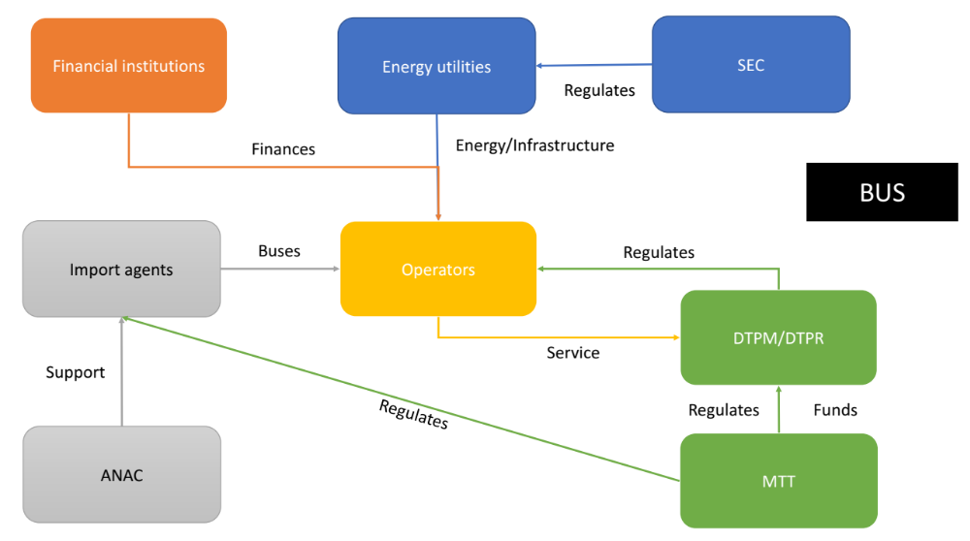
Figure 7. Stakeholder map, collective taxi (source: MMA, 2017)
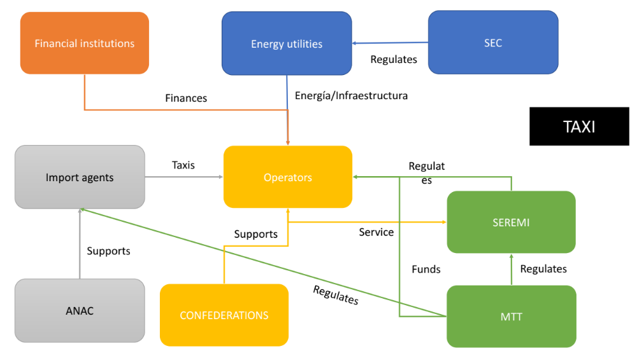

- Further work on this issue during the formulation phase has provided detailed assessment of the procedures that affect agents within these identified fields of intervention, with special attention to the detection of financial and non-financial barriers to the agent. This work concluded that these procedures are a) similar and b) needed of enhanced non-financial support. The project’s lines of work, pilot initiatives and activities have been informed accordingly.

Figure 7. Procedure maps, bus (RTM, left) / collective taxi (RTC, right) (in Spanish; source: MTT, 2018)
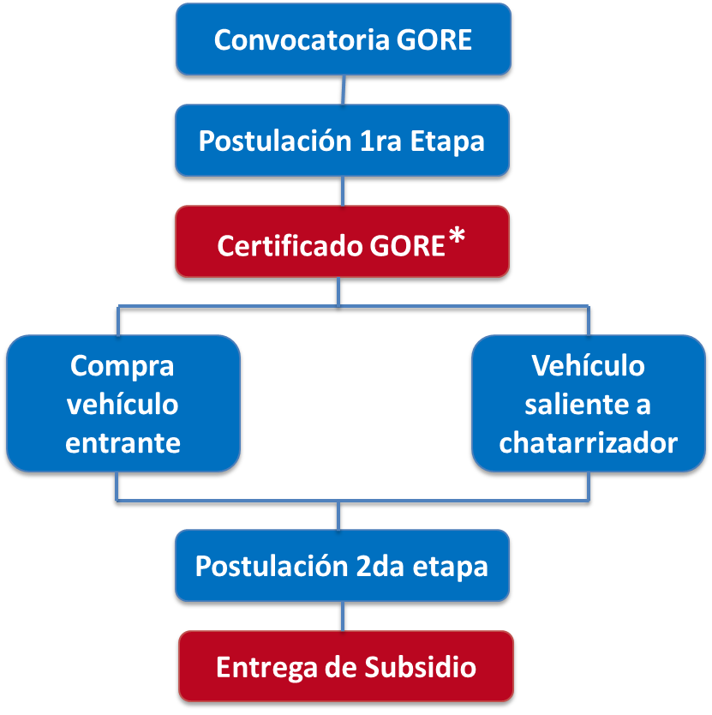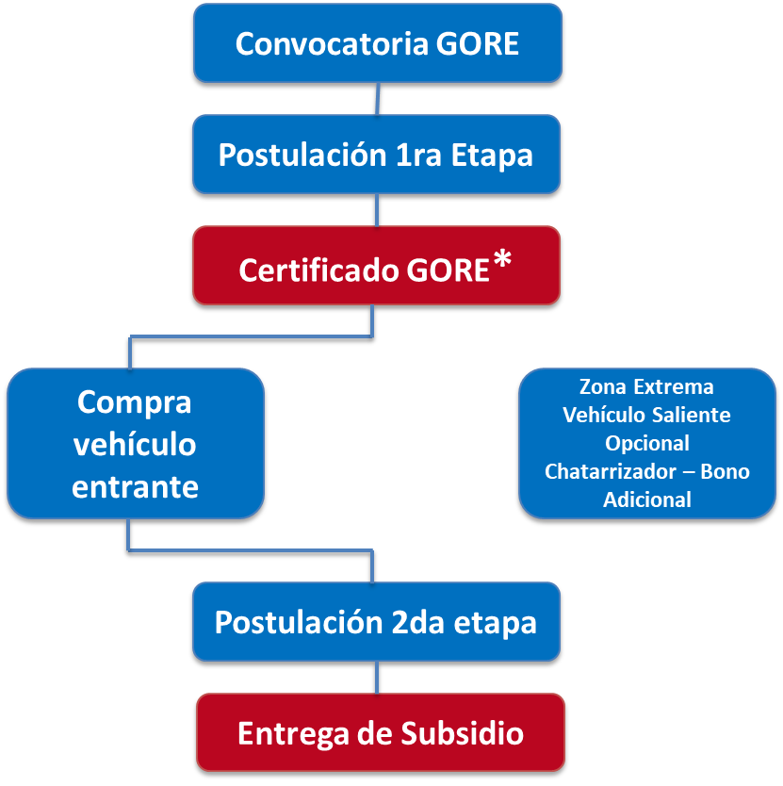

    - PDO (Outcome) Level Results Indicators
- PDO (outcome) Indicators include the following: (i) Degree of support for low GHG development in the policy, planning and regulatory framework, (ii) Non-financial barriers are removed faster than in BAU scenario, (iii) A Chilean Low-Emission Transport Strategy is ready to formalise and counts with the support of diverse stakeholders, (iv) Replicas facilitated, (v) Degree of strength of financial and market mechanisms for low GHG development, and (vi) Investment mobilised.

  - Project Description
    - Project Rationale
- Project Rationale. The STGZ NAMA (reported in Chile’s first BUR in 2014 and submitted to a detailed evaluation commissioned by CAF in 2016), which successfully showcased pilot strategies in the Municipality of Santiago, can be considered as a ‘predecessor’ of this project. The NAMA included 4 initiatives: 1) Promotion of Zero and Low Emission Vehicles (ZLEV) in (private) taxi fleets, municipality fleet and charging stations; 2) Incorporation of low carbon buses into the public transportation system in Santiago (refers to systems under Santiago Municipality’s jurisdiction); 3) Promotion of non-motorised vehicle use, including the implementation of 6 km of new bicycle lanes, a pilot programme for a bicycle sharing system, 1 connectivity solution for two existing bicycle lanes and bike signs in two areas within the STGZ; and 4) Traffic re-design and traffic management with new pedestrian and semi-pedestrian streets, exclusive lanes for ZLE buses and bicycle parking. The NAMA’s reported to-do measures deal with institutional fleets and transit measures in Santiago. All assumptions on which this project is based are coherent with the NAMA’s results (technical parameters, sources of funding, challenges) and no overlapping exists between the two (measures in the NAMA are to be executed within systems under Santiago Municipality’s jurisdiction, while measures in this project are executed under ministries’ jurisdictions and have much wider scope; Santiago metropolitan area fully includes 26 municipalities, one of them that of Santiago proper, and public transport in it is of MTT’s competency). This project takes these preceding measures to the full scope of further public realms in Chile, both in the contexts of Santiago metropolitan area, Chile´s decentralised jurisdictions in other cities, and the national policy and regulatory space.
- The objective and proposed activities of the project are aligned with the programming priorities, and specifically focused on Demonstrating systemic impacts of integrated low- emission urban mobility systems (CCM-2 P3). The project will produce the higher-level outcomes of promoting policy, planning and regulatory frameworks that foster accelerated adoption of integrated low-emissions mobility systems (Outcome B); and of demonstrating and operationalising financial mechanisms to support integrated low-emissions mobility systems (Outcome C).
- Consistent with the above, this project will embrace the following principles through-out its implementation:
(1) Inclusive development: It is important that poor households and small businesses can perceive the benefits from the project activities. For this, the equitable distribution of benefits is a requirement for long term inclusive development and community support.
(2) Systemic Change: Bringing together stakeholders from different levels (national, regional and local) and establishing a joint agenda will be key to address and resolve underlying systemic constraints.
(3) Local Initiative: Experiences show that whereas effective and sustainable solutions can only be achieved if local actors shape and drive their own agendas, a bottom up approach will be fundamental for long term sustainability.
(4) Contextualized shared solutions: Working through an active knowledge management and capacity development platform, will assure that throughout the project, information, tools, know-how and resources are properly applied to different contexts and needs, improving the generation of effective and economically viable processes committed to impact on scale and a responsible value for money rationale.
- Global Environmental Benefits. The project will contribute total emission reductions of more than nine hundred fourty thousand (942,193) tCO₂eq over 20 years to the global efforts in search of low-carbon development.

    - Project Components
- GEF funds will specifically finance incremental activities oriented towards the accelerated adoption of integrated low-emission urban mobility systems. These include activities that increase the available information for planning, designing and implementing innovative sustainable urban mobility systems at national and subnational levels, that foster an enhanced policy, technical and regulatory environment to promote sustainable urban mobility, that increase the capacity for sustainable-transport innovation at national and subnational level, that identify and share best practices nationally and internationally, and that promote investments in sustainable urban mobility measures in relevant urban areas and in integrated urban planning measures in representative, replication-ready urban areas.
- In order to maximize the impacts and sustainability of activities, the Project will seek to coordinate its actions with existing government programmes and policies, as well as programmes and projects financed by CAF. In particular, the project will develop, early during its implementation, a comprehensive Gender Action Plan project approach to address the identified gender differences and gaps, gender-differentiated impacts and risks, and opportunities to promote the empowerment of women that support project objectives and outcomes. In particular, this will mean at least the implementation of gender-disaggregated indicators for all possible project elements (M&E and MRV implementations) and a focus on women engagement (positively-discriminated participation) in stakeholder participation (decision focus), knowledge management and capacity development activities (process focus), and any resulting new employment (impact focus).
- The proposed Project will be implemented over a period of five years and comprises the following components: (1) Promotion of policy, planning and regulatory frameworks that foster accelerated adoption of integrated low-emissions mobility systems through Participation, Knowledge Management and Capacity Development in the framework of a Chilean Low Emissions Transport Strategy (CLETS); (2) Demonstrative and Catalytic Actions that demonstrate and operationalise financial mechanisms to support integrated low-emissions mobility systems (Outcome C); and (3) Project Management, Monitoring and Evaluation, inclusive of the Project Close-out Period.
- Component 1. Promotion of policy, planning and regulatory frameworks that foster accelerated adoption of integrated low-emissions mobility systems through Participation, Knowledge Management and Capacity Development in the framework of a Chilean Low Emissions Transport Strategy (CLETS) (US$1.62M GEFTF, total US$1.69M).
- This component aims at increasing the available information for planning, designing and implementing innovative sustainable urban mobility systems at national and subnational levels, fostering an enhanced policy, technical and regulatory environment to promote sustainable urban mobility, increasing the capacity for sustainable-transport innovation at national and subnational level, and identifying and sharing best practices nationally and internationally.
- The Component is measured by Indicator 5: Degree of support for low GHG development in the policy, planning and regulatory framework. It gathers activity in four main lines of action, directed towards the remotion of non-financial barriers, the formalization and diffusion of the CLETS and facilitating the replication of project’s pilot initiatives and demonstrative activities.
- Component 2. Demonstrative and Catalytic Actions that demonstrate and operationalise financial mechanisms to support integrated low-emissions mobility systems (US$1.04M GEFTF, total US$59.04M)
- Within this Component, Financial mechanisms to support GHG reductions will be demonstrated and operationalised. It is measured by Indicator 6: Degree of strength of financial and market mechanisms for low GHG development. The Component supports up to four technically assisted investments in measures relevant to the CLETS, as well as the provision of capacity for a current CLETS demonstration (namely, that occurring in Transantiago) to act as knowledge source for replication and uptake.

    - Project Financing
- The Project has obtained GEF financing for US$2.90 million. The resources will be devoted to technical assistance.
- Counterpart funding from the participating country’s government is estimated at US$58.07 million. The MMA as the leading executing agency will contribute resources in the form of thematic expertise and overhead costs to the extent of US$72,300, MTT will contribute cash resources to the amount of US$58 million, and CAF in the amount of US$150,000 in kind.
- The Project’s Summary Budget is as presented in Table 6.

Table 6. Project’s Summary Budget
Project Component | GEF Project Financing | Co-financing | Total
1.- Promotion of policy, planning and regulatory frameworks that foster accelerated adoption of integrated low-emissions mobility systems through Participation, Knowledge Management and Capacity Development in the framework of a Chilean Low Emissions Transport Strategy (CLETS) | 1.617.000 | 72.300 | 1.689.300
2.- Demonstrative and Catalytic Actions that demonstrate and operationalise financial mechanisms to support integrated low-emissions mobility systems | 1.042.905 | 58.000.000 | 59.042.905
3.- Monitoring and Evaluation | 102.000 |  | 102.000
Subtotal | 2.761.905 | 58.072.300 | 60.834.205
Project Management Costs | 138.095 | 150.000 | 288.095
Total Project Cost | 2.900.000 | 58.222.300 | 61.122.300

    - Lessons Learned and Reflected in the Project Design
- The proposed Project was built on the experience and lessons learnt primarily from the STGZ NAMA and the co-financing project “Technological consortium for defining and implementing a strategy for the viability of electric mobility in Transantiago”, awarded in 2016 by the national economic promotion entity CORFO to the MTT, the Mario Molina Centre and the companies METRO and Chilectra with the external technical assistance of Finland’s VTT. It also draws heavily on the lessons learned from the Project GEFID 1349 “Sustainable Transport and Air Quality for Santiago” (FSP, The World Bank, completed 2009). The project helped reduce GHGs from ground transport in Santiago through the promotion of a long-term modal shift to more efficient and less polluting forms of transport.
- Based on past experiences in other CC projects, there is a need to ensure that Monitoring, Reporting, Verification and Evaluation (MRV, M&E) will be carried out in two dimensions: (i) to follow up on Project progress and results and (ii) to capture long-term costs, impacts and benefits of the intervention. With this in mind, the proposed Project envisages data collection, assessment and analysis as integral part of all components and activities therein and devotes considerable effort to produce data and to undertake its analysis, use and availability. Specifically, the M&E system as designed consists of three main elements: (i) the measurement of progress at the activity level; (ii) the measurement of progressive achievement of expected project outputs and results (outcomes) as defined in the Results Framework; and (iii) continuous evaluation of the Project during implementation to enable early and regular adjustments.

    - Coordination with Other Initiatives Including Relevant GEF Funded Initiatives
- Coordination and synergies will be sought with existing activities such as the Project GEFID 5598 First Biennial Update Report Enabling Activity. As mentioned, the present project idea scales up the Transport Green Zone in Santiago (STGZ) NAMA to national level. The NAMA is reported in Chile’s first BUR (2014).
- The Project will also coordinate its activities with Project GEFID 9496 Leapfrogging Chilean’s Markets to more Efficient Refrigerator and Freezers (MSP, United Nations Environment Programme, in implementation) and Project GEFID 9835 Strengthening Chile’s Nationally Determined Contribution (NDC) Transparency Framework (MSP, United Nations Environment Programme, in implementation), in aspects related to carbon-accounting and MRV methodologies.
    - Incremental Cost Reasoning
- Baseline analysis: As previously mentioned, public urban mobility accounts for some 5.4 million tCO2eq per year. Emissions reductions in urban public transport systems directly tackled by the project (those of Santiago, Concepción, Temuco, La Serena-Coquimbo and Villarrica) account for estimated 719.935 tCO2eq by 2035. Without GEF’s intervention, it is anticipated that total emissions from these public transport systems diminish very slightly in the case of bus systems, and keep growing, although at a diminishing rate, in the case of collective taxi (see Figure 6).
- This scenario is due to the following barriers to the development of integrated zero or low-emission urban public integrated and sustainable mobility: Non-financial barrier 1. Due to lack of information and reliable knowledge on available options, there is uncertainty over ZLE mobility’s perceivable benefits. This shortcoming appears to be hindering investment in ZLE mobility across the board. Data and knowledge on different costs, access modalities and O&M increase the perceived risk of investment, as well as make it uncertain that current capacities (especially human resources) would serve the new systems. Similarly, there appears to be limited awareness of the fact that ZLE technologies’ accelerated development in public transport would benefits mainly interest groups such as low-income population in general and low-income women in particular, at least in the case of Chile. This makes it a especially apt public policy to be supported, but it appears that awareness must be raised among the policy-making community.
- Non-financial barrier 2. The regulatory framework contains fossil-fuel lock-ins and is not supportive of integrated solutions. While the Chilean legislation is open enough to sustain different technologies, the same is not true of regulation and technical specifications, which frequently contain exclusive references to fossil fuel that make it difficult or impossible to get out of fossil fuel technologies or even compare them with ZLE ones. Also, in the specific case of public transport, complex public-private arrangements involving significant investment at different scales require timeframes that lock technological options in for long periods of time.
- Non-financial barrier 3. Existing systems contain remarkable innovation-sapping hurdles in the fields of access to data and interoperability. While barriers to the enhancement of existing systems are related to the previously identified barriers, the main barriers to innovation are placed in data management. Transparency, access to data and interoperability remain spaces where significant advances can be made to provide a supporting environment for innovation to take place.
- Non-financial barrier 4. Policy makers are not aware of available options, or perceive their benefits as uncertain. Similar to Barrier 1 (which focuses on markets), but specific of the policy-making community, a barrier is identified in the field of knowledge about different policy options and its risks and feasible outcomes. National, subnational and local authorities lack the means to be aware of state-of-the-art initiatives going on in places different to theirs.
- Financial barrier 5. Technical and regulatory uncertainty and innovation-sapping hurdles raise the perceived risk of public-transport investment, thus lifting the perceived break-even return level. As a relevant proportion of the benefits to be perceived from integrated and sustainable mobility are not private, but public, and long-term (climate change benefits, reduced morbidity, reduced urban noise), they can not be included in a private operator’s CBA.
- Non-financial barrier 6. The existing regulatory and institutional frameworks make it difficult to integrate sectors and sector-specific measures in comprehensive, integrated urban planning frameworks. The same non-privatisable-benefits problem identified in Barrier 5 is addressed, but due to the very case-specific condition of this problem, it cannot be addressed through the same means as public-transport investment, but needs a specific, learning-by-doing approach.
- The GEF Alternative. GEF resources will specifically finance incremental activities oriented towards the accelerated adoption of integrated low-emission urban mobility systems. These include activities that increase the available information for planning, designing and implementing innovative sustainable urban mobility systems at national and subnational levels, that foster an enhanced policy, technical and regulatory environment to promote sustainable urban mobility, that increase the capacity for sustainable-transport innovation at national and subnational level, that identify and share best practices nationally and internationally, and that promote investments in sustainable urban mobility measures in relevant urban areas and in integrated urban planning measures in representative, replication-ready urban areas.
- GEF resources will support activities to promote accelerated transfer of knowledge and capacity to all relevant stakeholders, including informative events, climate change considerations in transport-related post-graduate curricula, training to stakeholders, dissemination via traditional and social media and others. Knowledge Management and South-South cooperation are strategic approaches for ensuring regional level impacts, up-scaling, and sustainability, supported by the GEF alternative. Incremental Cost calculations are presented in Annex 4, and the technical basis and calculations in Annex 5.
- The project aims at changing the public-transport market in Chile by accelerating the adoption of integrated and sustainable mobility in Chile, while supporting a resolute policy commitment towards low-carbon sustainable development in the public-transport sector. This is to be done by diminishing non-financial barriers for all manner of cleaner technologies. In mode (see Figure 8), while considering cleaner technologies incremental. For bidding and licensing processes to take place during the project (see above), the MTT is willing to introduce the required regulatory changes with incremental technical assistance.

  - Implementation
    - Institutional and Implementation Arrangements
- Per agreement formalized in official letters submitted by the GEF focal point to CAF, CAF has been designated as the implementing agency responsible for implementing the technical and fiduciary aspects of the Project. It will be the GEF agency responsible for monitoring and providing overall implementation advice during project implementation and for the financial and operational implementation of the project. This implies that CAF will contract and deliver services for the project, following CAF rules and procedures, while providing financial services to manage GEF resources.
- A Project Steering Committee (PSC) will be established in order to monitor and support the smooth development of the project from the national level. It will be composed by the Undersecretaries of Environment (MMA) and Transport (MTT) or their delegates, the Head, Air Quality Division (MMA) as Project Director, CAF and the GEF OFP. The MMA convenes and chairs meetings, which will occur at least annually to review progress reports and make recommendations. The Project Coordinator (see below) acts as Secretary, with no vote. Procedures and mechanisms will be adopted at the first meeting.
- Each pilot project at the subnational level will establish its own Local Committee with support from the Pilot Implementation Specialist (see below). Assignment of responsibilities of members of the Technical Committees and other key partners will be formalized in subsidiary agreements to be signed during the project’s effectiveness period. A detailed description of roles and responsibilities within each initiative will be provided in the Project’s Operational Manual. In each Local Committee, all participating stakeholders will designate a representative: in each case, participating Regional Government, participating Municipality/ies, participating trade/union/cooperative entity/ies, Regional Ministerial Secretaries (SEREMIs) of Environment, Transport and Urban Planning, and others if necessary upon local contingency. The PMU’s Pilot Implementation Specialist (see below) acts as Secretary. Chairpersonship, procedures, meeting frequency and other necessary mechanisms will be adopted at each Local Committee’s first meeting.
- Therefore, the institutional implementation structure is divided into two collaborative levels, national and subnational. At the national level there is a steering body (Project Steering Committee – PSC) and a Project Management Unit (PMU). The PMU team will be composed of the Project Director, a Project Coordinator, a Monitoring and Evaluation, Knowledge Management and Lessons-Learned (MEKLE) Specialist, a Pilot Implementation Specialist and an Administrative/Financial Specialist, plus an external Communication Specialist (firm or individual). The PMU will be established in Santiago, Chile.
- A summary organigram is included as Figure 9. More details about the specific tasks and composition of the collegiate bodies, pilot initiatives and PMU are available in Annexes 6, 7 and 8, and a full description will be included in the Project’s Operational Manual.

    - Results Monitoring and Evaluation
- Based on past experiences on adaptation to climate change projects, data collection, assessment and analysis are envisaged as an integral part of all components and activities therein. Given the need for ongoing collection of data and information, insights and knowledge and their incorporation in practice as defined by the project description, the project institutional arrangement includes the participation of a dedicated Monitoring and Evaluation, Knowledge Management and Lessons-Learned (MEKLE) Specialist. This Specialist will be the source responsible for ensuring the origination of data, information and knowledge being obtained from project activity.
- CAF will be responsible for the overall monitoring and evaluation (M&E) of the Project through independent experts, CAF offices and/or partners.
- M&E of Project implementation will be conducted through three main mechanisms (i) assessment of progress at the activity level (specific M&E systems will be developed for the different investment activities) which will generate data required for the purpose of the project (e.g., validate relevance of activity and provide feedback to management instruments); (ii) the measurement of progressive achievement of expected project outputs and results (outcomes) as per indicators defined in the Project Results Framework; status of progress will be reported every six months as part of the project progress reports; and (iii) evaluation of the project at certain moments of its implementation: a) progress reviews during CAF implementation support missions; b) mid-term review of project implementation; c) final evaluation report to be carried out by the PMU with input from the PSC; and d) the Implementation Completion and Results Report (ICR). The ICR will be prepared within six months after closing of the Grant based on the final evaluation report prepared by the PMU.

Figure 9. Project organigram

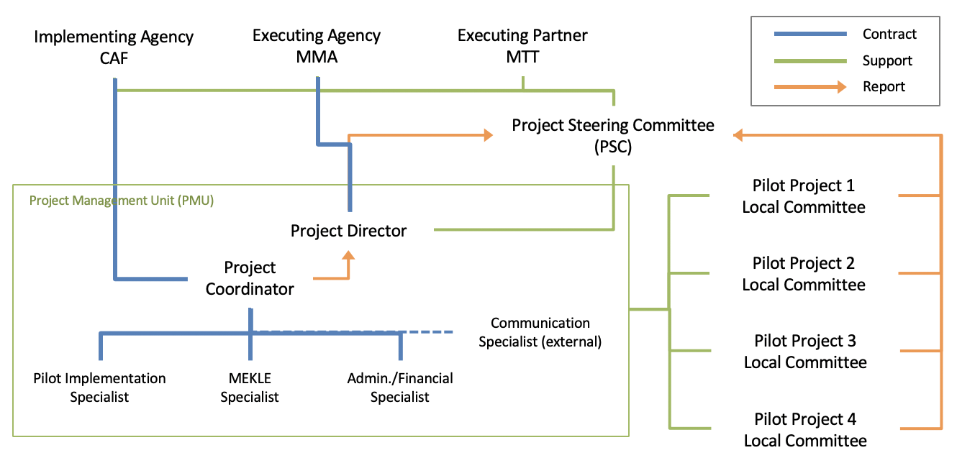
- The results monitoring framework of the project is presented in Annex 1.
- To increase country ownership, the Project will seize opportunities, where available, to align Project required M&E with Government-led M&E systems, already used and operational in participant institutions. This may not only help to reduce costs, but this approach will ensure post-project sustainability and the maintenance of established systems. A Monitoring and Evaluation Plan for the Project is provided in Annex 10.

    - Innovativeness, Up-Scaling and Sustainability
- In the context of the Project, ‘Technologies’ are understood to be combinations of knowledge, methodologies, skills and experiences. The Project integrates in every stage a focus on knowledge management through thorough monitoring and the identification and dissemination of best practices. These allow not only the evaluation of the Project, but also its adaptive management by the continuous analysis and use of data originated in the Project’s activities.
- Innovation: The project is one of its kind in Latin America, building upon the region’s experience in transport reform. Since Santiago urban transport system (Transantiago) has been developed in constant conversation with other major urban transport systems in the region (Bogotá, México DF, Curitiba), these systems have already overcome the barriers for mutual learning and knowledge exchange. Dedicated budget is planned in the GEF project for thorough monitoring and evaluation, MRV system and knowledge management activities including systematisation and dissemination. The project uses its own size and expected impact to provide an enabling environment for market uptake, scaling-up and replication and innovation; it does so through the already-mentioned focus on monitoring and systematisation; through the removal of fossil-fuel lock-ins and policy-open dialogues and interinstitutional coordination; through the adoption and promotion of platforms for innovation; and through its continuous provision of monitored and systematized experiences. All activities in the project are designed to provide catalytic effects far beyond its direct impact. Bus fleets in Santiago and major Chilean cities are expected to shift to ZLE at accelerated rates with the project with respect to BAU. Since the project is designed to get the markets in which it acts to critical-mass with respect to electric mobility, it has not been possible to estimate conversion-rate enhancements without further, detailed modelling. This should be possible during the design phase.
- Sustainability of the project is ensured, at a general yet robust level, by the MTT’s policy of keeping every efficiency gain for the future. This policy is translated to the technical, detailed level in the three main instruments in consideration by the project (Transantiago contracts, RTM and RTC programmes), so all fleet-level efficiency gains achieved by the project are to remain in the future. In the case of cycling infrastructure, the existence of subsided demand (in the comparison of detailed travel statistics available -2001-2012-, bicycle is the only mode that grows out of private car) and the removal of a critical barrier such as the needed technical planning provides grounds for project results in this field to be estimated as sufficient for the acquisition of critical mass in the local environments where it takes place (Santiago, La Serena). Of those polled (CEHU 2015), 18% of non-cyclists cite safety and lack of infrastructure as their motive for not using the bicyle, while 71% of male cyclists and 78% of female cyclists cite safety as their main criterion for itinerary selection. Similarly, all project outcomes with respect to policy, regulation and technical enhancement are supported by the existence of the CLETS and should keep as minimum standard for further rounds of policy-making.
- Potential for scaling-up: at the national level, the project tackles urban mobility in cities all along the size scale for Chile as defined by the Ministry of Housing and Urbanism:
- the metropolis Santiago (7+ million inhab.), which will be used as a source of knowledge from the incorporation of 120 electric buses to its transportation system (Transantiago) in 2018.
- the big urban area (GAU, see B.3) of Gran Concepción (900 thousand inhab.),
- the major cities (CM, see B.3) of Temuco-Padre Las Casas (350 thousand inhab.) and La Serena-Coquimbo (300 thousand inhab.), and
- the minor city of Villarrica (55 thousand inhab.).

At the international level, Santiago is in the list of 10-biggest cities in Latin America alongside others adding some 70 million inhabitants, so full replication in like-driven environments potentially reaches several times its initial size. The city has very high rates of public-transport and cycling-infrastructure usage among its vulnerable population.
- Knowledge management is incorporated to all project activity and coordinated through a Capacity Development and Knowledge Management (CDKM) Plan (see Annex 9). Participatorily-designed knowledge-management tools are to be explicitly used for national and international exchanges of good practices and dissemination among relevant stakeholders. Permanent systematisation and results-based guidance is to be provided through a project website and specific activities. The project also includes measures to enhance data access and interoperability in the Chilean public-transport sector, thus overcoming its own generation of knowledge and allowing for innovation to take place beyond the direct incremental knowledge set.
- At the international level, Santiago is in the list of 10-biggest cities in Latin America alongside others adding some 70 million inhabitants, so the project is one of its kind in Latin America, building upon the region’s experience in transport reform. Since Transantiago has been developed in constant conversation with other major urban transport systems in the region (Bogotá, México DF, Curitiba), these systems have already overcome the barriers for mutual learning and knowledge exchange. Dedicated budget is planned in the GEF project for thorough monitoring and evaluation, MRV system and knowledge management activities including systematisation and dissemination.
- The project uses its own size and expected impact to provide an enabling environment for market uptake, scaling-up and replication and innovation; it does so through the already-mentioned focus on monitoring and systematisation; through the removal of fossil-fuel lock-ins and policy-open dialogues and interinstitutional coordination; through the adoption and promotion of an open data policy; and through its continuous provision of monitored and systematized experiences.
- Given the conditions of ratification of the Paris Agreement and the current financing opportunities available, the possibilities for replication and up-scaling are considered to be good in project intervention areas and in areas with similar characteristics within the Latin-American region. Additionally, the overall design of the project revolves around the implementation of ‘pilot projects’, with the clear and explicit intention that these could be replicated nationally, with the potential for replication regionally and extra-regionally.
- The strategy to ensure sustainability is the consolidation of inter-institutional agreements and the creation of regulations in coordination with the governing bodies involved in the policy process. The institutionalization of climate change considerations into planning tools, management tools, and guidelines will guarantee a structural and operational presence of climate change considerations in decision-making institutions that will resist changes in government administration. The project will achieve the development of a national community/cadre of practice in sustainable urban mobility that will prove to be an important asset in extending this expertise to other countries and regions. There is a strong sense of ownership among multiple stakeholders involved at national and sub-national levels, working in a collaborative manner and led by different types of stakeholders (from governmental dependencies to private companies big and small). This robust constituent base provides a solid foundation for the sustainability of project outputs beyond the project’s life.
- The project will follow a Capacity Development and Knowledge Management Plan (which is included as Annex 9) to foster participatory processes, capacity building, and access to information (knowledge about the activities, impacts, and benefits) as means to effectively engage communities that are affected and/or play a role in the public-transport subsector. Their involvement, understanding of the issues, and the role they can play act as a tool to promote sustainability of activities beyond the life of the project at the subnational, national and regional levels. CAF as the GEF Agency, will assure that knowledge is systematized and available through open channels, through-out and after the project implementation, with the governmental entities responsible for those instruments.

  - Key Risks and Mitigation Measures
    - Overall Risk Rating and Explanation of Key Risks
- A summary of overall risk rating for the project is presented in Table 5.

Table 5. Risk Rating Summary Table
Risk | Overall Risk Rating
Implementation Risk: at different levels (policy-making process, private participants, finance) information is not actionable due to other barriers not being removed. | Medium
Political Risk: political will is not maintained through administrations. | Medium
Commercial Risk: it is not possible to align commercial incentives with the sharing of data and other innovation mechanisms. | Medium
Cultural Risk: situations are not comparable across countries and cities. | Low
Uncertainty Risk: actual fossil fuel and renewably-sourced electricity prizes differ substantially from those modelled along the project. | Low

- The proposed project is classified under the category of LOW risk. The project has no or minimal negative environmental or social potential negative impact, and it will not be controversial in terms of stakeholder interests. The project will not adversely affect ecosystems or environmental quality, moreover, it has a positive impact by eliminating causes of its degradation. Risks and mitigation measures to be taken by the project are detailed in Annex 11.

  - Summary Project Analyses
    - Economic and Financial (if applicable) Analysis
- The logic for choosing project activities included the selection of intervention areas through the expert discussion of socioeconomic and environmental conditions in the selected intervention areas. Based on the understanding of the socio-economic and environmental conditions of the intervention areas and on the circumstances surrounding the participation and management of the various social and institutional actors in the area, the portfolio of possible measures to adapt to climate change was defined, grouped by typologies that respond to two major groups: (i) activities promoting policy, planning and regulatory frameworks that foster accelerated adoption of integrated low-emissions mobility systems through Participation, Knowledge Management and Capacity Development in the framework of the CLETS; and (ii) demonstrative and catalytic actions that demonstrate and operationalise financial mechanisms to support integrated low-emissions mobility systems. The purification of the portfolio of measures was done through technical reasoning (use of criteria such as emission reductions potential) and knowledge based on previous experiences in the region. The measures were chosen based on a qualitative analysis of their feasibility and not necessarily on individual costs, probable execution times, availability of favourable frameworks (in the legal, institutional and environmental aspects), and the estimated time for their implementation. Those measures that were estimated can be implemented in relatively short times, have the highest probability of co-financing, and those that are most likely to consolidate alliances, were favoured.
- The project is expected to be cost-effective by complementing the baseline investments defined under the ‘GEF Alternative’. The project is also expected to be cost-effective as a result of its ability to bring together various partners from national economic development sectors such as environment, public transport, energy, and urban mobility sectors. Additionally, project activities will contribute to the achievement of more sustainability, while addressing climate change. In this way, and with the relatively limited resources available, a far-reaching impact is anticipated, since management/policy instruments affecting multiple sectors will be developed and embraced. Investments in the generation and exchange of knowledge, technology transfer, institutional strengthening; mainstreaming of climate change considerations into policies, strategies and programmes; and the design and implementation of mitigation measures in priority sectors will provide opportunities for South-South transboundary collaboration, while achieving tangible economies of scale in knowledge management through the dissemination of experiences and lessons learned.
- The anticipated fiscal impact of the project on the participating countries is expected to be modest. Counterpart contributions are largely in kind, in terms of staff, the provision of office space, and the recurrent costs for fuel, equipment maintenance and consumables, which are already absorbable into the existing budgets of the implementing agencies and should therefore not be a challenge in the future. Finally, the cost-effectiveness of the project is further strengthened through the involvement of CAF as the GEF Implementing Agency, together with the National Ministries. This ensures that an international partner with experience in managing GEF projects is able to support project execution and strengthen the administrative, financial and technical oversight of the project, with priority on efficient execution of funds, achievement of economies of scale, and the maximization of return on project investments.

    - Technical
- The project is considered to be technically sound, given that:
  - Processes and methods to be used are well tested and will thus facilitate the Project’s innovative approach.
  - The Project will minimize technical difficulties in applying new technologies by developing and implementing agreed protocols for training, collection, processing and dissemination of information, technology transfer and broader South-South collaboration.
  - The involvement of the private sector in pilot projects brings years of experience and technical know-how, thus providing a high degree of assurance to the quality of the pilot projects.
  - The project employs decentralized structures that ensure the participation and contribution of local stakeholders at the different required levels.

    - Financial Management
- All activities related to financial management will follow the Financial Procedures Agreement (inclusive of all annexes) between the Development Bank of Latin America (CAF) and the International Bank for Reconstruction and Development (IBRD) as Trustee of the Global Environmental Facility Trust Fund (GEFTF), signed on September 28th, 2015. This agreement contains provisions for project operations to meet and exceed all internationally-accepted financial and fiduciary management standards, to be evidenced in annual, final independent audits, and other periodic audits of the project accounts, as may be necessary. Staff of the project’s executing agency that are involved in the day-to-day management of project resources will be trained in financial management policies consistent with the provisions of the above-mentioned agreement, during and after the Project’s Inception.

    - Procurement
- All activities related to procurement will follow the Procurement Policies of CAF as defined in the Procurement and Contracting of Goods, Services and Works Manual, published on March 17th, 2015 by the Directorate of Physical Infrastructure, Logistics, and Administration, Version MN/DIOFLA 038 of February 2016. These policies contain provisions for operations to meet and exceed all internationally-accepted financial and fiduciary management standards, to be evidenced in annual and final independent audits of the project’s procurement and disbursement processes. PMU and Executing Agency Staff that are involved in the day-to-day management of project resources will be trained in CAF’s procurement policies as described above and in procurement planning during and after the Project’s Inception.

    - Environmental and Social (including Safeguards)
- The implementation of project activities will be in accordance the Environmental and Social Safeguards for CAF/GEF Projects Manual, Version 1 of May 2015. The Project is classified as Category C, according to the Guidelines and Procedures on Environmental and Social Safeguards for CAF/GEF Projects Manual (Section V.I.2 Annex I). Project interventions, in particular on-the ground interventions under Component 2, are not expected to cause major adverse environmental impacts, and instead, will improve the environmental and social conditions prevailing in the areas of intervention, including better air quality and reduced noise. Minor site-specific environmental impacts may be expected from some on-the-ground interventions, but mostly temporary.
- An Environmental and Social Management Framework (ESMF) is required for each Project pilot and demonstrative activity, that conforms to all safeguards triggered by the project and applicable national regulations, and to the Guidelines and Procedures on Environmental and Social Safeguards for CAF/GEF Projects Manual. The aim of each ESMF is to be a practical tool that adheres to the existing regulatory framework in each country, complemented with specific project activities when considered necessary, that describe clear processes to identify impacts, identify and implement mitigation actions, with clear timing and allocation of responsibilities as well.
- The identification of impacts will be done through participatory, ex-ante processes during Project implementation. All triggered safeguards will be addressed through the ESMF. Each Executive Committee shall be required to fully embrace their specific ESMF during project implementation, through agreements to be signed between the EXAG/PMU and each Committee, as a condition of first disbursement, and thereafter will be disclosed on the Project website.

    - Gender Mainstreaming
- Women suffer disproportionately from low-quality transport. Commuting time and quality have impact on constrained daily schedules, which are prevalent among working women that still need to also take a majority share in home- and child-care. Therefore, women are to benefit disproportionately from measures that imply breakthrough enhancements in public transport and mobility quality.
- This project benefits from an analysis of disaggregated data that may be unique to date for transport projects. It has been carried out for representative cities that span most of Chile’s city-size range (from half-million-daily-travel Valdivia to 18-million Santiago). This analysis shows that:
- The lower a woman’s income, the bigger the possibility of that woman traveling by foot or public transport.
  - In Santiago, for income quintiles 1 and 2 (being 1 the lowest), roughly double of women walk than men.
- The addition of public-transport and pedestrian travel by women of lower income is comparable in size to all travel in private vehicle.
  - In La Serena-Coquimbo, more women walk than men travel in private car, being these two the bigger subtotals of all disaggregated modes.
- Since women assign more importance to physical risk than men, women’s usage of public transport and bicycle/bicycle infrastructure is supressed if these modes are perceived as unsafe or insecure. In particular, use of bicycle infrastructure by women surges when infrastructure perceived as secure is provided.
  - Within the four cities for which detailed analysis has been carried out, Santiago, with a comparatively better bicycle infrastructure, has ten percentage points more participation of women in bicycle-infrastructure usage (30%) with respect to the other three, less-developed, cities (mean 18%). If this is measured in the upper quintile, where will instead of necessity would be better expressed, that difference increases (36% to mean 17% for Gran Valparaíso and La Serena-Coquimbo –Valdivia’s numbers are not significant in this regard-).

- These disaggregated data will be measured in project’s monitoring and MRV system and used for its evaluation. Therefore, the project will continue to contribute quantitative data to the emerging field of social science that studies the links and interrelations between mobility, emissions, vulnerability and health, in particular including a gendered perspective that allows for the identification and specification of gender imbalances, and for its elimination from public policy.
- The project contributes to the development of work categories that are new to the Chilean job market. This presents an opportunity for this job categories to develop in women-inclusive ways, so this aspect is to be taken care of in the preparation of training activities through positive-discrimination measures. Women can benefit particularly from the project in the form of direct employment (they can be positively discriminated in training for the new fleet). Since vulnerable women disproportionately use public transport, they also can be expected to benefit in positively-discriminated proportion from the project in travel quality, health benefits and noise reduction.
- Monitoring and reporting to be included in the project’s MRV system will include gender-disaggregated measurements of relevant variables as follows:

Quantitatively tracked:
- GHG emission reduction
- Number of beneficiaries (gender-wise)
- Health benefits (gender-wise)
- Noise reduction
- Total, gender-wise number of jobs created
Qualitatively tracked:
- Remotion of fossil-fuel lock-ins in regulation
- Quality of public transport for women

- Climate change can exacerbate inequalities. Because of their position in many societies, women tend to be more vulnerable to climate variability and change, and often experience larger negative impacts than men. CC Mitigation strategies should not consolidate or extend these inequalities. In its efforts to fully integrate gender mainstreaming, the project will be guided by the principles that gender elements are important drivers and incentives for achieving global environmental benefits, and in ensuring gender equity and social inclusion. The project also embraces the fact that the needs, interest, and capabilities of women are habitually structurally different from those of men, in relation to the access and use of transportation, and thus, must be given special consideration in ensuring equal access to the resources and services of the project.
- The project will seek to institutionalize gender mainstreaming at all levels of intervention and operation of the project, through the development and implementation of a specific Gender Mainstreaming Action Plan, which will follow the Gender Analysis Approach, Guidelines and Procedures described in Section XIII of the Environmental and Social Safeguards for CAF/GEF Projects Manual, with particular attention to the potential roles, benefits, impacts and risks for women and men to ensure meaningful participation and the equitable distribution of benefits among women and men to be derived from project interventions. The said country-specific plans will also address social vulnerability and the limited capacity to adapt to climate change and the challenges that often limit the participation of women in governance systems. To this end, the Project will build on progress and efforts being made nationally to consolidate gender mainstreaming and institutionalization and will embrace the lessons learned and opportunities provided by women participation in institutional structures. In consultation and with the participation of women at the levels of relevant government ministries, regional governments, and operational governance structures of the Project, special efforts will be made to ensure that gender equity concerns are voiced during project consultations at all levels, in all policy, programme, administrative and financial activities and procedures of the project, thereby contributing to a profound organizational transformation in all entities directly involved in the Project; gender training for both men and women in all opportunities provided by the Project; increasing women’s access to opportunities for continued personal growth, increasing their leadership, and their capacity as agents of change to disseminate measures through the communities in which they live; and empowerment of women by their participation in mobility- and climate change–related planning processes.
- In order for the Gender Mainstreaming Action Plan to be most effective and have the intended impact on project implementation and results, it would have to be developed as an early priority at Project Inception, and specifically within the first 3 months of project implementation. Since early project planning would typically define major strategies and actions which would influence the life of the project, it will be crucial for gender involvement and mainstreaming be secured in the early planning stage to ensure maximum and meaningful gender participation from the onset. The Gender Mainstreaming Action Plan will be a mandatory project policy document to be consulted and followed in the definition, conceptualization and implementation of all project activities and investments, and will form part of the required monitoring and evaluation of the project.
- In terms of the integration of gender considerations into specific project activities and outputs, the project will ensure that budgetary resources are allocated to incorporate gender analysis and gender concerns into all aspects of policy development, procedures, guidelines, projects, and monitoring systems of the Project, as part of the process to ‘institutionalize’ gender mainstreaming in climate change initiatives, and particularly, in the governance of mobility in the national and subnational jurisdictions targeted by the project. To this end, the National Steering Committee and the Executive Committees deciding on project interventions will have guaranteed spaces reserved for women participation in said processes, and similarly, all project training and consultation opportunities shall reserve no less than twenty percent (20%) of all spaces for women, either as individuals with a legitimate interest or as representatives of Women’s Organizations in the project intervention areas. Project activities to promote transfer of generated knowledge and capacity to all relevant stakeholders to create a better-informed climate-smart constituency will include the introduction of information and communication technologies, which are critical tools for women’s education, empowerment, economic productivity, and participation, thus contributing in a systematic manner to improvements in the overall livelihood of women.
- Consistent with the need to ensure gender mainstreaming through-out the project, performance indicators with gender-specific percentages have been defined and form part of the formal monitoring and evaluation framework of the overall project, as evidenced in the Logical Framework of the project. Compliance with the required outputs and standards of the Gender Mainstreaming Action Plan will be subject to independent external auditing to be explicitly referenced in the Project Operations Manual, in all subsidiary agreements, and in the Terms of Reference for the Mid-Term Evaluation and the Terminal Evaluation of the project.

    - Socioeconomic Benefits
- In line with, for example, World Health Organisation (WHO) studies, socioeconomic benefits to be obtained are diverse. Decreased travel time, reduced health issues, increased quality perception and noise reduction are estimated to reach directly at least thirty-eight thousand people and directly and indirectly avoid 710 premature deaths (see Figure 8 for the breakdown of direct death-avoidance). Since the project focuses on public transport modes and we have already documented the relationship between vulnerable population and women, and public transport, it is expected to generate benefits in positively-discriminated proportion for these two social segments even if the proportions of travel modes remain unchanged, which should not be the case (an enhancement in quality perception can be expected to lead to increments in use by women in bus and bicycle).

Figure 8. Direct health benefits (avoided premature deaths) per income quintile, disaggregated by gender
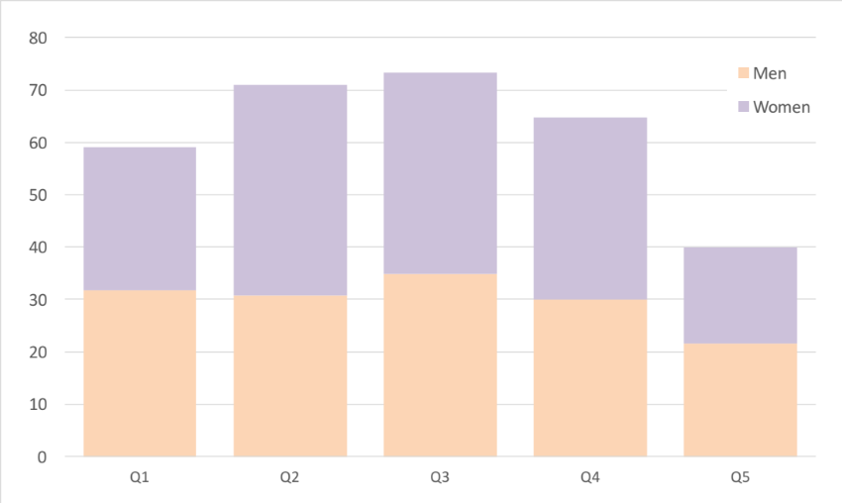

- Employment newly created by the initiatives supported by the project is expected to be of better quality than present employment in the subsector of maintenance and repairs. These two main areas of enhancement (emissions and employment) are supported by current research on the issue.

    - Stakeholder Participation
- Stakeholders participate in the identification of project priorities and in the definition of planned outputs and outcomes during interviews and consultations. All stakeholders must have the opportunity to review and comment on proposed project activities and to provide specific inputs to the project formulation process. Stakeholder participation may include the provision of co-financing, participation of technical staff in workshops, training, and tools development, the facilitation of local project events and processes, the provision of project oversight through participation on the PSC, as data sources and technical expertise relevant for the technical components of the project, and knowledge management through the institutionalization of project results and lessons learned to allow for up-scaling, replication and sustainability. At the regional level, stakeholder engagement will focus at the facilitation of regional project processes in project countries and in the identification of opportunities for optimization of resources, joint investments for project delivery, coordination and collaboration in the production of technical outputs.
- The inclusion and engagement of Civil Society Organizations (CSOs) and the public in the implementation of the project will be ensured via their direct participation in the governance and decision-making bodies of the project. Additionally, it must be emphasized that in all instances, the standards and guidelines of the Environmental and Social Safeguards for CAF/GEF Projects Manual apply.

ANNEX 1. RESULTS FRAMEWORK AND MONITORING
Country: Chile
Project Name: SUPPORTING THE CHILEAN LOW EMISSIONS TRANSPORT STRATEGY (CLETS)
.
Results Framework (Outcome Level)

Objective | Indicator | Means of verification | Risks and assumptions
GOAL. To support Chile in a transformational shift towards low-emission urban mobility systems
PURPOSE. Demonstrating systemic impacts of integrated low- emission urban mobility systems (CCM-2 P3) | Reduced growth in GHG emissions. Tonnes of CO₂ equivalent avoided, both direct and indirect, over the impact period | Project M&E and MRV systems
1.- To promote policy, planning and regulatory frameworks that foster accelerated adoption of integrated low-emissions mobility systems (Outcome B)
Indicator 5. Disaggregated degree of support for low GHG development in the policy, planning and regulatory framework
1.1.- Increased available information for planning, designing and implementing innovative sustainable urban mobility systems at national and subnational levels | Non-financial barriers are removed faster than in BAU scenario (disaggregated by gender) | Project M&E and MRV systems | Risk: information is not actionable due to other barriers not being removed
1.2.- An enhanced policy, technical and regulatory environment to promote sustainable urban mobility | A Chilean Low-Emission Transport Strategy is ready to formalise and counts with the support of diverse stakeholders (disaggregated by gender) | Project M&E and MRV systems | Risk: political will is not maintained through administrations
1.3.- Increased capacity for sustainable-transport innovation at national and subnational level | Non-financial barriers are removed faster than in BAU scenario (disaggregated by gender) | Project M&E and MRV systems | Risk: it is not possible to align commercial incentives with the sharing of data and mechanisms
1.4.- Best practices shared nationally and internationally | Replicas of project pilot and demonstrative activities are facilitated (disaggregated by gender) | Project M&E and MRV systems | Risk: situations are not comparable across countries and cities
2.- To demonstrate and operationalise financial mechanisms to support integrated low-emissions mobility systems (Outcome C)
Indicator 6. Degree of strength of financial and market mechanisms for low GHG development (disaggregated by gender)
2.1.- Technically assisted investments in sustainable urban mobility measures in representative, upscale-supportive urban areas | Investment mobilised (disaggregated by gender) | Project M&E and MRV systems | Risk: fossil fuel and renewably-sourced electricity prizes differ from those in model
2.2.- Technically assisted investments in integrated urban planning measures in representative, upscale-supportive urban areas | Investment mobilised (disaggregated by gender) | Project M&E and MRV systems | Risk: political will is not maintained through administrations
3. Project progress monitoring and information dissemination
Implementation is results-based and evaluated, monitoring and tracking is carried out and available, project replication is facilitated (disaggregated by gender)
3.1.- Results-based and evaluated implementation, monitoring and tracking, replication facilitated | Periodic reviews and independent terminal evaluation conducted (disaggregated by gender) | Project M&E and MRV systems | Assumption: CLP/USD exchange rate does not sustainedly deviate from the 500-700 range

Project Results Framework (Output Level)

ID | Base line | Target | Year 1 | Year 2 | Year 3 | Year 4 | Year 5 | Reporting frequency | Verification means |  | Responsible entity/group
1.1.1 | Different target audiences ignore the effective costs, impacts and benefits of sustainable mobility | Different target audiences know contextualised costs, impacts and benefits of sustainable mobility. | A study for the identification and characterisation of audiences is carried out. Diffusion and promotion activities have been carried out, both targeting the general public and specialised audiences, with at least 185 participants. | Diffusion and promotion activities have been carried out, both targeting the general public and specialised audiences, including those within pilot activities and with at least 300 participants. | Diffusion and promotion activities have been carried out, both targeting the general public and specialised audiences, including those within pilot activities and with at least 400 participants. | Diffusion and promotion activities have been carried out, both targeting the general public and specialised audiences, including those within pilot activities and with at least 330 participants. | Diffusion and promotion activities have been carried out, both targeting the general public and specialised audiences, with at least 150 participants. The activity uses results, lessons learnt and identified best practice. | Twice a year | MRV System | EXAG, PMU
1.1.2 | The professional/technical community is not used to electric fleet (operation, maintenance, repairs) | The professional/technical community includes professionals and technicians knowledgeable of electric fleet (operation, maintenance, repairs). | Training activities have been carried out, targeting specialised audiences, with at least 35 participants. | Training activities have been carried out, targeting specialised audiences and including those within pilot activities, with at least 100 participants. | Training activities have been carried out, targeting specialised audiences and including those within pilot activities, with at least 130 participants. | Training activities have been carried out, targeting specialised audiences and including those within pilot activities, with at least 130 participants. The activity uses results, lessons learnt and identified best practice. | Training activities have been carried out, targeting specialised audiences, with at least 50 participants. The activity uses results, lessons learnt and identified best practice. | Twice a year | MRV System | PMU
1.1.3 | CLETS's effective costs, impacts and benefits are estimated | CLETS's effective costs, impacts and benefits are known. | A MRV system is designed and operationalised. It is iteroperational with other relevant MRV initiatives and open for all learning purposes. | The MRV system is fed with data and information on all project activity. | The MRV system is fed with data and information on all project activity. | The MRV system is fed with data and information on all project activity. | The MRV system is fed with data and information on all project activity. | Twice a year | MRV System | PMU
1.2.1 | CLETS lacks a shared formulation | CLETS concites a shared vision within the relevant sector and subsectors. | An explicit, shared, participative formulation is established for the CLETS, that integrates it with other relevant policy documents. | The CLETS is widely available and has been formally presented by the competent authorities. | n.c. | n.c. | n.c. | Twice a year | Project documentation | EXAG
1.2.2 | Key professionals in regions ignore the effective costs, impacts, opportunities and benefits of sustainable mobility | There are key professionals in regions knowledgeable of the effective costs, impacts, opportunities and benefits of sustainable mobility. | Participants in the project are knowledgeable of the relevant state-of-the-art initiatives on sustainable mobility. | Participants in the project are knowledgeable of the relevant state-of-the-art initiatives on sustainable mobility. | Participants in the project are knowledgeable of the relevant state-of-the-art initiatives on sustainable mobility. The project provides opportunities for others to learn from its progress. | Participants in the project are knowledgeable of the relevant state-of-the-art initiatives on sustainable mobility. The project provides opportunities for others to learn from its progress. | The project provides opportunities for others to learn from its progress. | Twice a year | MRV System | PMU
1.3.1 | BIP is the only common system, only usable in some modes | More intermodal instruments have been tested and lessons have been learnt and are widely available. | n.c. | n.c. | Means towards enhanced intermodality are studied and characterised. | More intermodal instruments have been tested. | More intermodal instruments have been tested and lessons have been learnt and are widely available. | Twice a year | Project documentation | EXAG, BIP
1.3.2 | The certification process for vehicles contains fossil-fuel lock-ins | The certification process for vehicles does not contain fossil-fuel lock-ins. | The certification process has been studied and fossil-fuel lock-ins identified. | The certification process for vehicles does not contain fossil-fuel lock-ins | n.c. | n.c. | n.c. | Twice a year | Project documentation | EXAG, 3CV
1.3.3 | Analogic colectivo routes. | A process for the useful digitisation of colectivo routes has been tested and systematised. | n.c. | A process for the useful digitisation of colectivo routes is in place. | A process for the useful digitisation of colectivo routes has been tested and systematised. | n.c. | n.c. | Twice a year | Project documentation | PMU, COLECTIVO
1.3.4 | Mobility data are incomplete, hard to access and non-interoperable | There exists a shared Open Data strategy in implementation that aims at making all disclosable public data on mobility available and interoperable. | An Open Data Strategy is in discussion among all relevant actors | A shared Open Data strategy is agreed and in implementation. | A shared Open Data strategy is in implementation. | A shared Open Data strategy is in implementation. | A shared Open Data strategy is in implementation. | Twice a year | Project documentation | EXAG, PMU
1.4.1 | Key professionals in like-minded initiatives worldwide share experiences in a limited and informal way. | There are key professionals in like-minded initiatives worldwide with whom links and channels exist for an enhanced co-learning. | Means are provided for enhanced dialogue between like-minded initiatives worldwide . | Means are provided for enhanced dialogue between like-minded initiatives worldwide . | Means are provided for enhanced dialogue between like-minded initiatives worldwide . | Means are provided for enhanced dialogue between like-minded initiatives worldwide . | Means are provided for enhanced dialogue between like-minded initiatives worldwide . | Twice a year | Project documentation | PMU, BIKE
1.4.2 | No effective mechanism exists for the identification, systematisation and dissemination of best practice | CLETS includes an effective mechanism for the identification, systematisation and dissemination of best practice | A mechanism is designed for the easy identification, systematisation and uptake of best practice. | Best practice is identified and systematised. | Best practice is identified, systematised and formally disseminated. | Best practice is identified, systematised and formally disseminated. | Best practice is identified, systematised and formally disseminated. | Twice a year | Project documentation | PMU
2.1.1 | Transantiago's electrification strategy fails to account for gender, emissions and socioeconomic factors. Lessons learnt are not identified, systematised and disseminated. | Transantiago's electrification strategy accounts for gender, emissions and socioeconomic factors. Lessons learnt are identified, systematised and disseminated. | A study is carried out for the identification and measurement of Transantiago's impacts on gender, emissions and socioeconomic factors. A mechanism is in discussion for the identification, systematisation and dissemination of lessons learnt. | Transantiago's impacts on gender, emissions and socioeconomic factors are measured, reported and verified. A mechanism for the identification and systematisation of lessons learnt is in place. | Transantiago's impacts on gender, emissions and socioeconomic factors are measured, reported and verified. A mechanism for the identification and systematisation of lessons learnt is in place and its output disseminated. | Transantiago's impacts on gender, emissions and socioeconomic factors are measured, reported and verified. A mechanism for the identification and systematisation of lessons learnt is in place and its output disseminated. | Transantiago's impacts on gender, emissions and socioeconomic factors are measured, reported and verified. A mechanism for the identification and systematisation of lessons learnt is in place and its output disseminated. | Quarterly | MRV System | EXAG, DTPM
2.1.2 | Regional cities have no effective sustainable mobility strategies | At least 2 regional cities have advanced elements (bus) of effective sustainable mobility strategies. | 2 Local Committees are in place for the undertaking of pilot initiatives as per the corresponding ToR. | 2 pilot initiatives are ongoing as per the corresponding ToR. | 2 pilot initiatives are ongoing as per the corresponding ToR. | 2 pilot initiatives have been carried out, monitored, evaluated and lessons learnt from them. | n.c. | Quarterly | MRV System | EXAG, DTPR
2.1.3 | Regional cities have no effective sustainable mobility strategies | At least 1 regional city has advanced elements (collective taxi) of an effective sustainable mobility strategy. | A Local Committee is in place for the undertaking of a pilot initiative as per the corresponding ToR. | A pilot initiative in ongoing as per the corresponding ToR. | A pilot initiative in ongoing as per the corresponding ToR. | A pilot initiative has been carried out, monitored, evaluated and lessons learnt from it. | n.c. | Quarterly | MRV System | PMU, COLECTIVO
2.2.1 | Bicycle infrastructure standards do not cater to women and vulnerable population. Defficient peatonalisation standards. Intermodality is hampered by little-known constrains | Bicycle infrastructure standards attend women and vulnerable population's needs. Effective peatonalisation standards. A contextualised analysis of barriers to intermodality has been carried out. A pilot initiative has been designed, implemented and learned from. | A Local Committee is in place for the undertaking of a pilot initiative as per the corresponding ToR. | A pilot initiative in ongoing as per the corresponding ToR. | A pilot initiative has been carried out, monitored, evaluated and lessons learnt from it. | n.c. | n.c. | Quarterly | Project documentation | PMU, DDU, UCI, BIKE, EXAG

ANNEX 2. DETAILED PROJECT DESCRIPTION
COUNTRy: Republic of Chile
Project Name: SUPPORTING THE CHILEAN LOW EMISSIONS TRANSPORT STRATEGY (CLETS)

Project Rationale. The STGZ NAMA (reported in Chile’s first BUR in 2014 and submitted to a detailed evaluation commissioned by CAF in 2016), which successfully showcased pilot strategies in the Municipality of Santiago, can be considered as a ‘predecessor’ of this project. The NAMA included 4 initiatives: 1) Promotion of Zero and Low Emission Vehicles (ZLEV) in (private) taxi fleets, municipality fleet and charging stations; 2) Incorporation of low carbon buses into the public transportation system in Santiago (refers to systems under Santiago Municipality’s jurisdiction); 3) Promotion of non-motorised vehicle use, including the implementation of 6 km of new bicycle lanes, a pilot programme for a bicycle sharing system, 1 connectivity solution for two existing bicycle lanes and bike signs in two areas within the STGZ; and 4) Traffic re-design and traffic management with new pedestrian and semi-pedestrian streets, exclusive lanes for ZLE buses and bicycle parking. The NAMA’s reported to-do measures deal with institutional fleets and transit measures in Santiago. All assumptions on which this project is based are coherent with the NAMA’s results (technical parameters, sources of funding, challenges) and no overlapping exists between the two (measures in the NAMA are to be executed within systems under Santiago Municipality’s jurisdiction, while measures in this project are executed under ministries’ jurisdictions and have much wider scope; Santiago metropolitan area fully includes 26 municipalities, one of them that of Santiago proper, and public transport in it is of MTT’s competency). This project takes these preceding measures to the full scope of further public realms in Chile, both in the contexts of Santiago metropolitan area, Chile´s decentralised jurisdictions in other cities, and the national policy and regulatory space.

The objective and proposed activities of the project are aligned with the programming priorities, and specifically focused on Demonstrating systemic impacts of integrated low- emission urban mobility systems (CCM-2 P3). The project will produce the higher-level outcomes of promoting policy, planning and regulatory frameworks that foster accelerated adoption of integrated low-emissions mobility systems (Outcome B); and of demonstrating and operationalising financial mechanisms to support integrated low-emissions mobility systems (Outcome C).

Consistent with the above, this project will embrace the following principles through-out its implementation:
(1) Inclusive development: It is important that vulnerable households, women and small businesses can perceive the benefits from the project activities. For this, the equitable distribution of benefits is a requirement for long term inclusive development and community support.
(2) Systemic Change: Bringing together stakeholders from different levels (national, regional and local) and establishing a joint agenda will be key to address and resolve underlying systemic constraints.
(3) Local Initiative: Experiences show that whereas effective and sustainable solutions can only be achieved if local actors shape and drive their own agendas, a bottom up approach will be fundamental for long term sustainability.
(4) Contextualized shared solutions: Working through an active knowledge management and capacity development platform, will assure that throughout the project, information, tools, know-how and resources are properly applied to different contexts and needs, improving the generation of effective and economically viable processes committed to impact on scale and a responsible value for money rationale.
Global Environmental Benefits. The project will contribute total emission reductions of more than nine hundred fourty thousand (942,193) tCO₂eq over 20 years to the global efforts in search of low-carbon development.

Project Components and activities. GEF funds will specifically finance incremental activities oriented towards the accelerated adoption of integrated low-emission urban mobility systems. These include activities that increase the available information for planning, designing and implementing innovative sustainable urban mobility systems at national and subnational levels, that foster an enhanced policy, technical and regulatory environment to promote sustainable urban mobility, that increase the capacity for sustainable-transport innovation at national and subnational level, that identify and share best practices nationally and internationally, and that promote investments in sustainable urban mobility measures in relevant urban areas and in integrated urban planning measures in representative, replication-ready urban areas.

In order to maximize the impacts and sustainability of activities, the Project will seek to coordinate its actions with existing government programmes and policies, as well as programmes and projects financed by CAF. In particular, the project will develop, early during its implementation, a comprehensive Gender Action Plan project approach to address the identified gender differences and gaps, gender-differentiated impacts and risks, and opportunities to promote the empowerment of women that support project objectives and outcomes. In particular, this will mean at least the implementation of gender-disaggregated indicators for all possible project elements (M&E and MRV implementations) and a focus on women engagement (positively-discriminated participation) in stakeholder participation (decision focus), knowledge management and capacity development activities (process focus), and any resulting new employment (impact focus).

The proposed Project will be implemented over a period of five years and comprises the following components: (1) Promotion of policy, planning and regulatory frameworks that foster accelerated adoption of integrated low-emissions mobility systems through Participation, Knowledge Management and Capacity Development in the framework of a Chilean Low Emissions Transport Strategy (CLETS); (2) Demonstrative and Catalytic Actions that demonstrate and operationalise financial mechanisms to support integrated low-emissions mobility systems (Outcome C); and (3) Project Management, Monitoring and Evaluation, inclusive of the Project Close-out Period.

Component 1. Promotion of policy, planning and regulatory frameworks that foster accelerated adoption of integrated low-emissions mobility systems (Outcome B) through Participation, Knowledge Management and Capacity Development in the framework of a Chilean Low Emissions Transport Strategy (CLETS) (US$1.62M GEFTF, total US$1.69M)
This Component seeks to remove non-financial barriers to the penetration of low- or zero-emissions vehicles in fleets and to innovative smart mobility. It is measured by Indicator 5: Degree of support for low GHG development in the policy, planning and regulatory framework. The Component gathers activity in four main lines of action, directed towards the remotion of non-financial barriers, the formalization and diffusion of the CLETS and facilitating the replication of project’s pilot initiatives and demonstrative activities.

Outcome 1.1.- Increased available information for planning, designing and implementing innovative sustainable urban mobility systems at national and subnational levels
The measurement of this outcome is done on whether non-financial barriers are removed faster than in BAU scenario.

Output 1.1.1. Information campaigns
The baseline for this activity is that different target audiences ignore the effective costs, impacts and benefits of sustainable mobility. Through specification of audiences, followed by diffusion and informative activities, different target audiences get to discern contextualized costs, impacts and benefits of sustainable mobility.

Output 1.1.2. Training
The baseline for this activity acknowledges that the professional/technical community linked to public transport is not used to the operation, maintenance, or repairs needed by electric fleets. Through specialized training, the professional/technical community within pilot initiatives and countrywide includes professionals and technicians knowledgeable of electric fleet (operation, maintenance, repairs). These training activities must consider gender balance and will be monitored gender-wise.

Output 1.1.3. MRV system
The baseline for this activity is that CLETS’s effective costs, impacts and benefits are estimated. Through studies and thorough monitoring, reporting and verification, CLETS’s effective costs, impacts and benefits will be demonstrated and disseminated.

Outcome 1.2.- An enhanced policy, technical and regulatory environment to promote sustainable urban mobility
This line of work will ensure that the Chilean Low-Emission Transport Strategy is ready to formalize and counts with the support of diverse stakeholders.

Output 1.2.1. Support to the formalization and diffusion of the Chilean Low Emissions Transport Strategy
The baseline for this activity is that CLETS lacks a shared formulation beyond the public-administration sphere. Through participation activities, it will be sought that CLETS reflects a shared vision within the relevant sector and subsectors, and that it provides them with support for their own efforts towards sustainability.

Output 1.2.2. Experience exchange and dissemination, national level
The baseline for this activity is that key professionals in regions ignore the effective costs, impacts, opportunities and benefits of sustainable mobility. Through experience exchange and other knowledge-management interventions, the line of work will ensure that there are key professionals in regions knowledgeable of the effective costs, impacts, opportunities and benefits of sustainable mobility.

Outcome 1.3.- Increased capacity for sustainable-transport innovation at national and subnational level
The measurement of this outcome is done on whether non-financial barriers are removed faster than in BAU scenario.

Output 1.3.1. Support to the interoperability of methods of payment
The baseline for this activity is that BIP is the only common system, only usable in some modes and only in Transantiago. Through technical assistance, the project will support that more intermodal instruments are tested and lessons are learnt and are widely available.

Output 1.3.2. Energy certification of vehicles
The baseline for this activity is that the certification process for vehicles contains fossil-fuel lock-ins that hamper low- or zero-emissions innovation. Through technical assistance, the line of work will contribute to a shared outcome that the certification process for vehicles does not contain fossil-fuel lock-ins.

Output 1.3.3. Collective-taxi information crowdsourcing
The baseline for this activity is that colectivo routes are known only through analogic means. The project will support innovation on processes for the useful digitization of colectivo routes, so that such processes are tested and systematized.

Output 1.3.4. Open Data strategy
The baseline for this activity is that mobility data are incomplete, hard to access and non-interoperable in Chile. The project will support that a shared Open Data strategy is discussed and in implementation among all relevant actors, aiming at making all disclosable public data on mobility available and interoperable.

Outcome 1.4.- Best practices shared nationally and internationally
This line of work aims at facilitating information and first-hand knowledge on project pilot initiatives and demonstrative activities to interested agents, so replication and uptake are faster than in absence of this line of work.

Output 1.4.1. Dissemination (international level)
The baseline for this activity is that key professionals in like-minded initiatives worldwide, including those supported by the project, share experiences in a limited and informal way. The project supports exchange and policy-dialogue activities carried out by relevant initiatives under no geographical limitation, but expected to focus primarily in Latinamerica. Activity will be carried out to ensure that links and channels exist for an enhanced co-learning between key professionals in like-minded initiatives worldwide.

Output 1.4.2. Identification, systematisation and promotion of best practices
In the baseline situation, no effective mechanism exists for the identification, systematisation and dissemination of best practice in transport-related sustainability initiatives in Chile. Hereby, it will be sought that CLETS implementation includes an effective mechanism for the identification, systematisation and dissemination of best practice.

Component 2. Demonstrative and Catalytic Actions that demonstrate and operationalise financial mechanisms to support integrated low-emissions mobility systems (Outcome C) (US$1.04M GEFTF, total US$59.04M)
Within this Component, Financial mechanisms to support GHG reductions will be demonstrated and operationalised. It is measured by Indicator 6: Degree of strength of financial and market mechanisms for low GHG development. The Component supports up to four technically assisted investments in measures relevant to the CLETS, as well as the provision of capacity for a current CLETS demonstration (namely, that occurring in Transantiago) to act as knowledge source for replication and uptake.

Outcome 2.1.- Technically assisted investments in sustainable urban mobility measures in representative, upscale-supportive urban areas
This line of work will support the direct removal of barriers to investment in sustainable urban mobility through pilot and demonstrative initiatives. Its impact measurement will be the investment mobilized within the scope of these initiatives.

Output 2.1.1. ZLE Transantiago (knowledge source)
The baseline for this activity is that Transantiago's electrification strategy fails to account for gender, emissions and socioeconomic factors, and it is not fully prepared to disseminate its progress and learnt lessons, so lessons learnt are not identified, systematized and disseminated. Through the provision of capacity for Transantiago to act as knowledge source for replication and uptake, Transantiago's electrification strategy will account for gender, emissions and socioeconomic factors in its MRV system and count with established capacity for the identification, systematization and dissemination of lessons learnt.

Output 2.1.2. ZLE Bus in Concepción and Temuco
The baseline for this activity is that Chilean regional cities have no effective sustainable mobility strategies. Through its support to pilot initiatives in the cities of Concepción and Temuco, at least these two regional cities will have advanced (bus) elements of effective sustainable mobility strategies.

Output 2.1.3. ZLE Collective taxi in La Serena
The baseline for this activity is that Chilean regional cities have no effective sustainable mobility strategies. Through its support to a pilot initiative in the city of La Serena, at least this city will have advanced (collective taxi) elements of an effective sustainable mobility strategy.

Outcome 2.2.- Technically assisted investments in integrated urban planning measures in representative, upscale-supportive urban areas
This line of work will support the direct removal of barriers to investment in sustainable urban mobility through a pilot initiative. Its impact measurement will be the investment mobilized within the scope of this initiative.

2.2.1. Integrated urban mobility intervention in Villarrica
The baseline for this activity is a situation in which bicycle infrastructure standards do not cater to women and vulnerable population, deficient peatonalisation standards are applied if at all and intermodality is hampered by little-known constrains. Through its support to a pilot initiative in the city of Villarrica, the project will contribute to enhanced attention to women and vulnerable population's needs within bicycle infrastructure standards, to the development of effective peatonalisation standards and to a contextualized analysis of barriers to intermodality. At the end of project, a pilot initiative will have been designed, implemented and learned from.

During the preparatory phase of the project it has been a key approach to build strong relations between the three project Components, aimed at increasing synergies, stronger feedback and validation of expected outputs and results, as well as to boost the interaction between the stakeholders involved. This means that although activities and results will mostly have a normal/classic sequence in each component, they will provide/receive (accordingly) strong feedback and updating from the results achieved by ongoing activities and through strong participation and discussion with and between local, subnational, national and regional stakeholders. This synergy seeks to ensure that information, instruments and methodologies will have a strong technical basis in terms of relevance, objectivity and argumentation, proved by pilot activities in the field, and that learning and findings from these provide feedback and validation to management, institutional, regulatory and investment instruments. This section presents the Project rationale and activities.

ANNEX 3. SUMMARIZED PROJECT IMPLEMENTATION SCHEDULE

Component/Outcome/Output | Chronogram (by quarters)
Component/Outcome/Output | 1-1 | 1-2 | 1-3 | 1-4 | 2-1 | 2-2 | 2-3 | 2-4 | 3-1 | 3-2 | 3-3 | 3-4 | 4-1 | 4-2 | 4-3 |  | 4-4 | 5-1 | 5-2 | 5-3 | 5-4
1.- Promotion of policy, planning and regulatory frameworks that foster accelerated adoption of integrated low-emissions mobility systems through Participation, Knowledge Management and Capacity Development in the framework of a Chilean Low Emissions Transport Strategy (CLETS)
1.1.- Increased available information for planning, designing and implementing innovative sustainable urban mobility systems at national and subnational levels
1.1.1. Information campaigns | X | X | X | X | X | X | X | X | X | X | X | X | X | X | X |  | X | X | X | X | X
1.1.2. Training |  | X | X | X | X | X | X | X | X | X | X | X | X | X | X |  | X | X | X | X
1.1.3. MRV system | X | X | X | X | X | X | X | X | X | X | X | X | X | X | X |  | X | X | X | X | X
1.2.- An enhanced policy, technical and regulatory environment to promote sustainable urban mobility
1.2.1. Support to the formalisation and diffusion of the Chilean Low Emissions Transport Strategy | X | X | X | X | X | X
1.2.2. Experience exchange and dissemination, national level |  | X | X |  |  | X | X |  |  | X | X |  |  | X | X |  |  |  | X | X
1.3.- Increased capacity for sustainable-transport innovation at national and subnational level
1.3.1. Support to the interoperability of methods of payment |  |  |  |  |  |  |  |  |  |  | X | X | X | X | X |  | X | X | X
1.3.2. Energy certification of vehicles |  | X | X | X | X | X | X
1.3.3. Collective-taxi information crowdsourcing |  |  |  |  |  |  | X | X | X | X | X | X
1.3.4. Open Data strategy |  |  | X | X | X | X | X | X | X | X | X | X | X | X | X |  | X | X | X | X | X
1.4.- Best practices shared nationally and internationally
1.4.1. Dissemination (international level) |  |  | X |  |  |  | X |  |  |  | X |  |  |  | X |  |  |  |  | X
1.4.2. Identification, systematisation and promotion of best practices |  | X | X | X | X | X | X | X | X | X | X | X | X | X | X |  | X | X | X | X | X
2.- Demonstrative and Catalytic Actions that demonstrate and operationalise financial mechanisms to support integrated low-emissions mobility systems
2.1.- Technically assisted investments in sustainable urban mobility measures in relevant urban areas

2.1.1. ZLE Transantiago (knowledge source) |  | X | X |  |  | X | X |  |  | X | X |  |  | X | X |  |  |  | X | X
2.1.2. ZLE Bus in Concepción and Temuco |  |  | X | X | X | X | X | X | X | X | X | X | X
2.1.3. ZLE Collective taxi in La Serena |  |  |  | X | X | X | X | X | X | X | X | X | X | X
2.2.- Technically assisted investments in integrated urban planning measures in representative, replication-ready urban areas
2.2.1. Integrated urban mobility intervention in Villarrica |  |  |  |  | X | X | X | X | X | X | X | X | X | X | X
3.- Monitoring and Evaluation

3.1.- Adequate monitoring of all project indicators to ensure successful project implementation and evaluation

3.1.1.- Periodic reviews and independent terminal evaluation conducted | X |  | X |  | X |  | X |  | X | X | X |  | X |  | X |  |  | X |  | X | X

ANNEX 4. INCREMENTAL COST MATRIX

A financial and emissions model (see below) has been developed, based on detailed financial rationale for bus and taxi. Assumptions have been made of the adoption of technologies in the systems to be intervened by the project, and model sensitivity analysis carried out for different variables, including incremental funding above this project idea (although central assumptions do not include any such funding). In general, more unfavourable conditions are considered in the central analysis. The complete model includes the period 2015 (baseline year) – 2034, throughout which equipment (buses and collective taxis for calculation herein) incorporated to service during the foreseen project period (2018-2022 as a modelling assumption) will be in operation. During project formulation, it will be taken care of that the project document includes clear requirements for such contributions to be mobilized during project implementation through concession contracts (Transantiago) and renovation support programmes linked to licensing (bus in other cities and collective taxi) signed/issued during project period.

The model provides the following estimations of global environmental benefits to be obtained: a) Total emission reductions of 719,935 tCO₂eq are achieved b) through GEF contribution of 3.27 million USD and co-financing of 36.20 million USD; c) this results in 4.54 USD/tCO₂eq (GEF funding/project total emissions reduction).

Funding (USD) |  | TOTAL
Baseline | Private | 395.880.637
Baseline | Public | 275.632.116
Co-funding | Private | 11.580.975
Co-funding | Public | 21.348.846
GEF funding |  | 3.270.000
PROJECT TOTAL |  | 36.199.821
Emissions reduction (tCO₂eq) |  | TOTAL
Co-funding |  | 115.999
GEF funding | Direct | 195.692
GEF funding | Indirect | 408.244
PROJECT TOTAL |  | 719.935

Funding flows 2017-2036
(USD)

Funding (USD) |  | TOTAL | 2017 | 2018 | 2019 | 2020 | 2021 | 2022 | 2023 | 2024 | 2025 | 2026 | 2027 | 2028 | 2029 | 2030 | 2031 | 2032 | 2033 | 2034 | 2035 | 2036
Baseline | Private | 395.880.637 | 14.185.882 | 21.135.000 | 21.165.000 | 26.551.500 | 35.970.555 | 19.442.925 | 45.152.295 | 18.135.480 | 42.123.000 | 16.815.000 | 25.422.000 | 10.716.000 | 14.905.500 | 63.070.500 | 10.545.000 | 10.545.000 | - | - | - | -
Baseline | Public | 275.632.116 | 25.790.406 | 23.419.382 | 19.495.114 | 18.726.202 | 8.407.095 | 42.257.871 | 11.950.020 | 23.288.232 | 9.788.420 | 9.788.420 | 15.317.054 | 9.788.420 | 9.788.420 | 9.788.420 | 9.788.420 | 9.788.420 | 4.615.450 | 4.615.450 | 4.615.450 | 4.615.450
Co-funding | Private | 11.580.975 | - | - | - | 893.475 | 3.710.700 | 1.162.800 | 4.950.450 | 863.550 | - | - | - | - | - | - | - | - | - | - | - | -
Co-funding | Public | 21.348.846 | - | - | - | - | 1.132.628 | 1.566.795 | 1.802.500 | 1.442.500 | 1.522.500 | 1.242.500 | 1.242.500 | 1.242.500 | 1.242.500 | 1.242.500 | 1.242.500 | 1.242.500 | 1.242.500 | 1.242.500 | 1.566.795 | 1.132.628
GEF funding |  | 2.900.000 | - | - | 163.500 | 521.300 | 987.275 | 521.300 | 395.975 | 310.650 | - | - | - | - | - | - | - | - | - | - | - | -
PROJECT TOTAL |  | 36.199.821

Emissions reduction 2017-2036
(tCO₂eq)

Emissions reduction (tCO₂eq) |  | TOTAL | 2017 | 2018 | 2019 | 2020 | 2021 | 2022 | 2023 | 2024 | 2025 | 2026 | 2027 | 2028 | 2029 | 2030 | 2031 | 2032 | 2033 | 2034 | 2035 | 2036
Co-funding |  | 115.999 | - | - | - | 321 | 1.655 | 2.073 | 3.853 | 4.164 | 5.866 | 6.205 | 7.007 | 7.016 | 7.251 | 10.084 | 10.084 | 10.084 | 10.084 | 10.084 | 10.084 | 10.084
GEF funding | Direct | 195.692 | - | - | - | 51 | 4.450 | 8.889 | 12.443 | 12.732 | 13.146 | 13.121 | 13.121 | 13.104 | 13.087 | 13.079 | 13.079 | 13.078 | 13.078 | 13.078 | 13.078 | 13.078
GEF funding | Indirect | 408.244 | - | - | - | - | - | - | - | - | 3.214 | 7.024 | 12.475 | 17.311 | 22.027 | 33.450 | 40.015 | 46.939 | 52.120 | 55.432 | 57.727 | 60.510
PROJECT TOTAL |  | 719.935

ANNEX 5. CALCULATION AND MODELLING PARAMETERS
This document presents the study and modelling of main variables of an intervention for the introduction of electric vehicles in the Chilean public-bus and collective-taxi regulated markets. The study is done to support the Chilean Low Emission Transport Strategy (CLETS).

Two technological interventions were analysed to identify what would be the incremental cost for an operator, and to identify the main barriers that avoid the natural introduction of low emission and mainly electric vehicles.

The analysis includes the following scenarios:

Scenario | Description
1 | Public buses in Santiago Metropolitan City
2 | Public buses in Regional Chile
3 | Shared (collective) taxi in Regional Chile

The following section details the general assumptions and parameters used for the analysis. Later, each of the scenarios is evaluated using a typical cost-benefit analysis (CBA), where an operator evaluates the option of purchasing and operating an electric vehicle instead of the usual petrol or diesel baseline option.

The general assumptions made for this analysis are the following:

- This analysis assumes that the baseline projects are already financially feasible and therefore, happen. Considering this, the CBA in this case evaluates only the incremental costs incurred by the operator considering a scenario of electric mobility.
- Values considered (petrol and diesel prices, electricity price, discount rates, energy consumption rates, etc.) tend to be conservative on the project side, to avoid underestimation of incremental costs.
- Technological costs were obtained from state-of-the-art literature, meetings with stakeholders (suppliers, sectorial experts, etc.), and latest reports published for the Chilean and Latin-American context.
The general parameters considered, are:

- Private discount rate: 10%
- USD exchange rate: 680 CLP/USD
- Temporal scale:
  - Public buses: 8 years (length of near future concession in Santiago)
  - Shared taxis: 5 years
- Fuel prices:
  - Gasoline/Petrol: 750 CLP/liter (1.1 USD/liter)
  - Diesel: 500 CLP/liter (0.735 USD/liter)
  - Electricity: 70 CLP/kWh (0.103 USD/kWh)
- Annual depreciation rates:
  - Diesel bus: 15%
  - Electric bus: 20%
  - Diesel taxi: 20%
  - Electric taxi: 20%
- Loan amount: 85% of total vehicle price
- Loan period:
  - Diesel Bus: 10 years (equivalent to useful life)
  - Electric Bus: 14 years (equivalent to useful life)
  - Shared taxis: 5 years (equivalent to private loan usually used by taxi drivers)
- Kilometres per year:
  - Buses in Santiago: 77,000
  - Buses in Regional Chile: 53,500
  - Shared taxis in Regional Chile: 73,000
Specific assumptions and parameters are presented for each scenario. For the purpose of this analysis, a comparison of the purchase of 1 electric vehicle in each case is considered.

Public Buses in Santiago

The analysis is done for the decision to purchase and operate a 12-meter electric bus instead of a diesel euro VI bus, during the 8-year concession granted by the metropolitan government. The financial operation includes upfront disbursement of 15% of total vehicle price, and a loan with a period equivalent to the useful life of the vehicles.

The baseline bus considered was a Euro VI diesel bus, with a final price of USD 230.000, considering taxes. The alternative electric bus considered for this analysis, is the 12m BYD K9, with a total price of USD 590.000, considering taxes. In both cases, considering that a big fleet will be purchased (as recommendation by vendors), a 5% discount was considered.

In the case of Santiago, an additional financial component is considered, related to a government subsidy equivalent to 395.61 CLP/km (0.58 USD/km)) paid to the operator during the concession lifetime. This subsidy is included in the concession conditions and is increased by 18% (466.82 CLP/km or 0.686 USD/km) in the case of electric buses.

Additional infrastructure costs of USD 10.000 per bus, were considered for electric buses, and include the BYD slow charging equipment (5.5 – 6 hours/charge). No costs were considered for leasing of batteries, as BYD in Chile offers warranty of over 8 years for these.

Because of contradictory information obtained from literature about maintenance costs, these were assumed equal in both cases (diesel and electric).

Other costs or financial flows not considered in the analysis, such as income, salaries, tires, and others, were not included and are assumed equal for both options.

The following table summarizes the main data and parameters considers for the analysis of electric buses for the Santiago public transport system.

Data and parameters:

ITEM | Baseline |  | Project
Vehicle type | Diesel Euro VI |  | Electric
Energy source | Diesel |  | Electricity
Useful life | 10 | years | 14 | years
Performance | 2.52 | km/liter | 1 | km/kWh
Investment | 218,500 | USD/veh | 560,500 | USD/veh
% Total cost in Loan | 85% |  | 85%
Loan period (years) | 10 |  | 14
Annual interest rate | 3.1% |  | 3.1%
Loan amount | 185,725 | USD/veh | 476,425 | USD/veh
Infrastructure Costs |  |  | 10,000 | USD/veh
Per Km subsidy | 395.61 | CLP/km | 466.8198 | CLP/km
Depreciation rate | 15% |  | 20%
Residual value (%) | 27% |  | 17%
Residual value | 48,145 | USD/veh | 57,248 | USD/veh
GHG Emission Factor | 978 | g/km-veh | 300 | g/km-veh

Annual Cash Flows and Emissions

Euro VI Diesel Bus (CLP/year):
 | 0 |  | 1 |  | 2 |  | 3 |  | 4 |  | 5 | 6 | 7 |  | 8 |  | 9
Investment | -22,287,000
Annual Loan Payment |  | -14,881,049 |  | -14,881,049 |  | -14,881,049 |  | -14,881,049 |  | -14,881,049 |  | -14,881,049 |  | -14,881,049 |  | -14,881,049
Fuel Costs |  | -15,306,866 |  | -15,306,866 |  | -15,306,866 |  | -15,306,866 |  | -15,306,866 |  | -15,306,866 |  | -15,306,866 |  | -15,306,866
Per Km Subsidy |  | 30,461,970 |  | 30,461,970 |  | 30,461,970 |  | 30,461,970 |  | 30,461,970 |  | 30,461,970 |  | 30,461,970 |  | 30,461,970
Residual Value |  |  |  |  |  |  |  |  |  |  |  |  |  |  |  |  |  | 32,738,858
Net Flows | -22,287,000 | 274,055 |  | 274,055 |  | 274,055 |  | 274,055 |  | 274,055 |  | 274,055 |  | 274,055 |  | 274,055 |  | 32,738,858
NPV (10%) | -6,940,467 | CLP

BYD K9 Electric Bus (CLP/year):
 | 0 |  | 1 |  | 2 |  | 3 |  | 4 |  | 5 |  | 6 |  | 7 |  | 8 |  | 9
Investment | -63,971,000
Annual Loan Payment |  | -28,875,640 |  | -28,875,640 |  | -28,875,640 |  | -28,875,640 |  | -28,875,640 |  | -28,875,640 |  | -28,875,640 |  | -28,875,640
Fuel Costs |  | -5,390,000 |  | -5,390,000 |  | -5,390,000 |  | -5,390,000 |  | -5,390,000 |  | -5,390,000 |  | -5,390,000 |  | -5,390,000
Per Km Subsidy |  | 35,945,125 |  | 35,945,125 |  | 35,945,125 |  | 35,945,125 |  | 35,945,125 |  | 35,945,125 |  | 35,945,125 |  | 35,945,125
Residual Value |  |  |  |  |  |  |  |  |  |  |  |  |  |  |  |  |  | 38,928,554
Net Flows | -63,971,000 | 1,679,485 |  | 1,679,485 |  | 1,679,485 |  | 1,679,485 |  | 1,679,485 |  | 1,679,485 |  | 1,679,485 |  | 1,679,485 |  | 38,928,554
NPV (10%) | -38,501,566 | CLP

GHG Emissions (tonCOeq/year):
Bus Type | 0 | 1 | 2 | 3 | 4 | 5 | 6 | 7 | 8 | TOTAL
Euro VI Diesel | 0 | 75.33 | 75.33 | 75.33 | 75.33 | 75.33 | 75.33 | 75.33 | 75.33 | 603
Electric | 0 | 23.10 | 23.10 | 23.10 | 23.10 | 23.10 | 23.10 | 23.10 | 23.10 | 185

The following table presents a summary of results for the decision of purchasing an electric bus instead of a diesel Euro VI bus, to be used considering Santiago´s public transport system conditions.

Results:

 |  | Baseline | Project | Difference
Average annual flows | Million CLP/year | 0.27 | 1.68 | 1.41
NPV (10%) | Million CLP | -6.94 | -38.50 | -31.56
Annual GHG Reduction | tonCO2eq/year |  |  | 52.23
Total GHG Reduction | tonCO2eq |  |  | 417.87
Average annual flows | USD/year | 403 | 2,470 | 2,067
NPV (10%) | USD | -10,207 | -56,620 | -46,413
Average GHG Cost | USD/tonCO2eq |  |  | -111.1

Results show that for an 8-period economic evaluation, the option of purchasing an electric bus instead of a diesel bus in Santiago is higher by around USD 46,500. When comparing the annual cash flows, the option of an electric bus tends to be more attractive mainly because of the increased per km subsidy and lower operational costs (electricity vs. diesel). When comparing the upfront cost of the vehicle purchase, the difference is of about USD 61,300 (considering the battery purchase). These differences allow for the design of alternative financing options, mixing upfront subsidies with soft loans that sum up to an equivalent donation of USD 46,500.

Public Buses in Regional Chile

The analysis is done for the decision to purchase and operate a 12-meter electric bus instead of a diesel euro V bus, for public transport systems in Regional Chile. The temporal scope considers an 8-year evaluation similar to the conditions of Santiago. The financial operation includes upfront disbursement of 15% of total vehicle price, and a loan with a period equivalent to the useful life of the vehicles.

The baseline bus considered was a Euro V diesel bus, with a final price of USD 200.000, considering taxes. The alternative electric bus considered for this analysis, is the 12m BYD K9, with a total price of USD 590.000, considering taxes. In both cases, considering that a big fleet will be purchased (as recommendation by vendors), a 5% discount was considered.

In the case of Regional Chile, an upfront subsidy of 9,500,000 CLP (13,971 USD) is considered for both technologies as part of a national public bus renovation program (renueva tu micro).
Additional infrastructure costs of USD 10.000 per bus, were considered for electric buses, and include the BYD slow charging equipment (5.5 – 6 hours/charge). No costs were considered for leasing of batteries.

Maintenance costs were assumed equivalent in both technologies. Other costs or financial flows not considered in the analysis, such as income, salaries, tires, and others, were not included and are assumed equal for both options.

The following table summarizes the main data and parameters considers for the analysis of electric buses for the public transport system in Regional Chile.

Data and parameters:

ITEM | Baseline |  | Project
Vehicle type | Diesel Euro V |  | Electric
Energy source | Diesel |  | Electricity
Useful life | 10 | years | 14 | years
Performance | 2.46 | km/liter | 1 | km/kWh
Investment | 190,000 | USD/veh | 560,500 | USD/veh
% Total cost in Loan | 85% |  | 85%
Loan period (years) | 10 |  | 14
Annual interest rate | 3.1% |  | 3.1%
Loan amount | 161,500 | USD/veh | 476,425 | USD/veh
Infrastructure Costs |  |  | 10,000 | USD/veh
Upfront subsidy | 9,500,000 | CLP | 9,500,000 | CLP
Depreciation rate | 15% |  | 20%
Residual value (%) | 27% |  | 17%
Residual value | 48,145 | USD/veh | 57,248 | USD/veh
GHG Emission Factor | 998 | g/km-veh | 300 | g/km-veh

Annual Cash Flows and Emissions

Euro V Diesel Bus (CLP/year):
 |  | 0 |  | 1 |  | 2 |  | 3 |  | 4 |  | 5 |  | 6 |  | 7 |  | 8 |  | 9
Investment | -9,880,000 |  |  |  |  |  |  |  |  |  |  |  |  |  |  |  |  |  | 0
Annual Loan Payment |  |  | -12,940,043 |  | -12,940,043 |  | -12,940,043 |  | -12,940,043 |  | -12,940,043 |  | -12,940,043 |  | -12,940,043 |  | -12,940,043 |  | 0
Fuel Costs |  |  | -10,852,337 |  | -10,852,337 |  | -10,852,337 |  | -10,852,337 |  | -10,852,337 |  | -10,852,337 |  | -10,852,337 |  | -10,852,337 |  | 0
Residual Value |  |  |  |  |  |  |  |  |  |  |  |  |  |  |  |  |  |  | 28,468,572
Net Flows | -9,880,000 |  | -23,792,380 |  | -23,792,380 |  | -23,792,380 |  | -23,792,380 |  | -23,792,380 |  | -23,792,380 |  | -23,792,380 |  | -23,792,380 |  | 28,468,572
NPV (10%) | -124,737,136 |  | CLP

BYD K9 Electric Bus (CLP/year):
 | 0 | 1 |  | 2 |  | 3 |  | 4 |  | 5 |  | 6 |  | 7 |  | 8 |  | 9
Investment | -54,471,000
Annual Loan Payment |  | -28,875,640 |  | -28,875,640 |  | -28,875,640 |  | -28,875,640 |  | -28,875,640 |  | -28,875,640 |  | -28,875,640 |  | -28,875,640
Fuel Costs |  | -3,745,000 |  | -3,745,000 |  | -3,745,000 |  | -3,745,000 |  | -3,745,000 |  | -3,745,000 |  | -3,745,000 |  | -3,745,000
Residual Value |  |  |  |  |  |  |  |  |  |  |  |  |  |  |  |  |  | 38,928,554
Net Flows | -54,471,000 | -32,620,640 |  | -32,620,640 |  | -32,620,640 |  | -32,620,640 |  | -32,620,640 |  | -32,620,640 |  | -32,620,640 |  | -32,620,640 |  | 38,928,554
NPV (10%) | -211,990,200 |  | CLP

GHG Emissions (tonCOeq/year):
Bus Type | 0 | 1 | 2 | 3 | 4 | 5 | 6 | 7 | 8 | TOTAL
Euro VI Diesel | 0 | 53.41 | 53.41 | 53.41 | 53.41 | 53.41 | 53.41 | 53.41 | 53.41 | 427
Electric | 0 | 16.05 | 16.05 | 16.05 | 16.05 | 16.05 | 16.05 | 16.05 | 16.05 | 128

The following table presents a summary of results for the decision of purchasing an electric bus instead of a diesel Euro V bus, to be used considering public transport system conditions in Regional Chile.

Results:

 |  | Baseline | Project | Difference
Average annual flows | Million CLP/year | -23.79 | -32.62 | -8.83
NPV (10%) | Million CLP | -124.74 | -211.99 | -87.25
Annual GHG Reduction | tonCO2eq/year |  |  | 37.36
Total GHG Reduction | tonCO2eq |  |  | 298.89
Average annual flows | USD/year | -34,989 | -47,972 | -12,983
NPV (10%) | USD | -183,437 | -311,750 | -128,313
Average GHG Cost | USD/tonCO2eq |  |  | -429.30

Results show that for an 8-period economic evaluation, the option of purchasing an electric bus instead of a diesel bus in Regional Chile is dearer by more than USD 128,000. Compared to the results obtained from Santiago, this option is more expensive, mainly due to the lower yearly mileage and lower overall state subsidy.

Shared Taxis in Regional Chile

The analysis is done for the decision to purchase and operate an electric light-duty vehicle instead of a petrol (gasoline) euro V light-duty vehicle, for shared taxi (colectivos) transport systems in Regional Chile. The temporal scope considers a 5-year evaluation, which coincides with the loan period taxi drivers usually commit to. The financial operation does not include upfront disbursement for the purchase, and the loan considers a period of 5 years.

The baseline taxi considered was a Euro V petrol light-duty vehicle, with a final price of around CLP 10,390,000, considering taxes. The alternative electric taxi considered for this analysis, is the BYD e6 with a price of around CLP 33,558,000. This option was chosen as the model has, according to technical specifications, has a driving range of up to 400 km with a full charge.

For shared taxis in regional Chile, and specifically for the case of electric technology, an upfront subsidy of 6,300,000 CLP (9,265 USD) is considered as part of a national shared taxi renovation program (renueva tu colectivo). For the baseline vehicle, an upfront subsidy of 1,700,000 CLP is considered.

Additional infrastructure costs of USD 4,743 per taxi, were considered, and include the BYD slow charging equipment. Additionally, an annual cost of 4,615 USD was considered for the leasing of batteries used. This last information was obtained from analyses we had made previously.

Maintenance costs were considered lower for electric vehicles (8 CLP/km vs. 20 CLP/km) as information obtained from operators. Other costs or financial flows not considered in the analysis, such as income, salaries, major repairs, and others, were not included and are assumed equal for both options.

The following table summarizes the main data and parameters considers for the analysis of electric shared taxis for Regional Chile.

Data and parameters:

ITEM | Baseline |  | Project
Vehicle type | Gasoline Euro V |  | Electric
Energy source | Gasoline |  | Electricity
Useful life | 5 | years | 5 | years
Performance | 10.06 | km/liter | 4.96 | km/kWh
Investment | 15,279 | USD/veh | 49,350 | USD/veh
% Total cost in Loan | 100% |  | 100%
Loan period | 5 | years | 5 | years
Annual interest rate | 9% |  | 9%
Loan amount | 12,779 | USD/veh | 40,085 | USD/veh
Infrastructure Costs |  |  | 4,743 | USD/veh
Battery Lease |  |  | 4,615 | USD/year
Upfront subsidy | 2,500 | USD/veh | 9,265 | USD/veh
Depreciation rate | 20% |  | 20%
Residual value (%) | 33% |  | 33%
Residual value | 5,007 | USD/veh | 16,171 | USD/veh
GHG Emission Factor | 232 | g/km-veh | 70 | g/km-veh

Annual Cash Flows and Emissions

Euro V Diesel Bus (CLP/year):
 | 0 | 1 | 2 | 3 | 4 | 5 | 6
Investment
Annual Loan Payment |  | -2,234,133 | -2,234,133 | -2,234,133 | -2,234,133 | -2,234,133
Fuel Costs |  | -5,805,174 | -5,805,174 | -5,805,174 | -5,805,174 | -5,805,174
Maintenance Cost |  | -1,466,657 | -1,466,657 | -1,466,657 | -1,466,657 | -1,466,657
Battery Lease
Residual Value |  |  |  |  |  |  | 3,404,595
Net Flows |  | -9,505,964 | -9,505,964 | -9,505,964 | -9,505,964 | -9,505,964 | 3,404,595
NPV (10%) | -34,113,277 | CLP

BYD K9 Electric Bus (CLP/year):
 | 0 | 1 | 2 | 3 | 4 | 5 | 6
Investment
Annual Loan Payment |  | -7,007,826 | -7,007,826 | -7,007,826 | -7,007,826 | -7,007,826
Fuel Costs |  | -1,030,242 | -1,030,242 | -1,030,242 | -1,030,242 | -1,030,242
Maintenance Cost |  | -586,663 | -586,663 | -586,663 | -586,663 | -586,663
Battery Lease |  | -3,137,912 | -3,137,912 | -3,137,912 | -3,137,912 | -3,137,912
Residual Value |  |  |  |  |  |  | 10,996,285
Net Flows |  | -11,762,643 | -11,762,643 | -11,762,643 | -11,762,643 | -11,762,643 | 10,996,285
NPV (10%) | -38,382,556 | CLP

GHG Emissions (tonCOeq/year):
Bus Type | 0 | 1 | 2 | 3 | 4 | 5 | TOTAL
Euro VI Diesel | 0 | 17.85 | 17.85 | 17.85 | 17.85 | 17.85 | 89
Electric | 0 | 5.37 | 5.37 | 5.37 | 5.37 | 5.37 | 27

The following table presents a summary of results for the decision of purchasing an electric taxi instead of a petrol Euro V taxi, to be used considering shared taxi transport system conditions in Regional Chile.

Results:

 |  | Baseline | Project | Difference
Average annual flows | Million CLP/year | -9.51 | -11.76 | -2.26
NPV (10%) | Million CLP | -34.11 | -38.38 | -4.27
Annual GHG Reduction | tonCO2eq/year |  |  | 11.83
Total GHG Reduction | tonCO2eq |  |  | 62.40
Average annual flows | USD/year | -13,979 | -17,298 | -3,319
NPV (10%) | USD | -50,167 | -56,445 | -6,278
Average GHG Cost | USD/tonCO2eq |  |  | -100.61

Results show that for a 5-period economic evaluation, the option of purchasing an electric light duty vehicle instead of a gasoline light duty vehicle in Regional Chile is higher by more than USD 6,200. Assuming that other non-financial barriers are taken care of, this analysis shows that the alternative of selecting an electric vehicle considering shared taxi annual mileage might be an attractive option by giving a subsidy as upfront or credit, but equivalent to around USD 6,200. Other market conditions such as high fossil-fuel prices, low electricity, lower battery costs, and others expected the short-medium term will make this option even more attractive.

Sensitivity Analysis and Robustness of Model

The present study includes a sensitivity analysis to test changes in the objective function (increased total cost) with change in model parameters.

To do this, 16 scenarios (besides the original evaluation) were constructed by changing the following parameters:

Scenario | Parameter Changed | Parameter Values
Scenario | Parameter Changed | Buses in Santiago | Buses Regional Chile | Shared Taxis
1 | US Dollar | 660 CLP/USD
2 | US Dollar | 700 CLP/USD
3 | Petrol/Diesel | Diesel: 450 CLP/liter |  | Petrol: 720 CLP/liter
4 | Petrol/Diesel | Diesel: 550 CLP/liter |  | Petrol: 880 CLP/liter
5 | Electricity | 50 CLP/kWh
6 | Electricity | 90 CLP/kWh
7 | Yearly kilometers | 70,000 | 48,000 | 65,000
8 | Yearly kilometers | 84,000 | 58,000 | 80,000
9 | Loan interest rate | 2% |  | 3%
10 | Loan interest rate | 4% |  | 12%
11 | Years of evaluation | 7 |  | 4
12 | Years of evaluation | 9 |  | 6
13 | % of upfront payment | 0% |  | 15%
14 | % of upfront payment | 30%
15 | All – Conservative scenario | Worst parameter value identified on each case
16 | All – Optimistic scenario | Best parameter value identified on each case

Results show that there is great variability in the expected value of the objective function, as the model tends to be highly sensitive to certain parameters.

Net Present Value (10% discount rate) from different sensitivity scenarios (USD):

Sensitivity Scenario | Buses Santiago | Regional Buses | Shared Taxis
16 | 30.077 | -69.090 | 2.539
13 | -16.515 | -96.938 | -7.397
9 | -35.826 | -116.861 | -2.269
4 | -34.404 | -119.799 | -3.042
5 | -34.331 | -119.919 | -4.637
8 | -35.430 | -123.623 | -3.255
11 | -44.647 | -119.133 | -6.213
1 | -42.752 | -126.624 | -6.469
BASE Model | -46.413 | -128.313 | -6.278
2 | -49.865 | -129.906 | -6.099
12 | -47.527 | -136.175 | -5.908
7 | -57.397 | -134.046 | -9.733
10 | -55.429 | -138.055 | -8.381
6 | -58.495 | -136.708 | -7.919
3 | -58.422 | -136.828 | -9.515
14 | -76.312 | -159.688 | -8.516
15 | -104.157 | -170.042 | -15.088

Change of Net Present Value with respect to Base Model for different sensitivity scenarios:

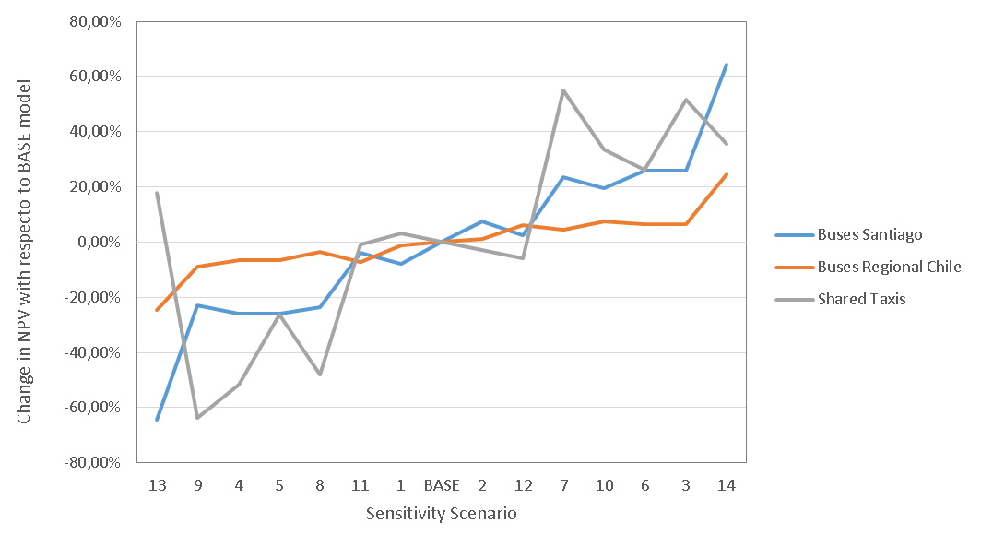

The previous table shows that depending on market conditions, the incremental cost of purchasing an electric vehicle may vary considerably. In the case of public buses in Santiago this value moves from a benefit of around 30,000 USD to a cost of over 100,000 USD. In the case of regional buses, results range from a cost of around 69,000 USD to 170,000 USD. For shared taxis, results show a similar situation to public buses in Santiago. There is some scenario with positive benefit (savings). The previous graph shows how the net present value changes with respect to the base model when some of the parameters change. The maximum variations (considering assumptions made) are in the order of +-60% for buses and +-25% for shared taxis.

To better understand and identify the parameters that most influence the model, an elasticity variable is constructed for each scenario (except for the conservative and optimistic ones). This variable records percent changes in incremental cost with percent changes in parameter value, compared to the base model ($\%IncrementalCost/\%ParameterChange$).

Incremental Cost Elasticity Values:

Parameter | Buses Santiago | Buses Regions | Shared Taxis
Upfront Payment | 64% | 24% | 26%
Loan Interest Rate | 64% | 25% | 96%
Fuel Prices | -259% | -66% | -515%
Electricity Price | 91% | 23% | 91%
Yearly Kilometers | -260% | -43% | -502%
Years of Evaluation | 30% | 57% | 5%
Dollar Price | 268% | 45% | -103%

Results show that most influential parameters are fuel prices, yearly kilometres, and dollar price. With respect to yearly kilometres, interventions should be focused in those vehicles that have the highest yearly kilometers. For example, in the case of Transantiago, there are some buses that are driven over 90,000 kms/year.

With respect to fuel prices, although the base model considers the actual context in Chile, diesel and petrol prices should rise in the near-medium future, according to World Bank projections. On the electricity side, Chile´s electricity generation system has been increasing its share of renewables (solar, wind, hydro) which might reduce electricity user prices by up to 20% starting 2021.

Project crude oil prices (World Bank Group, 2016)

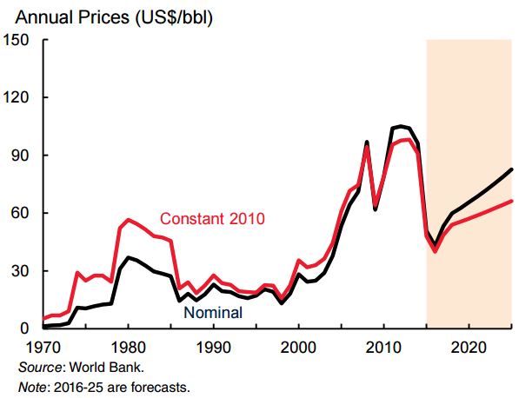

Final incremental cost of purchasing an electric vehicle is still high for the end user and highly variable to different internal and external elements. Some aspects such as increasing fossil fuel prices at the global market, decreasing electricity prices in Chile, decreasing prices of electric vehicles, and increasing capacity of batteries, might set a more advantageous context for this type of interventions.

ANNEX 6. IMPLEMENTATION ARRANGEMENTS
COUNTRy: Republic of Chile
Project Name: SUPPORTING THE CHILEAN LOW EMISSIONS TRANSPORT STRATEGY (CLETS)

Project Administration and Implementation Arrangements

    - National Level: At the national level, the Project Steering Committee (PSC) will be the steering body of the project, overseeing the achievement of the project’s objective as per the Grant Agreement. It will provide overall strategic guidelines to the Project Coordinator (within the Project Management Unit, see below) in order to guide his/her operational work at the project level, thus strengthening the integral dimension of the project. The Committee performs its function, based on constant information of all progress and results from the different Components by the Project Coordinator.

    - The Project Management Unit is responsible to consolidate and foster the national and regional dimensions of the project; it promotes a bidirectional process (top-down as well as bottom-up), to secure the uptake of results, based on validated experiences. It is responsible for the fiduciary oversight and reporting of the project, including financial management and procurement consolidation according to the project’s Operational Manual and procurement plan. It is also responsible for monitoring and evaluation (M&E), provides and coordinates technical advice, and coordinates and assists overall orientation concerning project conception, strategies, criteria and methodologies, as well as organizes and supports project activities.

    - Subnational Level: The Project Management Unit will secure the operational and administrative implementation at the subnational level by agreeing up to four project sites out of Santiago, where all pilot and demonstrative activities will take place. These project sites have been selected, between sites previously analysed, on the basis of local commitment to the CLETS. Support will be provided to Local Committees running each of these pilot initiatives, other technical staff assigned to the project by government ministries and executing agencies in the design and implementation of technical activities at this subnational level. In addition to these overall responsibilities on the technical aspects, the Project Management Unit will assist with all finance and administrative services and secure quality, coherence, tools, training and monitoring, thus ensuring adequate uptake and coordination between overall project and each pilot’s activities.

    - Local Committees will act as steering bodies for each local pilot or demonstrative activity; on the one hand its function is to approve key processes and decisions, such as the Annual Operation Plan, to secure the overall coherence of these activities with the project and to feed its results into national policy dialogue; while providing technical guidance and support on each other when required. The exact composition of each Local Committee depends on the activity and its specific sectorial context. The composition of each Local Committee as well as the description of roles of its members will be specified in the Project’s Operational Manual.

Financial Management

    - All activities related to financial management will follow the Financial Procedures Agreement (inclusive of all annexes) between the Development Bank of Latin America (CAF) and the International Bank for Reconstruction and Development (IBRD) as Trustee of the Global Environmental Facility Trust Fund (GEFTF), signed on September 28th, 2015. This agreement contains provisions for project operations to meet and exceed all internationally-accepted financial and fiduciary management standards, to be evidenced in annual, final independent audits, and other periodic audits of the project accounts, as may be necessary. Staff of the project’s executing agency and PMU that are involved in the day-to-day management of project resources will be trained in financial management policies consistent with the provisions of the above-mentioned agreement, during and after the Project’s Inception.

    - Specifically, the project will implement an adequate integrated financial management system for the Project, including internal control systems that: (i) are in accordance with international accounting standards; (ii) reliably record and report all assets, liabilities and financial transactions of the Project; (iii) provide sufficient financial information for managing and monitoring Project activities; and (iv) integrate financial information, disbursements, purchasing, physical and financial progress of Project indicators, procurement, and control of contracts, to allow the generation of quarterly programmatic financial reports on the financial and physical advance of each component, as well as financial information by disbursement category. The detail of these procedures will be contained in the Project Operations Manual.

Disbursements

    - Disbursements will be made against Project Annual Work Plans (AWP) approved by the Project Steering Committee and CAF. Disbursement shall be in accordance with guidelines defined in CAF Disbursement Policies. Statement of Expenses (SOE) documentation will be maintained by the PMU for post-review and audit purposes. The authorized transfers for project expenditures will be set at a level sufficient to cover approximately six months of estimated expenditures eligible for financing as per the approved Annual Work Plan. Replenishments of funds will be made on evidence of satisfactory utilization of the previous advance(s) as evidenced by the documentation submitted in support of disbursement applications. Deposits and its replenishments, up to an amount of 6 months of eligible project needs, will be made on the basis of Applications for Withdrawals accompanied by the supporting and other documentation specified in the CAF Disbursement Policies.

    - CAF The PMU will be responsible for submitting appropriate disbursement applications to CAF. Payments under SOEs will be made on evidence of satisfactory utilization of the previous advance(s) as evidenced by the documentation submitted in support of disbursement applications.

Procurement

    - All activities related to procurement will follow the Procurement Policies of CAF as defined in the Procurement and Contracting of Goods, Services and Works Manual, published on March 17th, 2015 by the Directorate of Physical Infrastructure, Logistics, and Administration, Version MN/DIOFLA 038 of February 2016. These policies contain provisions for operations to meet and exceed all internationally-accepted financial and fiduciary management standards, to be evidenced in annual and final independent audits of the project’s procurement and disbursement processes. Staff of the project’s implementing agency that are involved in the day-to-day management of project resources will be trained in CAF’s procurement policies as described above and in procurement planning during and after the Project’s Inception.
Environmental and Social (including safeguards)

    - The implementation of project activities will be in accordance the Environmental and Social Safeguards for CAF/GEF Projects Manual, Version 1 of May 2015. The Project is classified as Category C, according to the Guidelines and Procedures on Environmental and Social Safeguards for CAF/GEF Projects Manual (Section V.I.2 Annex I). Project interventions, in particular on-the ground interventions under Component 2, are not expected to cause major adverse environmental impacts, and instead, will improve the environmental and social conditions prevailing in the areas of intervention, including better air quality and reduced noise. Minor site-specific environmental impacts may be expected from some on-the-ground interventions, but mostly temporary.

    - An Environmental and Social Management Framework (ESMF) is required for each Project pilot and demonstrative activity, that conforms to all safeguards triggered by the project and applicable national regulations, and to the Guidelines and Procedures on Environmental and Social Safeguards for CAF/GEF Projects Manual. The aim of each ESMF is to be a practical tool that adheres to the existing regulatory framework in each country, complemented with specific project activities when considered necessary, that describe clear processes to identify impacts, identify and implement mitigation actions, with clear timing and allocation of responsibilities as well.

    - The identification of impacts will be done through participatory, ex-ante processes during the Project implementation. All triggered safeguards will be addressed through the ESMF. Each Executive Committee shall be required to fully embrace their specific ESMF during project implementation, through agreements to be signed between the Executing Agencies/PMU and each Local Committee, as a condition of first disbursement, and thereafter will be disclosed on the Project website.

    - Consistent with the ESMF, procedures to identify and mitigate impacts adhere to the applicable national regulatory framework. That is, the responsibility to implement and monitor the implementation of mitigation activities is determined (and clearly spelled out in the ESMFs) by the regulatory framework. Nevertheless, considering that most activities will be small, and being aware, based on previous experience, of the prevailing weakness in translating regulations into operational actions for small activities, especially the adequate monitoring of environmental and social management, the ESMF specifies activities to be carried out by the project to fill in the gap (e.g., ensure that minimum mitigation measures are part of any contract for works and for the supervision of those works, capacity building activities through participatory processes, etc.).

    - In addition, each Expert will be responsible to report progress on safeguards implementation as specified in each ESMF (e.g., completion of all environmental requirements by law such as permits or licenses, progress in the preparation and implementation of environmental management plans, etc.) to the PMU. The PMU will use this information as an input for the preparation of the overall progress reports to be submitted to CAF every six (6) months. The Expert will collect information on environmental management from the entities responsible of the execution of the different investment.

Monitoring and Evaluation

    - The PMU will be responsible for the overall monitoring and evaluation (M&E) of the Project through the Coordinator, the MEKLE Specialist and partners. M&E of Project implementation will be conducted through three main mechanisms (i) assessment of progress at the activity level (specific M&E systems will be developed for the different investment activities) which will generate data required for the purpose of the project (e.g., validate relevance of adaptation activity, and provide feedback to management instruments); (ii) the measurement of progressive achievement of expected project outputs and results (outcomes) as per indicators defined in the Results Frameworks of the participating countries that feed the Regional Results Framework of the overall project; status of progress will be reported every six months as part of the project progress reports; and (iii) evaluation of the project at certain moments of its implementation: (i) progress reviews during CAF implementation support missions; (ii) mid-term review of project implementation; (iii) final evaluation report to be carried out by the RCU with the input from the country offices and (iv) the Implementation Completion and Results Report (ICR). The ICR will be prepared within six months after closing of the Grant based on the final evaluation report prepared by the RCU.

    - At the pilot level, PMU and partners shall be jointly responsible for monitoring and evaluation, with the oversight of the Project Coordinator. The executing entity(ies) of each activity must provide relevant data and analysis to the Expert, who shall coordinate with the PMU on the interpretation and validity of monitoring results, and the identification of issues which may warrant consultation with the PSC, especially those relating to delivery of project outputs and outcomes. To increase country ownership, the Project will seize opportunities, where available, to align Project required M&E with in-country/Government led M&E systems, already used and operational in partner institutions. This may not only help to reduce costs, but this approach will ensure post-project sustainability of the maintenance of the systems.

Role of Partners

    - Stakeholders participate in the identification of project priorities and in the definition of planned outputs and outcomes during interviews and consultations. All stakeholders must have the opportunity to review and comment on proposed project activities and to provide specific inputs to the project formulation process. Stakeholder participation may include the provision of co-financing, participation of technical staff in workshops, training, and tools development, the facilitation of local project events and processes, the provision of project oversight through participation on the PSC, as data sources and technical expertise relevant for the technical components of the project, and knowledge management through the institutionalization of project results and lessons learned to allow for up-scaling, replication and sustainability. At the regional level, stakeholder engagement will focus at the facilitation of regional project processes in project countries and in the identification of opportunities for optimization of resources, joint investments for project delivery, coordination and collaboration in the production of technical outputs.

ANNEX 7. TOR, PROJECT COORDINATOR

Location Santiago, Chile
Estimated starting date
Duration
Reports to Project Director

Functions and activities
- Organize and participate in the inception workshop, revision and planning the annual work plan and budget and annual progress and monitoring workshops with local stakeholders and other organizations involved in Project implementation.
- Provide technical supervision and guidance to partners in the execution and implementation of project activities.
- Conduct permanent supervision and provide permanent orientation to project staff and Executing Partners.
- Coordinate daily communication between the Project Management Unit and project partners.
- Conduct the project, the Project Management Unit and execute the Annual Operational Plan and the project according to the PRODOC.
- Ensure ongoing monitoring with project staff and partners about the risks of the Project, taking into account the Risk Matrix and ensure that mitigation measures proposed in the PRODOC are implemented and propose alternatives, if appropriate. Prepare other progress reports as needed, in coordination with project specialists.
- Support CAF in the preparation of the Project Implementation Report (PIR).
- Prepare reports on cash/in-kind co-financing from co-financiers and other partners, whether or not considered in the Project Document.
- Help out with the organization of the mid-term and final evaluation of the project, in close collaboration with the Executing Partners of the Project and CAF.
- Coordinate and perform M&E activities, including: i) regular field visits; ii) monthly monitoring, output progress and outcome indicators; iii) provide technical and operational guidance to the staff of participating institutions, and iv) propose any changes to the Project execution strategies, if the project is not working as expected.
- Coordinate the revision and approval of the Terms of Reference and technical specifications of the corresponding contracts.
- Coordinate the work of other specialists and consultants hired for the execution of the project.
- Any other task needed for the adequate progress of project activities.

Key performance indicators
- Submission of operational plans, and approval
- Submission of reports, and approval
- Submission of financial renditions, and approval
- Submission of the PIR, and approval

Required competences
- Professional with a Bachelor’s degree in engineering. A Postgraduate Degree in public transport or innovation would be desirable.
- Accredited work experience in national public management, project management and leadership of professional teams, multi-sectoral environmental management projects; development of management tools and institutional issues in environmental science or engineering.
- Experience working with public and private sectors, NGOs and multicultural environments in coordination, negotiation and leadership tasks and with international and/or national technical experts and scientists.
- Knowledge and experience with environmental regulations in Chile and managerial work with the public sector.
- Experience in mid-term and long-term project management with funds from various sources (public-private-international). Experience with the public sector, project management and experience in management, control and administration of financial instruments and resources (bidding funds, regional funds and others) will be highly valued.
- Competences, abilities and skills in oral and written communication, coordination and teamwork, leadership, conflict resolution and negotiation, work under pressure within deadlines and consultation processes in the public-private sector.
- Availability for frequent trips.

ANNEX 8. TOR, PILOT INITIATIVES
Terms of Reference for the pilot initiative "Electromobility Buses: Caso Concepción"

Introduction

In order to carry out the introduction of low emission public transport in regions, it is considered the most recommendable strategy to become part of the instruments currently under development and from there to advance in its realization.

In this sense, the Regional Governments are currently carrying out renovation programs for public transport vehicles, buses and collective taxis, due to which it is considered appropriate that the development of this program be complemented by the GEF Transportation Project.

Background

Bus Renovation Program. Law 20,378, includes a Bus Renewal Program that allows owners of vehicles from regions other than the area of influence of the public transport system of the Metropolitan Region (Transantiago) to change their machines to new ones.

In this regard, Article 4 transitory states that "Regional Governments will be entitled to convene a process of renewal of buses, minibuses, trolleybuses and taxibuses. This process must consider the purchase of used buses, minibuses, trolleybuses and taxibuses, having to dispose of their destruction and conversion into scrap, guaranteeing their subsequent renewal by buses, minibuses, trolleybuses and taxibuses of lesser antiquity ". Likewise, it is indicated that "The Minister of Transport and Telecommunications will issue a regulation, which will also bear the signatures of the Ministers of Finance and of the Interior and Public Security, which will establish, among other matters, the procedure and the requirements that must be fulfilled. buses, taxibuses, minibuses and trolleybuses that will be included in the program; These must be operational for the public transportation of passengers during the last three years from the date of publication of this law."

This Program began in 2011, with the enactment of Supreme Decree 44/2011 of the Ministry of Transport and Telecommunications, which establishes the general requirements of the program, including the requirements for incoming and outgoing vehicles. As a general rule, the program considers the replacement of a "outgoing" bus with a newer "incoming" bus, with the "outgoing" bus becoming scrap.

As indicated, the Bus Renewal Program is executed by the Regional Governments (GOREs) and coordinated by the Ministry of Transport and Telecommunications. The Regional Councilors are responsible for approving the resources that will be allocated to the Program. The general scheme of execution of the program is as shown in the inserted scheme (in Spanish).

The values ​​to be delivered by each of the vehicles participating in the Program, is given by the capacity of the vehicle, and the difference in age between the incoming vehicle and the outgoing one. The greater the difference, the greater the value that is delivered.

Buses, Trolebuses and “Taxibuses” with capacity from 39 to 67 seats a.i.
(million CLP, in Spanish)
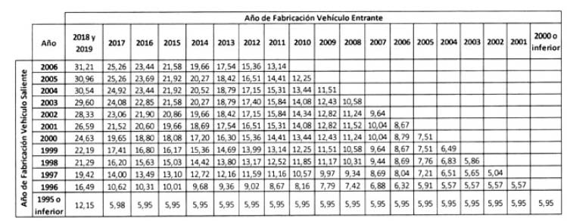

The Program considers requirements for both inbound and outbound vehicles. The requirements for outgoing vehicles are the following:

- Be operational for the public transport of passengers during the last three years since the publication of Law 20,378 (2009).
- Have current registration in the name of the applicant in the Registry of Motor Vehicles carried by the Civil Registry and Identification Service, at the time of application.
- Have or have had current registration of the vehicle, property of the applicant, in the National Registry of Public Transport Services carried by the Ministry, at least one opportunity, within the last 18 months from the date of application.
- Have a certificate of technical review and current driving license or expiration date not exceeding 18 months running at the time of application.
- Have a seniority equal to or greater than one hundred and forty-four months at the time of applying.

The requirements for the incoming vehicles are the following:

- Have current registration, in the name of the applicant in the Register of Motor Vehicles carried by the Civil Registry and Identification Service.
- Have current registration of the vehicle, property of the applicant, in the Public Transportation Registry. Said inscription must be practiced in a public transport service of passengers, from the same region and type of service to which the outgoing vehicle belonged.
- Have a capacity in number of passengers, equal to or greater than 50% with respect to the outgoing vehicle.
- Have a lower age than the outgoing vehicle not less than sixty months.
- If the outgoing vehicle is a bus, trolleybus or taxibus, the incoming vehicle can not be a minibus.
- Have been acquired by the applicant, at least during the last 12 months counted from the start date of the second stage of application, as established by the respective Regional Governments at the beginning of the call.

Participants

Those responsible for services, the number of vehicles and their average age are presented below (in Spanish):

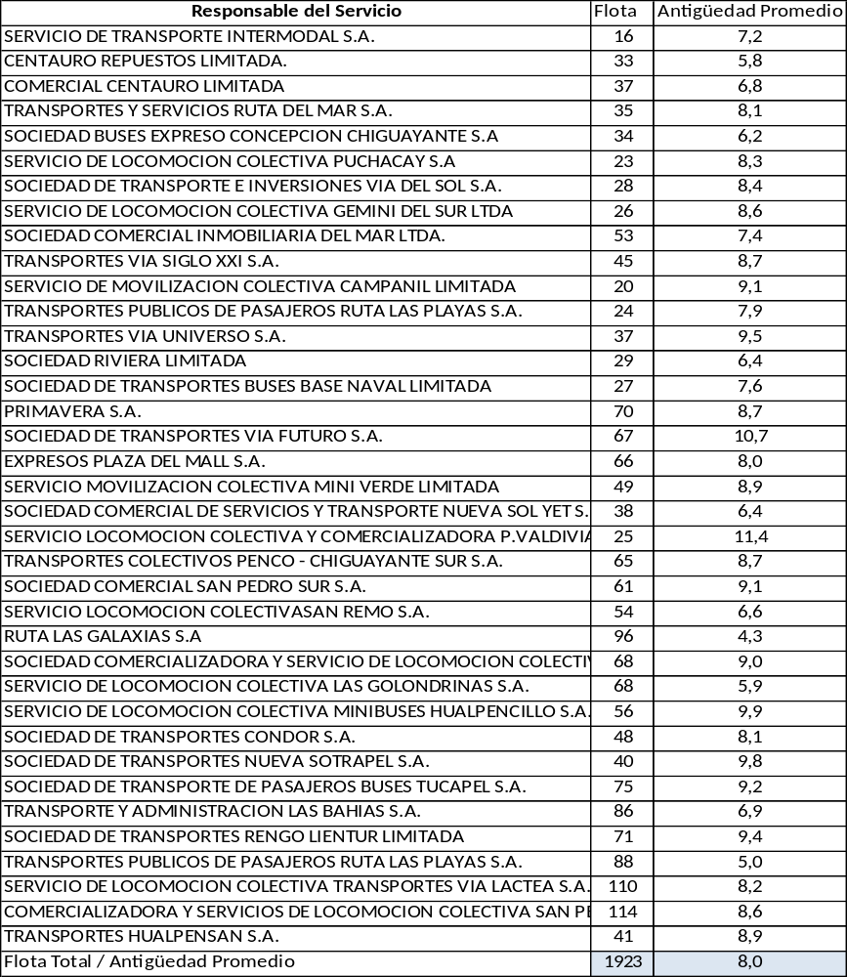

Activities

To carry out the Pilot Program, the following tasks and their associated times are considered in chronological order:

i) Presentation to regional authorities of the availability of resources for GEF technical assistance as support in the calls for the Bus Renewal Program. Management of the Call to said Programs considering the possibility of allocating resources to finance the renewal by electric buses. This first call should be a process for a limited number of buses. Execution time: 3 months

ii) Support the execution of the Call by the Regional Government where resources for renewal by electric buses are considered.
Execution time: 6 months

iii) Support the execution of activities to publicize the call to the Program made by the Regional Government.
Execution time: 3 months

iv) Develop training activities, prior to the start-up of the beneficiary vehicles of the Program, using the experience accumulated in the operation of the electric buses in Transantiago. In particular:
a) To owners of vehicles awarded as beneficiaries of the Renovation Programs.
b) To the drivers of the vehicles.
c) To the mechanics of the vehicles.
d) To firefighters and emergency personnel
Execution Time: 6 Months

v) Support the execution of public activities to launch the operation of the vehicles once they enter into operation.
Execution time: 3 months

vi) Carry out support activities for local authorities that allow the evaluation of the operation development of the low emission vehicles introduced to the system as part of the Renovation Program.
Support transport operators, monitoring the operation of the system.
Execution time: 6 months

vii) Develop dissemination activities where the results of the operation of the vehicles are delivered.
Develop evaluation workshops where eventual improvements to the Program are identified.
Execution time: 6 months

viii) Based on the evaluations carried out, make a new call for proposals to expand the possibility of financing a larger fleet.
Execution time: 6 months

Chronogram (quarters)
 | 3 | 6 | 9 | 12 | 15 | 18 | 21 | 24 | 27 | 30 | 33 | 36 | 39 | 42 | 45 | 48 | 51 | 54 | 57 | 60
Presentation to regional authorities
Support the execution of the Call
Support the execution of activities to publicize the call
Develop training activities
Support public activities to launch vehicle operation
Support activities for local authorities that allow the evaluation
Develop dissemination activities
New call for proposals
Cycle repetition

Terms of Reference for the pilot initiative "Electromobility Buses: Caso Concepción"

Introduction

In order to carry out the introduction of low emission public transport in regions, it is considered the most recommendable strategy to become part of the instruments currently under development and from there to advance in its realization.

In this sense, the Regional Governments are currently carrying out renovation programs for public transport vehicles, buses and collective taxis, due to which it is considered appropriate that the development of this program be complemented by the GEF Transportation Project.

Background

Bus Renovation Program. Law 20,378, includes a Bus Renewal Program that allows owners of vehicles from regions other than the area of influence of the public transport system of the Metropolitan Region (Transantiago) to change their machines to new ones.

In this regard, Article 4 transitory states that "Regional Governments will be entitled to convene a process of renewal of buses, minibuses, trolleybuses and taxibuses. This process must consider the purchase of used buses, minibuses, trolleybuses and taxibuses, having to dispose of their destruction and conversion into scrap, guaranteeing their subsequent renewal by buses, minibuses, trolleybuses and taxibuses of lesser antiquity ". Likewise, it is indicated that "The Minister of Transport and Telecommunications will issue a regulation, which will also bear the signatures of the Ministers of Finance and of the Interior and Public Security, which will establish, among other matters, the procedure and the requirements that must be fulfilled. buses, taxibuses, minibuses and trolleybuses that will be included in the program; These must be operational for the public transportation of passengers during the last three years from the date of publication of this law."

This Program began in 2011, with the enactment of Supreme Decree 44/2011 of the Ministry of Transport and Telecommunications, which establishes the general requirements of the program, including the requirements for incoming and outgoing vehicles. As a general rule, the program considers the replacement of a "outgoing" bus with a newer "incoming" bus, with the "outgoing" bus becoming scrap.

As indicated, the Bus Renewal Program is executed by the Regional Governments (GOREs) and coordinated by the Ministry of Transport and Telecommunications. The Regional Councilors are responsible for approving the resources that will be allocated to the Program. The general scheme of execution of the program is as shown in the inserted scheme (in Spanish).

The values ​​to be delivered by each of the vehicles participating in the Program, is given by the capacity of the vehicle, and the difference in age between the incoming vehicle and the outgoing one. The greater the difference, the greater the value that is delivered.

Buses, Trolebuses and “Taxibuses” with capacity from 39 to 67 seats a.i.
(million CLP, in Spanish)

The Program considers requirements for both inbound and outbound vehicles. The requirements for outgoing vehicles are the following:

- Be operational for the public transport of passengers during the last three years since the publication of Law 20,378 (2009).
- Have current registration in the name of the applicant in the Registry of Motor Vehicles carried by the Civil Registry and Identification Service, at the time of application.
- Have or have had current registration of the vehicle, property of the applicant, in the National Registry of Public Transport Services carried by the Ministry, at least one opportunity, within the last 18 months from the date of application.
- Have a certificate of technical review and current driving license or expiration date not exceeding 18 months running at the time of application.
- Have a seniority equal to or greater than one hundred and forty-four months at the time of applying.

The requirements for the incoming vehicles are the following:

- Have current registration, in the name of the applicant in the Register of Motor Vehicles carried by the Civil Registry and Identification Service.
- Have current registration of the vehicle, property of the applicant, in the Public Transportation Registry. Said inscription must be practiced in a public transport service of passengers, from the same region and type of service to which the outgoing vehicle belonged.
- Have a capacity in number of passengers, equal to or greater than 50% with respect to the outgoing vehicle.
- Have a lower age than the outgoing vehicle not less than sixty months.
- If the outgoing vehicle is a bus, trolleybus or taxibus, the incoming vehicle can not be a minibus.
- Have been acquired by the applicant, at least during the last 12 months counted from the start date of the second stage of application, as established by the respective Regional Governments at the beginning of the call.

Participants

Those responsible for services, the number of vehicles and their average age are presented below (in Spanish):

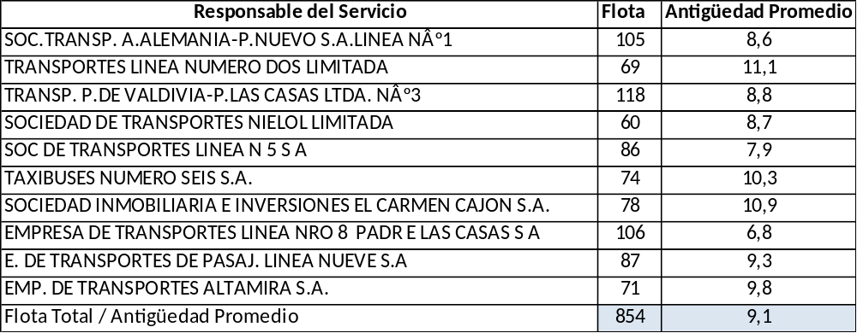

Activities

To carry out the Pilot Program, the following tasks and their associated times are considered in chronological order:

i) Presentation to regional authorities of the availability of resources for GEF technical assistance as support in the calls for the Bus Renewal Program. Management of the Call to said Programs considering the possibility of allocating resources to finance the renewal by electric buses. This first call should be a process for a limited number of buses. Execution time: 3 months

ii) Support the execution of the Call by the Regional Government where resources for renewal by electric buses are considered.
Execution time: 6 months

iii) Support the execution of activities to publicize the call to the Program made by the Regional Government.
Execution time: 3 months

iv) Develop training activities, prior to the start-up of the beneficiary vehicles of the Program, using the experience accumulated in the operation of the electric buses in Transantiago. In particular:
a) To owners of vehicles awarded as beneficiaries of the Renovation Programs.
b) To the drivers of the vehicles.
c) To the mechanics of the vehicles.
d) To firefighters and emergency personnel
Execution Time: 6 Months

v) Support the execution of public activities to launch the operation of the vehicles once they enter into operation.
Execution time: 3 months

vi) Carry out support activities for local authorities that allow the evaluation of the operation development of the low emission vehicles introduced to the system as part of the Renovation Program.
Support transport operators, monitoring the operation of the system.
Execution time: 6 months

vii) Develop dissemination activities where the results of the operation of the vehicles are delivered.
Develop evaluation workshops where eventual improvements to the Program are identified.
Execution time: 6 months

viii) Based on the evaluations carried out, make a new call for proposals to expand the possibility of financing a larger fleet.
Execution time: 6 months

Chronogram (quarters)
 | 3 | 6 | 9 | 12 | 15 | 18 | 21 | 24 | 27 | 30 | 33 | 36 | 39 | 42 | 45 | 48 | 51 | 54 | 57 | 60
Presentation to regional authorities
Support the execution of the Call
Support the execution of activities to publicize the call
Develop training activities
Support public activities to launch vehicle operation
Support activities for local authorities that allow the evaluation
Develop dissemination activities
New call for proposals
Cycle repetition

Terms of Reference of the pilot initiative "Electromobility Collective Taxis: La Serena-Coquimbo Conurbation"

Introduction

In order to carry out the introduction of low emission public transport in regions, it is considered the most recommendable strategy to become part of the instruments currently under development and from there to advance in its realization.

In this sense, the Regional Governments are currently carrying out renovation programs for public transport vehicles, buses and collective taxis, due to which it is considered appropriate that the development of this program be complemented by the GEF Transportation Project.

Background

Renovation program Collective Taxis. Law 20,378 also includes the possibility of carrying out Modernization Programs of Collective Taxis that, like the Bus Renewal Program, is enforceable in regions other than the area of ​​influence of the Public Transport system of the Metropolitan Region (Transantiago).

In this regard, Article 4 transitory states that Regional Governments may convene "collective taxi modernization programs, as minor public transport, aimed at the incorporation of less polluting technologies and improvements in aspects of safety or quality and efficiency for the benefit of the users. These programs will be regulated in the same regulation referred to above. " Given the above, it is the same Supreme Decree 44/2011 of the Ministry of Transport and Telecommunications, which establishes the general requirements of the program.

This Program began in 2015, with the modification of Supreme Decree 44/2011 of the Ministry of Transport and Telecommunications. This modification established the general requirements of the program, including the requirements for inbound and outbound vehicles. As a general rule, the program considers incentives given primarily by the performance of the "incoming" vehicle and where the "outgoing" vehicle continues to be the property of the applicant.

As in the case of the Bus Renewal Program, this Program is executed by the Regional Governments (GOREs) and coordinated by the Ministry of Transport and Telecommunications. The Regional Councilors are responsible for approving the resources that will be allocated to the Program. The general scheme of execution of the program is the insert.

As indicated, the values ​​to be delivered for each of the vehicles participating in the Program are given by the following rules:

(i) Incorporation of less polluting technologies and improvements in security aspects:

Vehicles Euro V and including two of the optional safety elements defined in Supreme Decree No. 26, of 2000, of the MTT: Voltage limiter in safety belts, Seat belt pretensioner, ABS brakes or Electronic stability program ( ESP). These vehicles receive a unique subsidy of $ 300,000.

(ii) Quality and efficiency:

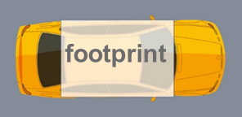
Have a footprint (or area between axes and trails) equal to or greater than 4 mt.2 and an urban performance equal to or greater than 10.5 km / l (petrol) and 13 km / l (diesel).

These vehicles receive a subsidy depending on the fuel and the urban performance of the vehicle (in Spanish and CLP):

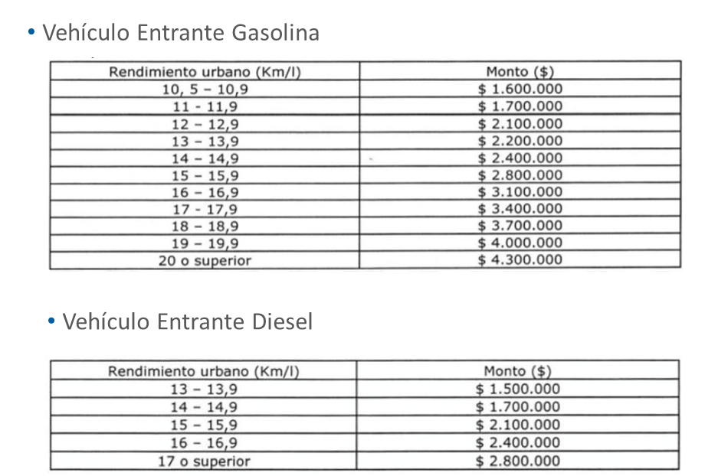

When it comes to an electric incoming vehicle, the amount is $ 6,600,000.

The Program considers requirements for both inbound and outbound vehicles. The requirements for outgoing vehicles are the following:

a) Count or have had current registration in the name of the applicant in the Civil Registry, at the time of application or at the time of cancellation in the RNTPP, if the replacement was made before the date of application.
b) Minimum age of 4 years at the time of application or cancellation in the RNTPP, if the replacement was made before the application.
c) Current registration in the RNTPP, on at least one occasion, within the last 18 months counted from the date of application.
d) Technical Review and Circulation Permit to date or expiration date not exceeding 18 months with respect to the date of application.

The requirements for the incoming vehicles are the following:

a) Current registration in the Civil Registry in the name of the applicant or invoice of first sale.
b) Current registration in the Public Transportation Registry in the same region as the outgoing vehicle.
c) New vehicle: Year of manufacture corresponding to the year of application or following.
d) The applicant must opt ​​for an incoming vehicle that: (i.) Incorporates less polluting technologies and improvements in aspects of safety or (ii.) quality and efficiency, in accordance with the above.

Participants

As the third Electromobility Pilot Program in the regions, the implementation of an Electromobility Program in Collective Taxis in the La Serena-Coquimbo Conurbation is proposed.

Those responsible for services, the number of vehicles and their average age are presented below (in Spanish):

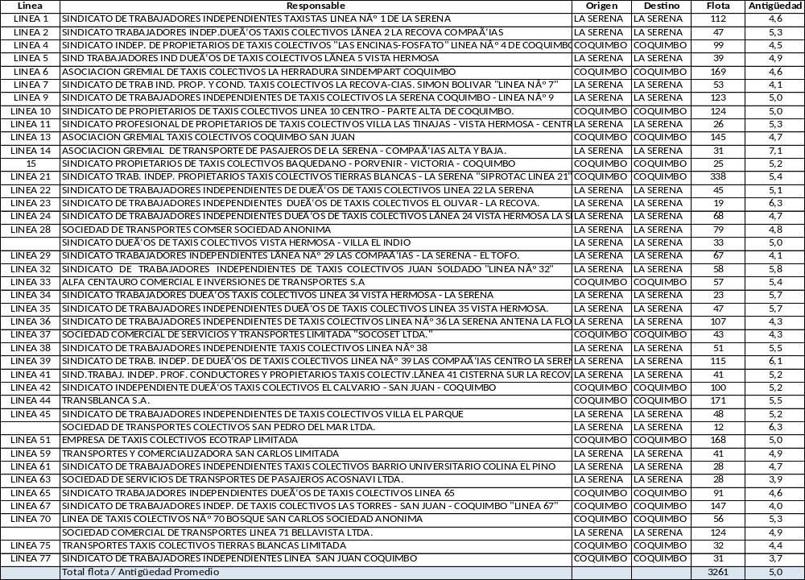

Activities

To carry out the Pilot Program, the following tasks and their associated times are considered in chronological order:

i) Presentation to regional authorities of the availability of resources for GEF technical assistance as support in the calls for the Bus Renewal Program. Management of the Call to said Programs considering the possibility of allocating resources to finance the renewal by electric buses. This first call should be a process for a limited number of buses. Execution time: 3 months

ii) Support the execution of the Call by the Regional Government where resources for renewal by electric buses are considered.
Execution time: 6 months

iii) Support the execution of activities to publicize the call to the Program made by the Regional Government.
Execution time: 3 months

iv) Develop training activities, prior to the start-up of the beneficiary vehicles of the Program, using the experience accumulated in the operation of the electric buses in Transantiago. In particular:
a) To owners of vehicles awarded as beneficiaries of the Renovation Programs.
b) To the drivers of the vehicles.
c) To the mechanics of the vehicles.
d) To firefighters and emergency personnel
Execution Time: 6 Months

v) Support the execution of public activities to launch the operation of the vehicles once they enter into operation.
Execution time: 3 months

vi) Carry out support activities for local authorities that allow the evaluation of the operation development of the low emission vehicles introduced to the system as part of the Renovation Program.
Support transport operators, monitoring the operation of the system.
Execution time: 6 months

vii) Develop dissemination activities where the results of the operation of the vehicles are delivered.
Develop evaluation workshops where eventual improvements to the Program are identified.
Execution time: 6 months

viii) Based on the evaluations carried out, make a new call for proposals to expand the possibility of financing a larger fleet.
Execution time: 6 months

Chronogram (quarters)
 | 3 | 6 | 9 | 12 | 15 | 18 | 21 | 24 | 27 | 30 | 33 | 36 | 39 | 42 | 45 | 48 | 51 | 54 | 57 | 60
Presentation to regional authorities
Support the execution of the Call
Support the execution of activities to publicize the call
Develop training activities
Support public activities to launch vehicle operation
Support activities for local authorities that allow the evaluation
Develop dissemination activities
New call for proposals
Cycle repetition

Terms of reference of the pilot initiative "Integration and Mobility: Execution of pilot experience in the city of Villarrica"

Introduction

In order to carry out the introduction of low emission public transport in regions, it is considered the most recommendable strategy to become part of the instruments currently under development and from there to advance in its realization.

In this sense, the Regional Governments are currently carrying out renovation programs for public transport vehicles, buses and collective taxis, due to which it is considered appropriate that the development of this program be complemented by the GEF Transportation Project.

Background

As the fourth Electromobility Pilot Program in regions, the implementation of an Integration and Mobility Program in the city of Villarrica is proposed.

Currently, urban buses in the city of Villarrica have a fleet management system and electronic payment. Based on the characteristics of this city, and the implementation of these systems, the implementation of a Pilot Program for integration with other modes of transport (Rural Buses and Taxis) is considered, as well as exploring the implementation of a public bicycle system and its associated infrastructure.

Activities

For the realization of this Pilot Program, the following tasks and their associated times are considered in chronological order:

i) Presentation to regional authorities of the availability of resources for technical assistance GEF as support for the implementation of a system of integration of the urban public transport system of the city of Villarrica and implementation of a public bicycle system and its associated infrastructure.
Execution time: 3 months

ii) Support the realization of studies to identify the possibilities of integration of the urban transport system of Villarrica and the implementation of a public bicycle system and its associated infrastructure.
Execution time: 6 months

iii) Technically support the approval of resources by the Regional Government to implement the actions identified in the previous point.
Execution time: 3 months

iv) Technically support the implementation of the measures identified in point ii).
Execution Time: 12 Months

v) Support the execution of public activities to publicize the measures implemented.
Execution time: 3 months

vi) Carry out support activities for local authorities that allow for the evaluation of the implementation of the measures developed.
Execution time: 6 months

Chronogram (quarters)
 | 3 | 6 | 9 | 12 | 15 | 18 | 21 | 24 | 27 | 30 | 33 | 36 | 39 | 42 | 45 | 48 | 51 | 54 | 57 | 60
Presentation to regional authorities
Support the realization of studies
Technically support the approval of resources
Technically support the implementation of measures
Support the execution of public activities
Support activities that allow for evaluation

ANNEX 9. CDKM PLAN
Capacity Development and Knowledge Management Plan

Establishing the Baseline
The first activity of the project is to profile the areas and sectors/subsectors of interest. Given the abundancy of data on them, these is a pretty straightforward, but fundamental, task.
This baseline will form the basis for the project’s MRV system while informing this CDKM Plan. In that sense, it will need to have three main characteristics:
- It must be multidimensional, including not only climate change information, but also socioeconomic characterisation and information on knowledge and capacities
- It must be nested at different scales, so as to inform both the pilot areas and the whole project, which is set at national level
- It must be time-sensitive, considering the initial situation not as a “fixed picture” but as an ongoing trend that will be modified by the project.

This information should be gathered and kept in ways that allow its dialogue with other MRV efforts, such as the UNFCCC reporting system, as well as that can be used by other initiatives, following an Open Data philosophy.
The exploitation of this information system allows for the adequate implementation of pilot projects, for the evaluation of the project’s progress, and also an evaluation of the impact of the initiatives provided to beneficiaries.

Establishing Pilot Initiatives
The project will establish up to four pilot initiatives. In them, the removal of different critical barriers to the development of sustainable mobility will be tested in relevant real conditions. In each of the pilot projects, a multi-actor alliance will be established to provide conditions for that removal, testing ways for inter-institutional and public-private collaboration.
Finally, tracking and monitoring of pilot initiatives and other project activities will inform the training programme, providing elements for the adaptive management of both: pilot initiatives and training programme.

Monitoring System
In the pilot initiatives, intensive monitoring will be put in place, focusing on process indicators that measure the local removal of barriers to the development of sustainable mobility. The monitoring system will also measure the following gender-disaggregated measurements:

Quantitatively tracked
- GHG emission reduction
- Number of beneficiaries (gender-wise)
- Health benefits (gender-wise)
- Noise reduction
- Total, gender-wise number of jobs created

Qualitatively tracked
- Removal of fossil-fuel lock-ins in regulation
- Quality of public transport for women

To do this, project activity and beneficiaries are to be tracked intensively and surveys taken regularly on each of the relevant activities in each of the pilot initiatives, which will be taken to appropriate analysis to be incorporated into the MRV system and project reports. This procedure yields a constant flow of data and information which will be included in learnt lessons.

Diffusion Activities
As a way to begin diffusion activities, a project launch seminar will be held where the objectives and scope of the project are to be explained. Invitees will include all relevant stakeholders at national and subnational levels. Relevant government and private actors in pilot localities and the national level will be included.
Since important barriers to the development of sustainable mobility have been identified in non-financial terrain, the project will make relevant effort in removing access-to-information barriers at different levels. For that, significant effort is foreseen in outreaching to relevant audiences, to ensure that information on both technical and procedural issues is available to potential entrants and other critical stakeholders.
Once project activities are ongoing, significant effort will be devoted to making them known to the affected communities and potentially like-minded actors. Apart from contributing to the replication of the initiatives in places not covered by the project, this will contribute to local communities supporting the project and its aims.
Thus, apart from contributing to the adequate progress of the project, these activities are in themselves tackling perception and trust barriers to the development of sustainable mobility.

Training Activities
The target audiences for training activities are project beneficiaries and specialists and professionals directly linked to the project, as well as decision makers. The work is organised from the identification of these different target groups directly linked to the project. If these target audiences are properly engaged by the institutions executing the project, the expected results will be achieved, as well as others not foreseen, in the process.
For optimum performance, the type of information given and the existing channel are recorded, with human and material resources allocated for monitoring these communication channels and their expeditious operation. The main challenge in the communication channel is at local levels, due to the institutional structures of the affected sectors/subsectors and their functional specifications. To this end, Local Committees will play an important role, responsible for facilitating the project's impact on the daily work of specialists and beneficiaries through learning.

Direct Training
- Efficient driving: the test implementation and studies of the public transport sector have identified driving habits as one important factor affecting emissions (in current fossil-fuel vehicles) and autonomy (in battery-powered ones). Therefore, effort is planned in the transference of best practice in efficient driving to drivers.
- EV mechanics: an important barrier is perceived by fleet managers and vehicle owners alike in the lack of proficient mechanics that can provide maintenance and repair services to the new EV fleet. Therefore, the project will ensure that this knowledge is available and perceived as available in the sector.
- Safe and Secure manipulation of electric vehicles: another important concern regards the manipulation of EVs by ER crews in emergency response situations. The project will ensure that this knowledge is transferred to the appropriate audiences (fire-fighters, rescue staff, etc).

Training of Trainers
- Owning an EV: a specialised training activity will be designed and implemented that provides potential EV owners with information on the differences between ownership of a fossil-fuel vehicle and an EV, including overall financial, technical and managerial aspects.
- Infrastructure development for EV fleet: this specialised training will provide decision makers in the urban-planning sector, at both local (regional and municipal) and ministerial level, with knowledge and best practice on relevant aspects of the design and implementation of recharge infrastructure.
- Smart City development: this training will gather together multiple stakeholders potentially or currently involved in the different aspects of sustainable mobility that are related to the concept of Smart City and its development. Conceived more as a workshop than a classical course, this training will provide not only knowledge, but also opportunities for the development of further initiatives and the coordination between existing ones.

Dissemination Activities
Pilot initiatives and existing impact initiatives (Transantiago) will be used for visits where the relevant results of evaluations for each of them will be shared with national (both other project activities and other) and international professionals and specialists. Promotional material will be generated on the different approaches being assessed at the various pilot initiatives. This includes materials handed out in field days and other supporting material for training, dissemination and replication of the project, best-practice manuals and similar materials.
Once the project produces its results, at least one manual of best practices and lessons learned will be published, covering the different fields of interest and differentiating them by audience if necessary. This manual (or manuals) will include adapted technical items, an economic analysis of the adopted technologies, the identification of smart solutions and other items of interest. This material will probably be an important project output that will help any interested practitioner at the national level, at similar situations in Latin America and beyond.
Regarding the information system, equipment and consulting services for its technical and communicational purposes has been considered. This will facilitate useful information to be selected that can be obtained at appropriate intervals and from optimal communication channels, thus also being an important tool beyond the project and its pilot areas.

Gender Mainstreaming
The project will develop, during the early stages of its implementation, a Gender Action Plan that will inform decision-making structures, activities, and monitoring and evaluation, obviously including this Plan.

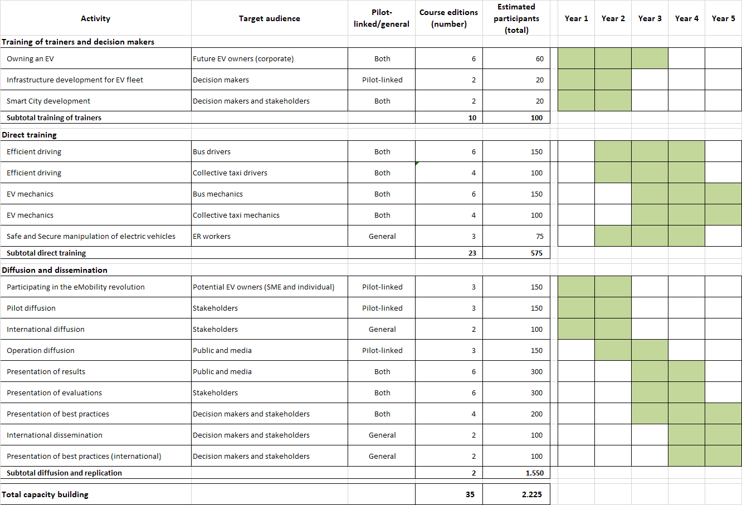
Knowledge management
Adaptive management
As outlaid above, a constant flow of data and information provides detailed acquaintance with the pilot initiatives’ and project’s performance. This multidimensional, nested and time-sensitive monitoring of demonstration units is undertaken by the project’s PMU and contracted specialists, in constant relaying to project committees, both local and the PSC.
This set of indicators (environmental, technical, social, and economic indicators) is analysed and put at the disposal of project Committees, along with its analysis, at a minimum on a yearly basis, in order to inform decisions for the following and subsequent years. This information also informs project’s communication.

Knowledge transfer
A complete set of direct-training and training-of-trainers activities is included in the project. This training programme is intended to improve the capacities of direct beneficiaries and the teams that provide them with technical assistance, including project staff, on a constant basis.
Besides, this programme, which organises and develops training and dissemination activities along the year and both for local stakeholders and others coming from neighbour regions, provides opportunities for the project PMU and Committees to constantly contact the pilot initiatives and of knowing first-hand about the progress therein.
Training events are estimated to develop in the numbers shown below (see detail above), providing opportunities for decision makers, staff, professionals and visiting peers to exchange knowledge and news.

 | Y1 | Y2 | Y3 | Y4 | Y5
Number of training and dissemination events | 7 | 14 | 19 | 17 | 7

Communication
A specialist firm/professional in communication is retained by the project and is part of the project management unit, in order to define, coordinate and carry out a coherent communication strategy that includes news on training and demonstration opportunities, learnt lessons when provided by project activities and information from the MRV system.
The project establishes a systematic, orderly, dynamic communication system, adapted to the needs and requirements of its various stakeholders and target audiences. For this, a comprehensive communication strategy will be designed and adopted (at international, national, regional, local, and micro-local level) that considers and respects the different profiles of the stakeholders. Its objectives are:

- to allow and ensure efficient and effective communication between different institutional and non-institutional actors;
- to have flexible communications whilst maintaining enough formality to allow for monitoring; and
- to establish and use channels that allow for both the dissemination of new practices and useful information and for user feedback and insights on the project.

The communication strategy of the project is also provided with a project webpage, a consultancy on defining appropriate communication strategies, and information dissemination and training for external stakeholders. Professional communication services in order to adequately format messages to audiences, and communication services, are planned and budgeted.

Dissemination and lessons learned
As already mentioned, the project ensures that both national and international peers at the different levels are provided with opportunities to see and ask about all pilot activities, as well as receive problem-solving advice on adopting best practices. Outreach activities are also planned. Besides, the project will keep an open stance to any collaboration request from peers at any level (local, national, international) to visit or receive knowledge from the project.
The project also plans for dissemination activities for professional audiences. Local professionals in charge of different aspects tackled by the project and neighbour-region decision makers, professionals and technicians are considered for training.
As already mentioned, a manual (or manuals) of best practices and lessons learned is to be compiled and distributed, thus codifying the experiences of the project and facilitating their replication.

ANNEX 10. MONITORING & EVALUATION WORK PLAN
M&E Activity | Responsibility | Estimated Budget (US$, Excl. Staff Time) | Time Frame
Inception Workshop* | CAF | Indicative Cost: 4,000 | Within first two months of project start-up
Inception Workshop* | PMU/Project Coordinator | Indicative Cost: 4,000 | Within first two months of project start-up
Inception Workshop* | Project Team | Indicative Cost: 4,000 | Within first two months of project start-up
Inception Workshop* | Consultant | Indicative Cost: 4,000 | Within first two months of project start-up
Develop long-term Plan for M&E, Knowledge Management & Lessons Learned | Project Coordinator will develop TORs - vetted by CAF | Indicative Cost: 26,000** | To be developed at start up, and applied continuously through-out project, annually and at start-up, mid-term and end of project (End of Project Knowledge Management Event)
 | CAF | Indicative Cost: 26,000**
 | Project Team | Indicative Cost: 26,000**
 | Consultant | Indicative Cost: 26,000**
Application of GEF Tracking Tool (Climate Change) | CAF | Indicative Cost: 5,000 | Annually
Application of GEF Tracking Tool (Climate Change) | PMU | Indicative Cost: 5,000 | Annually
Application of GEF Tracking Tool (Climate Change) | Project Team | Indicative Cost: 5,000 | Annually
Committee Meetings (with formally prepared minutes and resolutions) | CAF | Indicative Cost: 5,000 | One physical meeting per year and at least one virtual meeting per year
 | PMU | Indicative Cost: 5,000
Quarterly Financial Reports & SOEs | PMU | Indicative Cost: 0 | Within 30 days of each completed quarter
Quarterly Financial Reports & SOEs | Project Team | Indicative Cost: 0 | Within 30 days of each completed quarter
Project Progress Reports | PMU | Indicative Cost: 0 | At least every 6 months and due within 30 days of each completed semester.
Project Progress Reports | Project team | Indicative Cost: 0
Project Progress Reports | National Project Director | Indicative Cost: 0
Project Progress Reports | Committees | Indicative Cost: 0
Publications | PMU | Indicative Cost: 2,000 | Every semester
Publications | Project Team | Indicative Cost: 2,000 | Every semester
External Mid-Term Review | CAF | Indicative Cost: 18,000*** | Within 90 days of completion of the project’s mid-term
External Mid-Term Review | PMU/Project Coordinator | Indicative Cost: 18,000*** | Within 90 days of completion of the project’s mid-term
External Mid-Term Review | Project Team | Indicative Cost: 18,000*** | Within 90 days of completion of the project’s mid-term
External Mid-Term Review | International Consultant (1) | Indicative Cost: 18,000*** | Within 90 days of completion of the project’s mid-term
External Mid-Term Review | National Consultant (1) | Indicative Cost: 18,000*** | Within 90 days of completion of the project’s mid-term
External Final Evaluation | CAF | Indicative Cost: 25,000*** | At the end of project implementation
External Final Evaluation | PMU/Project Coordinator | Indicative Cost: 25,000*** | At the end of project implementation
External Final Evaluation | Project Team | Indicative Cost: 25,000*** | At the end of project implementation
External Final Evaluation | International Consultant (1) | Indicative Cost: 25,000*** | At the end of project implementation
External Final Evaluation | National Consultant (1) | Indicative Cost: 25,000*** | At the end of project implementation
Terminal Report | PMU | Indicative Cost: 2,000 | At least one month before the end of the project
Terminal Report | Project Team | Indicative Cost: 2,000 | At least one month before the end of the project
Terminal Report | Consultant | Indicative Cost: 2,000 | At least one month before the end of the project
Audits | RCU develops TORs - vetted by CAF | Indicative Cost: 10,000 | At least annually  (CAF reserves the right to request a partial or complete audit at any time)
Audits | Audit Firm to be hired by PMU - no objection from CAF | Indicative Cost: 10,000
Monitoring Visits to Project Sites | PMU | Indicative Cost: 5,000**** | At least yearly
Monitoring Visits to Project Sites | CAF | Indicative Cost: 5,000**** | At least yearly
Monitoring Visits to Project Sites | Project Team | Indicative Cost: 5,000**** | At least yearly
TOTAL INDICATIVE COST, EXCL. STAFF TIME AND CAF STAFF TRAVEL COSTS |  | 102.000
(*) to produce: Annual Work Plan; Discuss and finalize Required Monitoring & Evaluation Plan based on project’s Tracking Tool and inclusive of risk monitoring and control measures; Discuss Project Operations Manual; Discuss Roles, Responsibilities, and Decision-making Structures; Discuss Gender Action Plans; and Discuss Financial Reporting and Project Progress Reporting.
(**) Consultant’s cost plus costs associated with vetting of means of verification in the field throughout project implementation, Productions of Videos, Systematization of lessons, experiences and best practices; regional end of project event.
(***) Professional Fees and logistical costs for 1 International Consultant and 1 National Consultant.
(****) Cost of CAF travel to be charged to GEF IA Fees.

ANNEX 11. MAJOR RISKS AND MITIGATION MEASURES

Risk | Discussion | Proposed measure
Implementation Risk: at different levels (policy-making process, private participants, finance) information is not actionable due to other barriers not being removed. (Medium) | Coordination between the different measures in this project is key to its success. Knowledge-related actions, financial measures and regulatory and technical measures must phase in in a user-friendly form. | The project detailed-design phase has established the necessary implementation arrangements and a robust chronogram.
Political Risk: political will is not maintained through administrations. (Medium) | Municipal elections are due in October 2020. Presidential elections are due in December 2021. The project should assure adequate policy, technical and user-friendly diffusion in coordination with these dates. | A policy-dialogue plan is incorporated within the Project’s CDKM Plan.
Commercial Risk: it is not possible to align commercial incentives with the sharing of data and other innovation mechanisms. (Medium) | Representatives from all relevant stakeholders have contributed to or peer-reviewed the outlining of this document, allowing it to include the needs and perspectives of all stakeholders. | The project considers the participation and access to knowledge of all stakeholders through its CDKM Plan. Capacity and budget for the necessary interaction with stakeholders has been incorporated in the project’s implementation arrangements.
Cultural Risk: situations are not comparable across countries and cities. (Low) | At least at the regional level, the problems this project overcomes are common to major cities’ public transport systems. Dedicated capacities and budget are earmarked for monitoring, systematisation, exchange and learning along the project’s first five years. | A detailed integrated knowledge management and capacity development plan has been designed.
Uncertainty Risk: actual fossil fuel and renewably-sourced electricity prizes differ substantially from those modelled along the project. (Low) | The project’s models have been prepared through a thorough expert review process, submitted to sensitivity analysis and results from it are incorporated, thus rendering the model and key variables risk-explicit. | The M&E mechanisms in place during project implementation explicitly measure key indicators that provide price signals and trending.

ANNEX 12. ENDORSEMENT BY GEF FOCAL POINT

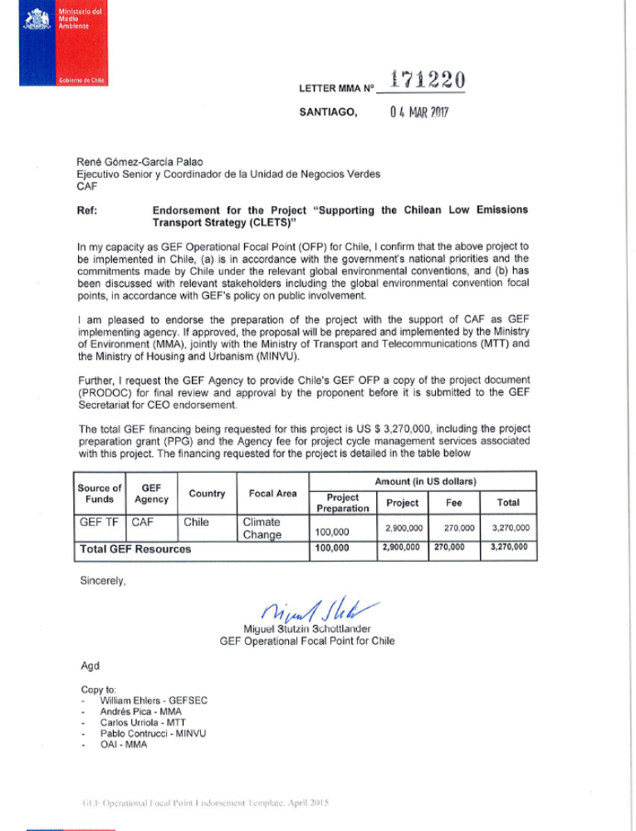

ANNEX 14. CO-FINANCING LETTERS

Available at this link.
Available at this link.
Available at this link.
Available at this link.
Available at, for example, this link.
Available at, for example, this link and this link.
Available at this link.
Available at this link.
Available at this link.
Available at this link.
Available at this link.
Available at this link.
Available at this link.
https://www.leychile.cl/Navegar?idNorma=1111283
See, for example, this link.
Equivalent to 200 km/day, 365 day/year.
http://www.byd.com/la/auto/es/ebus.html
http://www.byd.com/la/auto/es/ebus.html
http://www.renuevatumicro.cl/
http://www.byd.com/la/auto/es/e6.html
http://dtpr.mtt.gob.cl/WEBRTC/
World Bank Group (2016). Commodity Markets Outlook: July 2016. Available at: http://pubdocs.worldbank.org/en/328921469543025388/CMO-July-2016-Full-Report.pdf
https://www.df.cl/noticias/empresas/energia/licitacion-electrica-cuentas-de-electricidad-bajaran-hasta-20-a-partir/2016-08-17/134232.html

